



AMI-GITLAB MODERNIZATION

______________________________________

**RUNBOOK**

**Copyright Notice**

© 2023 Minfy™. Minfy Technologies

Confidentiality and Disclaimer Notice

This document, along with its contents, is the exclusive property of Minfy Technologies. Unauthorized reproduction, storage in a retrieval system, or transmission in any form or by any means, including but not limited to mechanical, photocopying, recording, or electronic methods, without the prior written consent of Minfy Technologies, is strictly prohibited. This prohibition extends to any translation of the document into another language or format. Any infringement will result in legal action.

Notice of Information Change

The information provided in this document is subject to change without prior notice and does not constitute a contractual obligation for Minfy Technologies. Minfy Technologies retains the right to modify any products or services detailed in this document at its discretion and without prior notification. Minfy Technologies assumes no responsibility for the direct or indirect consequences arising from the use of the information contained in this document.

For any inquiries or clarifications regarding this notice, please contact Minfy Technologies directly.

**Third Party Tools Involved:**

**1. HashiCorp Terraform**

<https://www.terraform.io/>

**2. Helm**

<https://helm.sh/>

**3. Prometheus**

<https://prometheus.io/>

**4. Grafana**

<https://grafana.com/>

**5. Fluent-bit**

<https://fluentbit.io/>

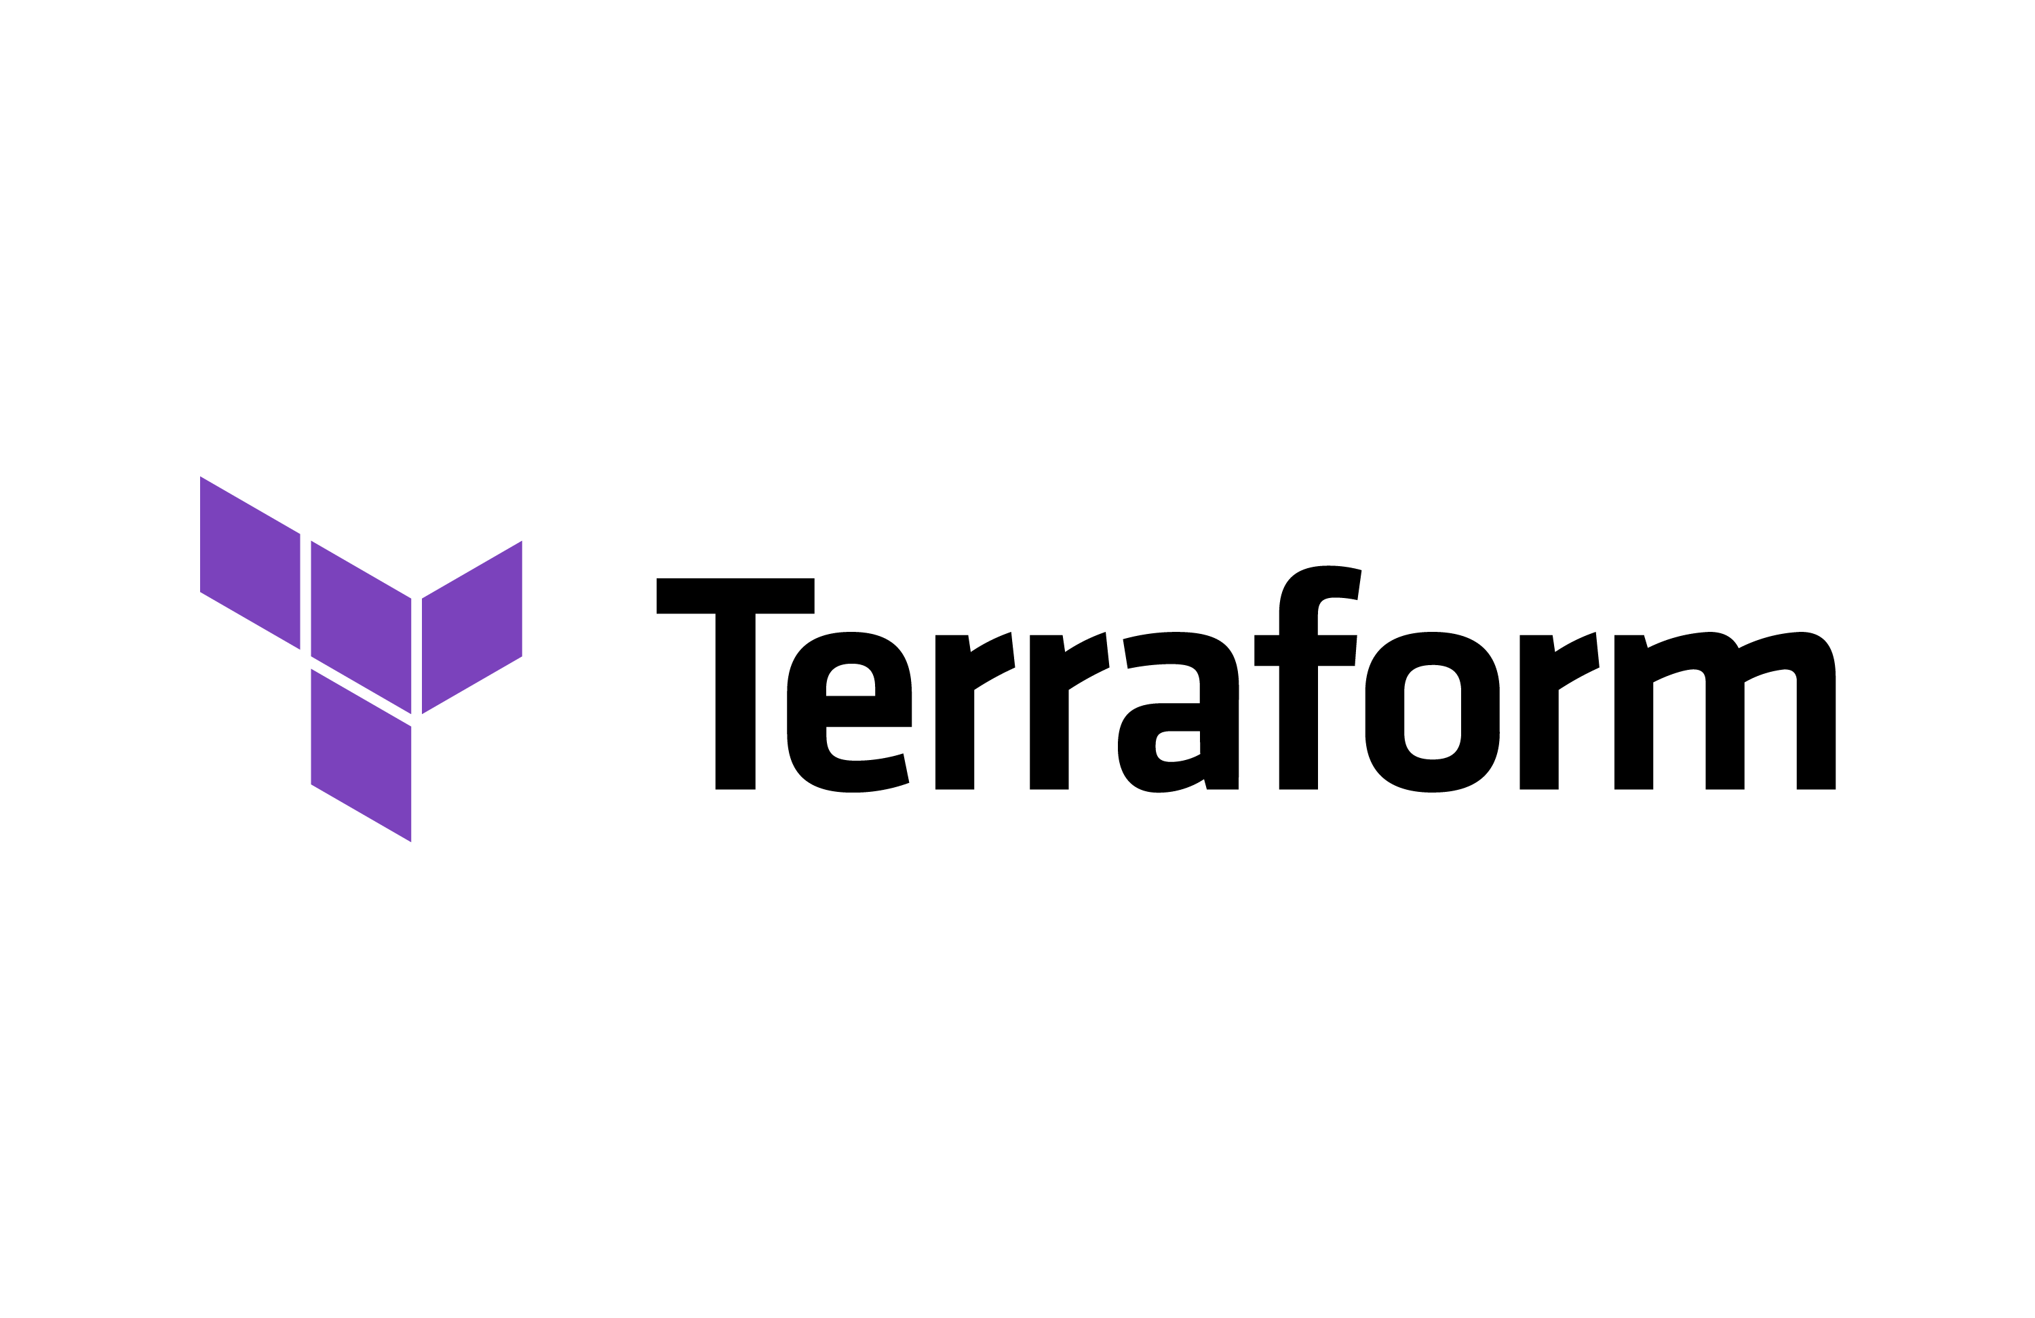 

  

**Purpose**  
  
This runbook delineates the Minfy DevOps team's extensive implementation of an Enterprise-grade infrastructure deployment utilizing Terraform. The orchestration involves key components such as Prometheus, Grafana, FluentBit, cAdvisor, AWS Cloud and Kubernetes. This strategic implementation is crafted with a forward-looking approach, ensuring adaptability for future deployments and facilitating ease in deploying across multiple accounts/tenants with minimal configuration adjustments across folders.

The primary objectives of this runbook are to enhance security measures, strengthen governance protocols, and establish robust control mechanisms for all existing and prospective accounts within the customer's AWS Organization. The integration of Prometheus, Grafana, FluentBit and Kubernetes further augments monitoring, logging, and orchestration capabilities, aligning with the long-term goals of the organization and emphasizing scalability and flexibility in managing infrastructure deployments.

Document Revision Details:

|  |  |  |  |
| --- | --- | --- | --- |
| **Revision** | **Name** | **Date** | **Description** |
| 1 | Ashish Sarawad | 06/2023 | This manual provides a full description of the AMI Technical Specification of Gitlab Modernization. |
| 2 | Ashish Sarawad | 03/2024 | This updated manual comprehensively outlines the technical specifications of the GitLab Modernization AMI, offering a detailed description of its features and functionality. |

Document Reviewer Details :

|  |  |  |
| --- | --- | --- |
| **Name** | **Date** | **Remarks** |
|  |  |  |
|  |  |  |
|  |  |  |

Document Sign Off Sheet:

|  |  |  |
| --- | --- | --- |
| **Name** | **Date** | **Remarks** |
|  |  |  |
|  |  |  |
|  |  |  |

Prepared by:

 Prepared for: **AMI-GITLAB**

CONTENTS

1. INTRODUCTION ........................................................................................ 7

2. MODERNIZATION ARCHITECTURE .............................................................. 8

3. CODE WALKTHROUGH ............................................................................... 10  
 i. Repository Structure …............................................................................ 10  
 ii. Contents of Files & Directories …........................................................... 11  
4. DEPLOYMENT STRATEGY ….......................................................................... 26  
 i. Preparation work ….................................................................................. 26  
 ii. Deployment flow …................................................................................. 46  
 iii. Codepipeline Operations …................................................................... 47  
5. GITLAB RUNNER CONFIGURATION ................................................................ 51  
 i. GitLab Runner Configuration Management for Linux-based Jobs …........... 51  
 ii. GitLab Runner Configuration Management for Windows-based Jobs …... 53  
6. MONITORING ….............................................................................................. 56  
 i. Architecture ….............................................................................................. 56  
 ii. Components deployed in Monitoring stack …............................................. 57  
 iii. Monitoring Workflow …............................................................................. 60  
7. LOGGING …..................................................................................................... 63  
 i. Architecture ….............................................................................................. 63  
 ii. Log Shipping Workflow …........................................................................... 64  
 8. CONCLUSION ….............................................................................................. 68

INTRODUCTION

In a time where technology is advancing rapidly, modernizing applications is a crucial strategic step. This runbook is your guide to smoothly managing this transition. The journey ahead involves careful planning, precise execution, and a strong commitment to industry-leading practices.

Modernization isn't just about keeping up; it's about making sure application deployment is at the forefront of technological innovation in the dynamic landscape of Amazon Web Services. This process covers every crucial aspect of modernization, starting with setting up a robust foundation in the AWS environment. We then move into deployment strategies focused on efficiency and resilience. Security is a top priority, with detailed measures in place to protect the assets. We have implemented monitoring to ensure top performance and quickly address any issues found. Our data backup strategies offer reassurance, creating a safety net for your valuable data.

This document is your dedicated guide, providing a structured path to align every aspect of GitLab modernization with industry best practices and security standards. We aim for clarity, offering a systematic roadmap to achieve your modernization goals.

In this effort, GitLab deployment won't just transition; it will transform to thrive in the AWS ecosystem. It's more than an upgrade; it's a strategic move toward a future where this application is set for growth in your organization, efficiency, and security. Let's embark on this journey together, ensuring your GitLab modernization is a resounding success.

With our shared commitment to excellence, this document acts as a vast landscape of modernization possibilities. Together, we'll navigate the intricacies of GitLab modernization, ensuring your journey is marked by achievement and innovation.

**MODERNIZATION ARCHITECTURE**

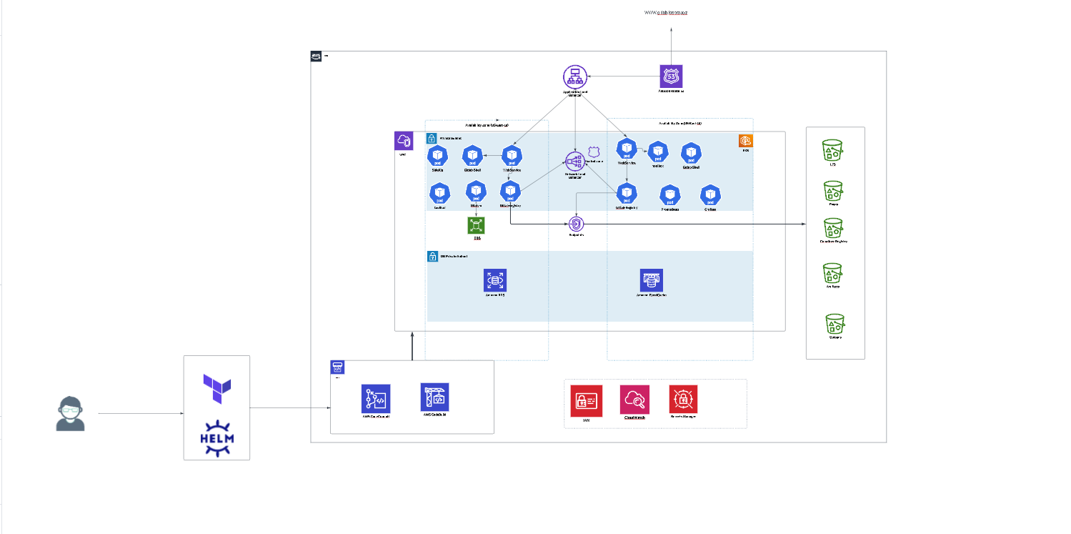  
  *Image 1: AMI-Gitlab Modernization Architecture*

We're upgrading GitLab using Amazon Web Services (AWS) and Kubernetes. It's like giving GitLab a boost with powerful tools. We have carefully planned and designing this upgrade to make sure application is strong and flexible. This design is the foundation that will make it work really well in the long run.  
  
In simpler terms, Kubernetes acts as the manager overseeing GitLab's performance, ensuring components like GitLab Webservice, Sidekiq, and Gitaly work together smoothly. This coordination resembles a robust functioning, maintaining order, resilience, and top-notch performance.

GitLab Webservice and Sidekiq are efficiently organized within Kubernetes containers, specifically in AWS Elastic Kubernetes Service (EKS). This strategy optimizes resource utilization, ensuring GitLab remains consistently available and responsive, even under heavy workloads.

For data storage, AWS S3 serves as a reliable guardian, securely housing GitLab's object data, including repositories and assets. With S3, data is not just stored but kept safe, organized, and easily retrievable whenever needed.

The database, managed by AWS RDS, plays a vital role in storing and handling GitLab's important data. RDS's automated backups and high reliability ensure data availability, simplifying data management and treating it with utmost care.

To meet caching needs, AWS ElastiCache provides a fully managed service, enhancing data retrieval efficiency and queue management. Its capabilities contribute to an optimized experience, ensuring user satisfaction.

This architectural design is a strong commitment to the security, scalability, and efficiency of GitLab in the AWS cloud. It establishes a robust infrastructure for continuous service, adaptability, and top performance, forming the foundation of your GitLab modernization journey with precision and excellence.

CODE WALKTHROUGH

**Repository Structure**   
  
This project is organized into two distinct repositories, each serving crucial roles in the Modernization Workflow.  
Separating infrastructure provisioning and application deployment allows for clear version control, modularity, and ease of collaboration among team members. This structured approach enhances the efficiency and maintainability of DevOps processes, promoting a streamlined and collaborative development environment.

**I. Infrastructure Provisioning Repository**  
This repository is dedicated to managing the infrastructure provisioning process.   
**Repository name – eks-infra**   
The “**eks-infra**" repository will provision the AMI’s infrastructure   
  
| templates  
 | aws_auth_cm.tpl  
 | docker_autoscaler_manager.sh  
 | userdata.sh.tpl  
| data_sources.tf  
| main.tf  
| network.tf  
| security_groups.tf  
| kubernetes.tf  
| s3_storage.tf  
| ecr.tf  
| redis_elasticache.tf  
| postgres_rds.tf  
| add_ons.tf  
| snapshot-lifecycle.tf  
| docker-autoscaler.tf  
| ebs-volume.tf  
| rds_backup_plan.tf  
| ami-gitops-README.md  
| outputs.tf  
| terraform.tfvars  
| variables.tf  
  
In crafting Terraform infrastructure code, we leveraged the extensive guidance provided by the official Terraform documentation [(https://registry.terraform.io/providers/hashicorp/aws/latest/docs](https://registry.terraform.io/providers/hashicorp/aws/latest/docs)). This valuable resource served as a foundational reference, ensuring our infrastructure-as-code adheres to industry best practices and AWS standards.

Additionally, for the GitLab-specific configurations and optimizations, we turned to the GitLab Environment Toolkit (<https://gitlab.com/gitlab-org/gitlab-environment-toolkit>). This toolkit, tailored for environments with up to 5,000 users, offered technical insights and best practices specific to GitLab, enhancing the precision and efficiency of our GitLab-related Terraform configurations. The parallel use of Terraform documentation and the GitLab Environment Toolkit reflects our commitment to robust, well-informed infrastructure development.  
  
**Contents of Files & Directories**  
  
Within the "**templates**" directory, we house templates crucial for infrastructure creation. The purpose of each template file is described below for clarity and understanding.  
  
I. **aws_auth_cm.tpl**  
The aws_auth_cm.tpl file is a Kubernetes ConfigMap definition in YAML format. This ConfigMap, named aws-auth, resides in the kube-system namespace. It is crucial for managing AWS Identity and Access Management (IAM) roles within an Amazon EKS cluster. Specifically, it maps roles, such as EKS-managed roles and Fargate profile pod execution roles, to Kubernetes user accounts. This mapping is essential for granting the necessary permissions and access to system components, ensuring seamless integration with the EKS cluster.

II. **docker-autoscaler.sh**  
The docker-autoscaler.sh script automates the setup of a GitLab Runner with Windows Docker executor and autoscaling capabilities. It includes the installation of GitLab Runner version 16.2.0, necessary dependencies, and the configuration of the Windows Docker executor. The script also integrates the AWS CLI, configures the region, and sets up the AWS Autoscaler plugin for dynamic scaling of Windows instances. This automation enhances the scalability and efficiency of the GitLab Runner setup on Windows instances within an AWS environment.  
  
III. **userdata.sh.tpl**  
The userdata.sh.tpl script is designed for use in AWS EC2 instances launched within an Amazon EKS environment. It is part of the user data provided during instance launch. The script leverages the EKS Bootstrap script to join the EC2 instance to the EKS cluster. Key parameters, such as the base64-encoded cluster CA and the API server URL, are injected during the instance launch process. This script ensures seamless integration of EC2 instances into the EKS cluster, facilitating the dynamic scaling of the infrastructure.

These template files collectively contribute to the streamlined configuration, scaling, and integration of components within the AWS environment, aligning with best practices for efficient and scalable operations.

Infrastructure provisioning is achieved through Terraform to facilitate automated and streamlined deployments. The purpose of each **Terraform template file (.tf)** is outlined below.

**I.** **data_sources.tf**  
The "data_sources.tf" file is designed to obtain essential information and resources. Its primary functions are to retrieve the latest Ubuntu 22.04 Amazon Machine Image (AMI) for automated deployments. The file intelligently handles scenarios where no specific AMI ID is provided, ensuring the selection of the most recent image. Additionally, it captures details about the Transit Gateway shared within the account, focusing on filtering based on the Amazon-side Autonomous System Number (ASN). Furthermore, the file acquires critical information, such as the default Key Management Service (KMS) key ARN for Amazon S3, RDS PostgreSQL database credentials, AWS secret manager details, and Redis credentials stored securely in AWS Secrets Manager. It addresses the configuration of default EKS (Elastic Kubernetes Service) node pools by fetching the appropriate Amazon Machine Image (AMI) release version, dynamically accommodating the latest version when specified as "latest" in the variable. Overall, this file plays a crucial role in the retrieval process, contributing to the seamless provisioning of our infrastructure.

**II. main.tf**  
This "main.tf" file establishes the foundation for Terraform project, defining the backend storage, AWS provider configuration, and ensuring compatibility with the required provider versions. It serves as a central configuration point for our infrastructure provisioning, providing clarity and maintainability.

**III.Network.tf**   
he "network.tf" file orchestrates the configuration of AMI’s network infrastructure using Terraform, encapsulating the creation of a Virtual Private Cloud (VPC), public and private subnets, internet gateways, and routing tables. It dynamically fetches AWS availability zones based on specified criteria. The VPC is equipped with essential attributes such as DNS support and hostnames. Public subnets are established for external-facing resources, each associated with a corresponding internet gateway and routing configurations. Additionally, private and database subnets are created for internal resources, each with dedicated routing and subnet associations. The file ensures robust networking by incorporating NAT Gateways and Elastic IP addresses for private subnets. Furthermore, it seamlessly integrates with the Transit Gateway for efficient and scalable connectivity. The configuration extends to include VPC endpoints, subnet groups for Redis and RDS, and a private hosted zone for internal DNS resolution. In summary, the "network.tf" file serves as a comprehensive blueprint for building a resilient and well-connected network infrastructure on AWS.

**IV.security_groups.tf**  
The "security_groups.tf" file defines security groups, it establishes an internal networking security group, facilitating both machine internal connections and outgoing internet access while meticulously avoiding changes that might trigger replacement due to EKS Cluster issues. Furthermore, it configures security groups for essential services, such as AWS RDS and ElastiCache Redis, enabling secure internal access to these resources. Additionally, it provisions security groups for the GitLab Windows Runner Manager and Worker, catering to the specific requirements of Windows-based environments, including the allowance of WINRM inbound traffic. Each security group is thoughtfully named, tagged, and associated with the corresponding Virtual Private Cloud (VPC), ensuring clarity and cohesion in our network security architecture.  
**V. kubernetes.tf**  
The "kubernetes.tf" file presents a comprehensive configuration for managing an Amazon EKS (Elastic Kubernetes Service) cluster along with associated node groups and Fargate profiles. It dynamically creates the EKS cluster, considering parameters such as the cluster version, log types, and VPC configurations. The provisioned launch templates ensure the use of custom Amazon Machine Images (AMIs) when specified, allowing for tailored configurations of supporting node pools, webservice pools, and Gitaly pools. Autoscaling parameters, desired node counts, and specific Kubernetes labels are defined for each node pool to optimize resource allocation.

The file further defines AWS Identity and Access Management (IAM) roles and policies required for EKS, including those for the EKS cluster itself, its associated node groups, and Fargate profiles. IAM roles have policies attached, granting the necessary permissions for EKS cluster management, worker node operations, and Fargate pod execution. Additionally, the file establishes an OIDC provider and IAM role for Fargate profiles, facilitating communication and resource access within the EKS environment. Lastly, Fargate profiles for key components like Keycloak and GitLab Runner are configured, specifying namespace selectors, subnet IDs, and other relevant parameters for seamless orchestration of containers.

This Terraform script reflects a well-structured approach to deploying and managing Kubernetes workloads on Amazon EKS, considering flexibility, security, and scalability in the cloud environment.

**VI. s3_storage.tf**  
The "s3_storage.tf" Terraform script provides a systematic and secure approach to provisioning Amazon S3 buckets for GitLab object storage. The script utilizes the AWS provider to create S3 buckets dynamically based on the specified configurations, including the bucket name, prefix, and random string generation for uniqueness. Considerations for bucket lifecycle management, versioning, server-side encryption, and public access blocking are incorporated to adhere to best practices for S3 bucket security and compliance.

IAM policies play a crucial role in granting the necessary permissions for S3 bucket operations. The script defines IAM policies for GitLab S3 access, GitLab S3 registry access, and KMS (Key Management Service) policies when required. These policies are carefully crafted to allow specific actions such as listing, putting, getting, and deleting objects based on the unique needs of GitLab and its S3 storage requirements. The conditional creation of these policies ensures a fine-grained and least-privilege approach to access control.

Moreover, the script intelligently constructs lists of S3 bucket ARNs, excluding the registry bucket where needed. This flexibility is essential for accommodating various configurations and deployments. The script's modularity and use of Terraform's expressive syntax contribute to a clear and maintainable infrastructure-as-code solution for managing GitLab's S3 storage requirements on AWS.

**VII. ecr.tf**  
The "ecr.tf" Terraform script efficiently manages the creation of Amazon Elastic Container Registry (ECR) repositories, catering specifically to GitLab components such as GitLab Webservice, GitLab Workhorse, and Keycloak.   
  
Each ECR repository definition includes essential attributes such as the repository name, image tag mutability set to "MUTABLE" to allow tag updates, and a set of tags for enhanced resource identification and organization. The use of Terraform's count feature enables conditional creation of ECR repositories, providing flexibility based on the boolean value of the "**create_ecr_repos**" variable.

The "**gitlab-webservice-repo**," "**gitlab-workhorse-repo**," and "**keycloak-repo**" resources showcase consistency in naming conventions, aligning with the corresponding GitLab components they represent. Additionally, the inclusion of tags, particularly the "Name" tag, contributes to improved resource management and visibility within the AWS environment  
  
**VIII. redis_elasticache.tf**  
The "redis.tf" Terraform script orchestrates the deployment and configuration of an Amazon ElastiCache Redis cluster with a focus on operational efficiency and security. It begins by establishing an AWS CloudWatch Log Group dedicated to Redis logs, incorporating a retention period of 7 days for effective log management. This log group is tagged for streamlined resource identification.

Subsequently, the script employs the aws_elasticache_replication_group resource to create the ElastiCache Redis replication group, applying various settings such as engine version, instance type, and encryption mechanisms. Notably, the configuration encompasses CloudWatch log delivery configurations for both slow logs and engine logs, ensuring centralized log storage and analysis. Leveraging Terraform's conditional expressions, the script adeptly tailors the deployment based on the specified count of Redis nodes. Through this modular and systematic approach, the script lays the foundation for a resilient and secure ElastiCache Redis environment.  
  
**IX. postgres_rds.tf**  
The "postgres.tf" Terraform script orchestrates the deployment and configuration of an Amazon RDS PostgreSQL database instance, emphasizing robustness and security. It dynamically manages the creation of the RDS instance, with conditional logic ensuring proper handling of optional configurations, such as multi-AZ deployment, encryption, and backup settings. The script enables flexibility in defining instance characteristics such as type, allocated storage, and database port. Notably, it incorporates security measures by specifying an IAM role for enhanced monitoring and utilizes AWS Secrets Manager for secure retrieval of sensitive information, such as database passwords. Additionally, the script facilitates parameter group customization, allowing specific PostgreSQL parameters, such as password encryption and statement logging duration, to be tailored to project requirements. Overall, the "postgres.tf" script provides a comprehensive and adaptable foundation for deploying and managing PostgreSQL databases on AWS, leveraging Terraform's declarative syntax for clarity and consistency in infrastructure as code.  
**X. add_ons.tf**  
The "addons.tf" script encapsulates the setup of essential Kubernetes add-ons for an Amazon EKS cluster, contributing to the cluster's functionality and resilience. It employs Terraform's declarative syntax to define and manage resources systematically. The script provisions key components such as the Kubernetes proxy, CoreDNS, VPC-CNI, and the AWS EBS CSI driver, enhancing the EKS cluster's networking, DNS resolution, and storage capabilities. To ensure seamless integration, dependencies between resources are carefully orchestrated, and conflicts are resolved during creation. Moreover, the script establishes specific IAM roles for each add-on, adhering to the principle of least privilege and bolstering security within the EKS environment. The role policies are meticulously crafted to align with the respective add-on's requirements, showcasing a tailored approach to access management. In summary, "addons.tf" is an integral part of the infrastructure-as-code strategy, delivering a clear, adaptable, and secure foundation for Kubernetes add-ons within the AWS EKS ecosystem.  
  
**XI. snapshot-lifecycle.tf**  
This Terraform script sets up AWS resources for Amazon EBS volume lifecycle management using AWS Data Lifecycle Manager (DLM). It creates an IAM role with a policy allowing DLM to assume the role and attaches an AWS-managed policy for DLM. The script also defines a DLM lifecycle policy for Gitaly volumes, scheduling daily snapshots, retaining them for a specified duration, and applying relevant tags. This streamlined configuration ensures efficient EBS volume lifecycle management through DLM.  
  
**XII. docker-autoscaler.tf**  
The "docker-autoscaler.tf" script orchestrates the deployment of a dynamic Amazon EC2 Auto Scaling Group tailored for Windows runners within a GitLab CI/CD pipeline. It follows a modular structure, featuring distinct resources for the Auto Scaling Group, a launch template specifying Windows runner configurations, and the requisite AWS Identity and Access Management (IAM) policies. This ensures efficient scaling and management of EC2 instances based on demand. The IAM policies delineate permissions for managing the Auto Scaling Group and EC2 instances, including actions like setting desired capacity and terminating instances. Additionally, it establishes an IAM role and instance profile for secure instance execution, adhering to the principle of least privilege. Furthermore, the script facilitates the association of IAM policies with the IAM role, creating a robust security posture. Lastly, the deployment includes an AWS EC2 instance, configured as a Docker Autoscaler Manager, to oversee and coordinate the scaling activities. This comprehensive script streamlines the setup of a resilient and scalable Windows runner environment, contributing to the efficiency of CI/CD workflows in the GitLab ecosystem.  
  
**XIV. ami-gitops-README.md**  
This document provides a GitOps-focused README, offering insights into the processes and best practices related to GitOps within the repository.

**XVI. outputs.tf**  
The "outputs.tf" file summarizes key details for an AWS infrastructure deployed via Terraform. It includes information on the EKS cluster, RDS PostgreSQL host, S3 buckets, Elasticache Redis connection, ECR repository URLs, S3 policy ARNs, IAM role ARNs, and the VPC ID. These outputs provide essential insights for monitoring and integration across AWS services.

**XVIII. terraform.tfvars**  
The terraform.tfvars file is a crucial configuration file in Terraform projects. It allows users to assign specific values to variables, streamlining customization for deployments without modifying core configuration files.  
  
**XIX. Variables.tf**  
In variables.tf, users declare and define variables for Terraform configurations. This HCL file ensures a structured approach to input parameters, enabling users to customize settings like AWS credentials or resource names. With the ability to add descriptions and default values, variables.tf enhances and simplifies maintenance in Terraform configurations.

**II. Application Deployment Repository**  
This repository is dedicated to managing theapplication deployment process.   
**Repository name – eks-apps**  
The “**eks-apps**" repository will deploy the AMI’s applications  
  
**1. common**  
| templates  
 | aws_auth_cm.tpl  
| fluentbit_values.yaml  
|kube-promethues-stack.yaml  
 | auth.tf  
 | aws-loadbalancer.tf  
 | cluster-autoscaler.tf  
 | data.tf  
 | fluentbit.tf  
 | kube-prom-stack.tf  
 | metricserver.tf  
 | provider.tf  
 | variables.tf

**Contents of files for common directory**

**I. templates**  
Within the "**templates**" directory, we house templates crucial for infrastructure creation. The purpose of each template file is described below for clarity and understanding.  
  
1**. aws_auth_cm.tpl**  
The YAML file aws_auth_cm.tpl creates a Kubernetes ConfigMap named "aws-auth" in the "kube-system" namespace. It defines roles for AWS EKS cluster nodes and Fargate profiles, mapping IAM roles to Kubernetes user accounts with specified groups. This configuration facilitates authentication and authorization for nodes and Fargate profiles in the Kubernetes cluster.  
  
2**. fluentbit_values.yaml**  
The fluentbit_values.yaml file defines configurations for deploying Fluent Bit in a Kubernetes environment. It specifies parameters such as the deployment type (DaemonSet), image details, service settings, resource limits, and various other options. The configuration includes inputs, filters, and outputs for log processing, with customization options for AWS CloudWatch Logs. Additionally, it provides flexibility for specifying environment variables, extra files, and volumes. The file also allows fine-tuning of probes, autoscaling, and network policies. It supports integrations with external tools like Prometheus and Grafana, offering a comprehensive and customizable setup for log collection and forwarding in Kubernetes clusters.

3**. kube-promethues-stack.yaml**  
The kube-prometheus-stack.yaml file serves as a template for deploying the kube-prometheus-stack, which is a comprehensive monitoring solution for Kubernetes environments. The YAML file includes configurations for deploying Prometheus, Grafana, Alertmanager, and other essential components of the monitoring stack. It defines various settings such as service types, ports, and persistent storage options. The file also allows customization of Prometheus rules, Grafana dashboards, and Alertmanager alerts. Overall, kube-prometheus-stack.yaml provides a structured and modifiable configuration for setting up a robust monitoring infrastructure tailored to Kubernetes clusters.

Application deployment is achieved through Terraform to facilitate automated and streamlined deployments. The purpose of each Terraform template file (.tf) is outlined below.  
   
**II. auth.tf**  
The auth.tf file serves as a Terraform configuration to manage authentication settings in a Kubernetes cluster, particularly for Amazon EKS. It dynamically generates the AWS AUTH Config for the cluster, leveraging a template file (aws_auth_cm.tpl) and incorporating various map roles and map users. The configuration includes settings for EKS managed roles and Fargate profile pod execution roles. Additionally, it establishes a Kubernetes ConfigMap named "aws-auth" within the "kube-system" namespace, containing the mapped roles and users in YAML format.

Furthermore, the file extends cluster access by creating a Kubernetes ClusterRole named "eks-console-dashboard-full-access-cluster-role," providing read-only access to various Kubernetes resources. This access is then bound to a ClusterRoleBinding named "eks-console-dashboard-full-access-cluster-rolebinding," associating it with a specific user group defined in the map roles. In summary, auth.tf streamlines the configuration of authentication settings and access control within the Kubernetes cluster, ensuring secure and well-defined role-based access for users and services.  
  
**III. aws-loadbalancer.tf**  
The aws-loadbalancer.tf file orchestrates the setup of the AWS Load Balancer Controller (LBC) for an Amazon EKS cluster. It begins by fetching the IAM policy for the controller from the official AWS Load Balancer Controller GitHub repository. Subsequently, it creates an AWS IAM policy and IAM role, associating the policy with the role. The IAM role is configured with a specific assume role policy, allowing the Load Balancer Controller service account to assume the role within the EKS cluster.  
The configuration also includes the creation of a Kubernetes service account named "aws-load-balancer-controller" within the "kube-system" namespace, with associated annotations linking it to the IAM role. This service account facilitates the interaction between the AWS Load Balancer Controller and the EKS cluster.  
Finally, the Helm provider is employed to deploy the AWS Load Balancer Controller as a Helm chart, ensuring seamless integration with the EKS cluster. The Helm release is customized with parameters such as the AWS region, VPC ID, Docker image repository, and version, among others. This comprehensive Terraform script streamlines the deployment and integration of the AWS Load Balancer Controller into an Amazon EKS environment.  
  
**IV. cluster-autoscaler.tf**  
  
The provided Terraform script "cluster-autoscaler.tf" configures the AWS Identity and Access Management (IAM) role and policies necessary for the Kubernetes Cluster Autoscaler. It defines an IAM role named "eks-cluster-autoscaler-role" with associated policies that grant permissions for autoscaling actions and EC2 instance-related operations. Additionally, the script creates a Helm release for the Cluster Autoscaler, specifying configurations such as the AWS region, cluster name, and enabling auto-discovery. The script also sets up RBAC configurations for the Kubernetes service account associated with the Cluster Autoscaler. Overall, this script facilitates the seamless integration of the Cluster Autoscaler with an Amazon EKS cluster, ensuring efficient and automated management of the cluster's node capacity based on workload demands.  
  
**V. data.tf**

The "data.tf" file specifies Terraform data blocks for retrieving information from remote states and AWS Secrets Manager. The first block, "terraform_remote_state," fetches the remote state of the "eks-infra" Terraform module stored in an S3 bucket, providing the necessary configuration details. The subsequent data blocks, named "redis_creds," "gitlab_secrets," "gitaly_creds," and "postgres_db_creds," each fetch a different set of secrets from AWS Secrets Manager by specifying the corresponding secret IDs. These secrets are presumably used within the Terraform configuration for sensitive information like database credentials, Redis configurations, and GitLab secrets.  
  
**VI. fluentbit.tf**

The "fluentbit.yml" Terraform script defines resources for Fluent Bit in an Amazon EKS cluster. It begins by creating an IAM policy named "eks-infra-fluentbit-policy" that allows essential actions on CloudWatch Logs. Subsequently, an IAM role, "eks-infra-fluent-iam-role," is established, associated with the EKS cluster's OIDC identity provider and constrained to the "system:serviceaccount:logging:fluent-bit-sa" service account.  
  
The IAM policy is attached to the IAM role, and a Helm release for Fluent Bit is configured. This release deploys Fluent Bit with specific settings, such as the service account name, IAM role annotations, AWS region, and other parameters tailored for the EKS cluster. The script enables efficient log management and integration with CloudWatch Logs for improved observability in the Kubernetes environment.  
  
**VII. kube-prom-stack.tf**  
The "kube_prom_stack.tf" Terraform script defines a Helm release for the Kubernetes Prometheus stack. It utilizes the Helm chart from the Prometheus Community repository to deploy the "kube-prometheus-stack" in the "monitoring" namespace of an Amazon EKS cluster. The configuration includes values sourced from a YAML file, specifically "kube-prometheus-stack.yaml," for fine-tuning the deployment.

Notably, the script incorporates a count condition to facilitate the conditional creation of the Helm release based on the variable "create_kube_prom_stack." Additionally, it dynamically sets the Grafana admin password by retrieving it securely from AWS Secrets Manager, enhancing security practices. The script is structured to enhance observability within the Kubernetes cluster through the comprehensive monitoring capabilities provided by the Prometheus stack and Grafana dashboard.  
  
**VIII. metricserver.tf**  
The "metricserver.tf" Terraform script orchestrates the deployment of the Metrics Server for Kubernetes by defining a Helm release. Conditionally triggered by the variable "create_metrics_server," the script utilizes the Helm chart sourced from the official Kubernetes SIGs repository. This Helm release ensures the installation of the Metrics Server version 3.11.0 within the "kube-system" namespace of the target Kubernetes cluster.

The count parameter facilitates the controlled creation of the Helm release, offering flexibility in managing the deployment based on specific configuration requirements. The Metrics Server plays a crucial role in collecting and exposing resource utilization metrics for nodes and pods in the Kubernetes cluster, contributing to efficient monitoring and scaling decisions. The script's simplicity aligns with best practices, emphasizing clarity and maintainability in the deployment process.

**IX. provider.tf**  
The "provider.tf" Terraform script configures Amazon S3 as the backend for state storage and specifies providers for AWS, Helm, Kubernetes, and template resources. It dynamically determines the AWS region from the EKS infrastructure's remote state output. The script also sets required versions for Terraform and providers, ensuring compatibility. Notably, it establishes connectivity to the EKS cluster by extracting authentication details from the remote Terraform state, enabling smooth interactions with Kubernetes and Helm for efficient infrastructure management.

**X. Variables.tf**  
In variables.tf, users declare and define variables for Terraform configurations. This HCL file ensures a structured approach to input parameters, enabling users to customize settings like AWS credentials or resource names. With the ability to add descriptions and default values, variables.tf enhances and simplifies maintenance in Terraform configurations.

**2. Gitlab**

| templates  
 | on_demand_runner_values_template.tpl.yml  
 | privilaged_runner_values_template.tpl.yml  
 |spot_runner_values_template.tpl.yml  
 |values_template.tpl.yml  
|webservice-custom-build   
 | workhorse-custom-build  
 | data.tf  
 | extra_ingress.tf  
 | gitlab_secrets.tf  
 | main.tf  
 | ondemand_runner.tf   
 | privileged_runner.tf   
 | provider.tf  
 | route53_record.tf   
 | spot_runner.tf  
 | values_templates.tpl.yml  
 | variables.tf

**Contents of files for gitlab directory**  
  
**I.** **templates**  
The template folder houses Helm chart values file templates essential for deploying gitlab application and gitlab runners in Amazon EKS using Helm charts. Within this folder, there are four distinct templates files:  
1. on_demand_runner_values_template.tpl.yml is for on-demand gitlab runner which is tailored for deploying gitlab runner in eks which uses On-demand EC2 instances as worker runners for its job.

2. spot_runner_values_template.tpl.yml is for spot gitlab runner which is tailored for deploying gitlab runner in eks which uses SPOT EC2 instances as worker runners for its job.

3. privilaged_runner_values_template.tpl.yml is for Privileged runner which is tailored for deploying gitlab runner in eks which uses on-demand EC2 instances as worker runners for its job but with privileged runner tag.

4. values_template.tpl.yml is the main values file for gitlab application deployment that serves as a base for configuring gitlab application using Helm charts in eks.

**II. webservice-custom-build**  
The webservice-custom-build folder encapsulates all elements required for constructing a customized GitLab webservice image. It includes application files, assets, and a Dockerfile, ensuring a tailored deployment aligning with client preferences. Below is a list and description of files and folder overview:   
  
**app:** Contains essential application files for the GitLab webservice, ensuring proper functionality and customization.  
**assets:** This directory houses JavaScript files crucial for enhancing the webservice's front-end behavior.   
**Dockerfile:** Orchestrates the build process for the custom GitLab webservice Docker image. This file is instrumental in implementing client-specified modifications and enhancements.   
  
**III. workhorse-custom-build**  
The workhorse-custom-build folder focuses on building a personalized GitLab Workhorse image. It contains assets and a Dockerfile, ensuring the Workhorse aligns with client requirements during GitLab deployment. Below is a list and description of files and folder overview:

**assets:** Like the webservice, this directory includes JavaScript files contributing to enhanced functionality in the GitLab Workhorse.

**Dockerfile:** Guides the build process for the customized GitLab Workhorse Docker image, accommodating client-specified modifications.

**IV. Data.tf**  
The "data.tf" file specifies Terraform data blocks for retrieving information from remote states and AWS Secrets Manager. The first block, "terraform_remote_state," fetches the remote state of the "eks-infra" Terraform module stored in an S3 bucket, providing the necessary configuration details. The subsequent data blocks, named "redis_creds," "gitlab_secrets," "gitaly_creds," and "postgres_db_creds," each fetch a different set of secrets from AWS Secrets Manager by specifying the corresponding secret IDs. These secrets are presumably used within the Terraform configuration for sensitive information like database credentials, Redis configurations, and GitLab secrets.

**V. extra_ingress.tf**

The "extra_ingress.tf" file specifies that there are three ingress configurations set up: one for the public registry service accessible via the "git.ami.com:5005" domain, another for the public registry accessible via the "registry.ami.com" domain, and one for internal access to "git.ami.com".  
Each ingress resource specifies metadata and annotations for configuring the AWS Application Load Balancer (ALB) settings, including backend protocols, SSL policies, and load balancer attributes.  
The "depends_on" attribute ensures proper ordering of resource creation, with dependencies on the deployment of the GitLab Helm chart.  
Additionally, there's a commented-out section for setting up ingress for the internal "git-ssh.ami.com" domain, demonstrating flexibility for future configurations.  
Lastly, a Kubernetes service resource is defined for the internal access to "git-ssh.ami.com," specifying annotations for load balancer configurations and port mappings.

**VI. gitlab_secrets.tf**  
The Terraform script, named gitlab_secrets.tf, orchestrates the deployment of Kubernetes secrets within a cluster, specifically for managing GitLab configuration. It employs AWS Secrets Manager to securely store sensitive information and then decodes and uses these secrets to create Kubernetes secrets for GitLab Rails and OpenID Connect configurations. The script establishes two Kubernetes secret resources, namely gitlab_rails_secret and gitlab-openidconnect-keycloak, with carefully configured parameters. These secrets are instrumental in securing critical information, such as API keys and configuration settings, essential for the secure operation of GitLab within a Kubernetes environment.

**VII. main.tf**  
The provided Terraform script, named main.tf, orchestrates the deployment of GitLab on Kubernetes within an AWS environment. It initiates the creation of a dedicated Kubernetes namespace, "ci-runner," designed for organizing Continuous Integration (CI) runner-related resources. Additionally, the script defines a PostgreSQL database, "gitlabhq_production," along with the associated role necessary for GitLab operation. The configuration includes a Kubernetes storage class, "gitaly_storage_class," tailored for GitLab's Gitaly component, utilizing AWS EBS (gp3) with specific parameters. The deployment of GitLab itself is facilitated through a Helm release, "gitlab-chart," specifying dependencies on previously established resources. Furthermore, the script incorporates the creation of IAM roles and policies essential for GitLab's interaction with AWS services, addressing aspects such as GitLab Container Registry and S3 caching for CI runners. To ensure dynamic parameterization, the script utilizes a template file for Helm values, allowing flexibility in adapting to various GitLab versions, domain information, and AWS resources. Overall, this Terraform script offers a structured and efficient approach to deploying GitLab on Kubernetes, emphasizing simplicity and professionalism in its design.

**VIII. ondemand_runner.tf**  
The ondemand_runner.tf automates the deployment of a Helm chart release called "gitlab-on-demand-runner" within a Kubernetes cluster. This release, sourced from the GitLab Helm repository, facilitates the setup of a gitlab runner system. Key aspects of the deployment include specifying the chart version, repository location, and namespace within Kubernetes. Configuration values for the Helm release are dynamically generated from a template file, ensuring flexibility and customization. Dependencies, such as a PostgreSQL database resource, are accounted for in the deployment workflow. Additionally, essential parameters, like service account annotations and authentication tokens, are set to ensure seamless integration with the GitLab environment.

**IX. privileged_runner.tf**  
The privileged_runner.tf automates the deployment of a Helm chart release called "gitlab-privileged-runner" within a Kubernetes cluster. This release, sourced from the GitLab Helm repository, facilitates the setup of a gitlab runner system. Key aspects of the deployment include specifying the chart version, repository location, and namespace within Kubernetes. Configuration values for the Helm release are dynamically generated from a template file, ensuring flexibility and customization. Dependencies, such as a PostgreSQL database resource, are accounted for in the deployment workflow. Additionally, essential parameters, like service account annotations and authentication tokens, are set to ensure seamless integration with the GitLab environment.

**X. Provider.tf**  
This file configures Terraform to use Amazon S3 as a backend for state storage. It sets up the S3 bucket named "gitlab-ami-terraform-state-bucket" in the "us-east-1" region. The file also specifies versions for Terraform and providers (AWS, Helm, Template, Kubernetes, PostgreSQL) and retrieves authentication details for AWS EKS. This configuration is crucial for managing and deploying infrastructure on AWS, EKS, and related services.

**XI. route53_record.tf**  
This Terraform code retrieves the DNS name of an internal Network Load Balancer (NLB) associated with a GitLab registry service. It uses the AWS Load Balancer data source with specific tags to identify the NLB. The code then creates an AWS Route 53 record, associating the NLB's DNS name with a specified Route 53 private hosted zone. The record is of type "A" (IPv4 address) and is configured as an alias to the NLB, ensuring accurate routing. The dependency on the NLB data source and a Helm release named "gitlab-chart" is managed through the "depends_on" attribute, ensuring proper execution order.

**XII. spot_runner.tf**  
The spot_runner.tf automates the deployment of a Helm chart release called "gitlab-spot-runner" within a Kubernetes cluster. This release, sourced from the GitLab Helm repository, facilitates the setup of a gitlab runner system. Key aspects of the deployment include specifying the chart version, repository location, and namespace within Kubernetes. Configuration values for the Helm release are dynamically generated from a template file, ensuring flexibility and customization. Dependencies, such as a PostgreSQL database resource, are accounted for in the deployment workflow. Additionally, essential parameters, like service account annotations and authentication tokens, are set to ensure seamless integration with the GitLab environment.

**XIII. Variables.tf**  
In variables.tf, users declare and define variables for Terraform configurations. This HCL file ensures a structured approach to input parameters, enabling users to customize settings like AWS credentials or resource names. With the ability to add descriptions and default values, variables.tf enhances and simplifies maintenance in Terraform configurations.

**3. keycloack**  
| themes  
 | data.tf  
 | Dockerfile  
 | keycloak.tf  
 | main.tf  
 | values.yaml  
 | variables.tf

**Contents of files for gitlab directory**  
**I. themes**

The "themes" folder within the Keycloak directory contains customized assets that enhance the visual appearance of the Keycloak authentication realm. NOTE: Now, it is compulsory for all the exporters to self-seal their export containers by using an electronic seal before gate-in. The logo assets contribute to brand identity, while the themes and color configurations contribute to a cohesive and visually appealing user interface. This customization allows organizations to create a unique and branded authentication experience within Keycloak, ensuring a seamless integration of identity management with a consistent and visually engaging look and feel.

**II.** d**ata.tf**  
The "data.tf" file plays a vital role in fetching essential information for Terraform configuration state. It retrieves remote state data stored in the "gitlab-ami-terraform-state-bucket" S3 bucket from eks-infra state file, specifically focusing on the infrastructure deployed in Amazon EKS. This includes key data stored in "prod/eks-infra/terraform.tfstate" within the "us-east-1" region. Additionally, it acquires secret versions from AWS Secrets Manager, ensuring secure access to PostgreSQL database credentials and Keycloak secrets for the Terraform deployment.  
  
**III.Dockerfile**   
The provided "Dockerfile" orchestrates the building and configuration of a Keycloak image. Initially, it utilizes the base image "quay.io/keycloak/keycloak:23.0.1" as a builder, enabling health and metrics support while configuring the database vendor and cache settings. The custom SSL certificate ("customer-domain.cer") is imported for secure communication, and Keycloak is built accordingly.  
In the final image, based on the latest Keycloak version, the builder's artifacts are copied. Additionally, custom themes from the "themes/ami" folder are included. The resulting Docker image is configured to run Keycloak, with entry points specified for proper execution. It's important to note that this Dockerfile is designed for demonstration purposes, and in a production environment, appropriate certificates should be used.

**IV. Keycloak.tf**  
The "keycloak.tf" file facilitates the creation of Keycloak resources within a Postgres database. It establishes a Postgres role, database, schema, and user with associated credentials and roles. The deployment leverages Helm through the "helm_release.keycloak-chart" resource, dependent on the "var.create_keycloak_cluster" variable. The template file dynamically configures Keycloak values, considering database details, domain name, and administrator password. The file exhibits a structured approach to deploying Keycloak in a Postgres environment.  
  
**V. main.tf**  
This file configures Terraform for managing infrastructure. It sets up an S3 backend for storing the Terraform state, AWS as the provider, and specifies required versions for Helm, AWS, and PostgreSQL providers. The file also retrieves authentication details for the EKS cluster and sets up the PostgreSQL provider with the necessary connection parameters. Additionally, it configures the Helm provider with EKS cluster details for deploying Helm charts. This file orchestrates the integration of Terraform, AWS, PostgreSQL, and Helm, providing a comprehensive approach to managing resources and deployments.  
  
**VI. values.yaml**  
The "values.yaml" file is a pivotal configuration document for deploying Keycloak using Helm. It offers a clear and comprehensive set of parameters for key aspects of the deployment. This includes the number of Keycloak replicas, Docker image details, and host mappings. The file also covers configurations for Service Accounts, RBAC rules, security contexts, and init containers for custom themes. Crucially, it defines essential environment variables, such as database settings, hostname, and admin credentials. In addition, the file provides settings for Ingress configuration, Network Policies, and the option to enable autoscaling with specific metrics and policies. For users employing Prometheus monitoring, it supports the creation of ServiceMonitor, PrometheusRule, and related resources.  
  
**VII. variables.tf**  
In variables.tf, users declare and define variables for Terraform configurations. This HCL file ensures a structured approach to input parameters, enabling users to customize settings like AWS credentials or resource names.

DEPLOYMENT STRATEGY

Deploying a GitLab environment within the AWS ecosystem is a carefully planned and organized process, comprising specific phases and essential considerations. The key focus of this approach is the setup of two separate environments: a test environment and an upcoming production (prod) environment. Each of these environments plays a unique role in the deployment process, providing a structured framework for comprehensive testing and validation. This sequential approach ensures a thorough evaluation before the crucial transition to the production environment, enhancing the overall reliability and performance of the GitLab deployment.

**Preparation Work (Prep-Work):**

The journey to a successful GitLab deployment in AWS begins with comprehensive preparation work, often referred to as "prep-work." This phase is characterized by a series of foundational tasks and essential groundwork that are pivotal to the overall success of the deployment. Let's delve into the key aspects of prep-work in more detail  
In starting of this phase, it is imperative to verify the sharing status of the **Transit Gateway** with this account. Terraform will automatically fetch the Transit Gateway ID using data block, requiring precise alignment with the configuration. In the network account, the VPC attachment request generated by Terraform should seamlessly undergo an automatic acceptance process. The coordination of these steps is crucial for the smooth integration of the designated VPC with the Transit Gateway. Post-deployment, checks must be performed to confirm successful attachment and establish communication between connected VPCs. Timely coordination, accurate configuration, and proactive monitoring are key elements for a seamless attachment process outlined in this runbook.  
  
  
**1. Code Commit Workflow Establishment:**  
The foundational step involves creating a robust AWS CodeCommit workflow, a critical component of version control and code review. This workflow contains the systematic progression of code submissions: code changes are initially committed to the development (dev) branch, followed by a peer review. Upon successful review and approval, code changes are seamlessly merged into the main branch, serving as a trigger for subsequent pipeline stages. This well-structured workflow ensures that your codebase remains organized, secure, and keenly manage

In automation setup, we're establishing two CodeCommit repositories for distinct roles: one for infrastructure provisioning and the other for application deployment. This clear separation ensures effective version control and collaboration. Notably, this approach allows seamless addition of future applications without disrupting the current environment, maintaining a scalable and adaptable development ecosystem.   
 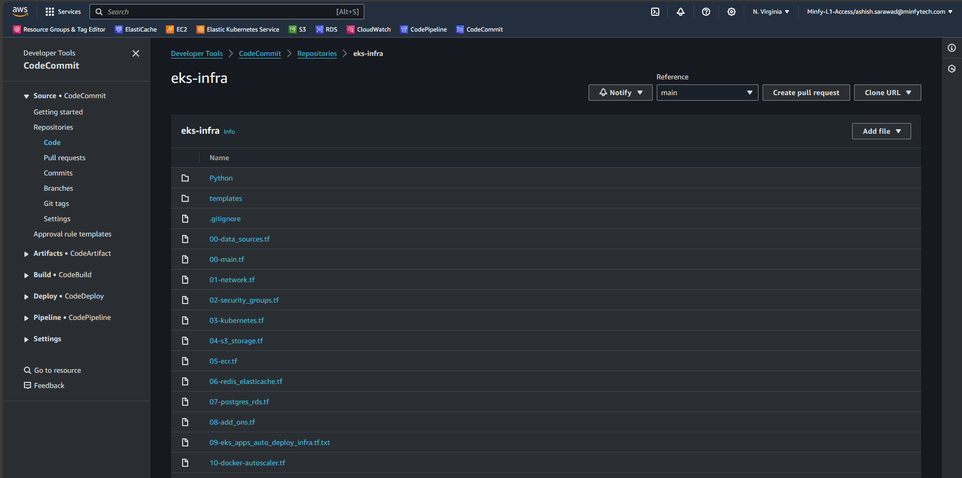  
 *Image 2: CodeCommit Repository for infrastructure management*

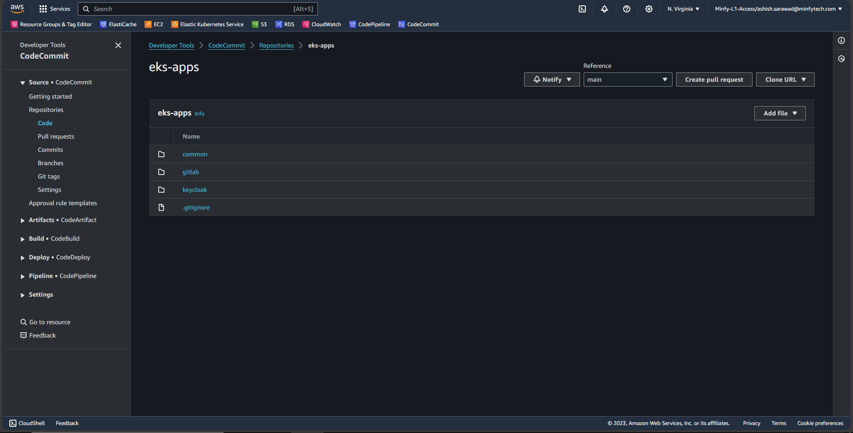  
 *Image 3: CodeCommit Repository for application deployment*  
  
**Steps involved in establishing the code versioning workflow with CodeCommit**  
**I.** To initiate the creation of an AWS CodeCommit Repository, access the “**AWS CodeCommit**” Console "**Developers Tools**" in AWS, proceed to "**Create Repository**" specify the desired Repository Name along with relevant tags, and conclude the process by clicking "**Create**".  
  
 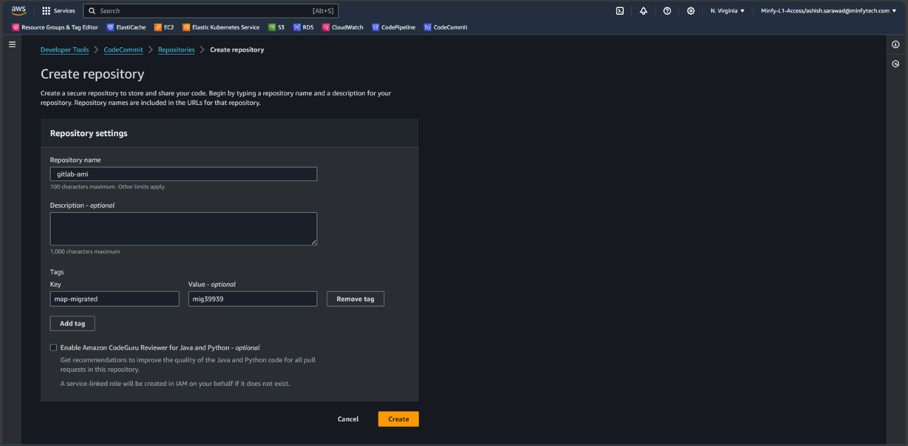  
 *Image 4: Creating Code Commit Repository*   
**II.** Navigate to the "**Branches**" section and initiate the creation of a "**dev**" branch from the "**main**" branch by selecting "**Create branch**" enabling a structured development environment.

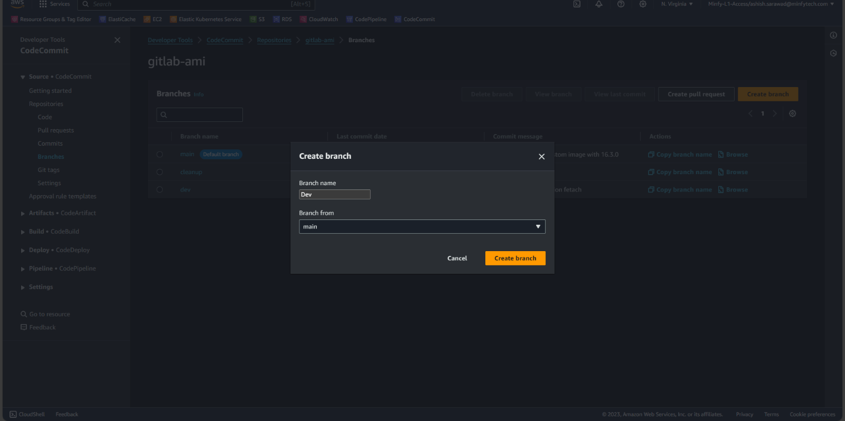  
  *Image 5: Creating dev branch from main*  
  
**III.** Now for hosting the constructed Terraform code in the CodeCommit repository, navigate to the repository console, click on "**Clone URL**" and select "**Clone HTTPS**" to obtain the clone URL. Subsequently, execute the provided commands in CLI to seamlessly push the code to the designated dev branch, ensuring a streamlined and organized version control process.   
“**git clone** [**https://repository_url**](https://repository_url/)”  
“**cd eks-infra**"  
“**git checkout dev**”  
“**git add .**”  
“**git commit -m “commit message”**”  
“**git push origin dev**”

**IIII.** Creating pull request to merge the code from **dev** branch to **main** branch  
After Successfully pushing the code into **dev** branch click on “**Create pull request**” And select Source as **dev** and destination as **main.**  Give a suitable **Title** and **description** to the pull request and click on “**Create pull request”**.

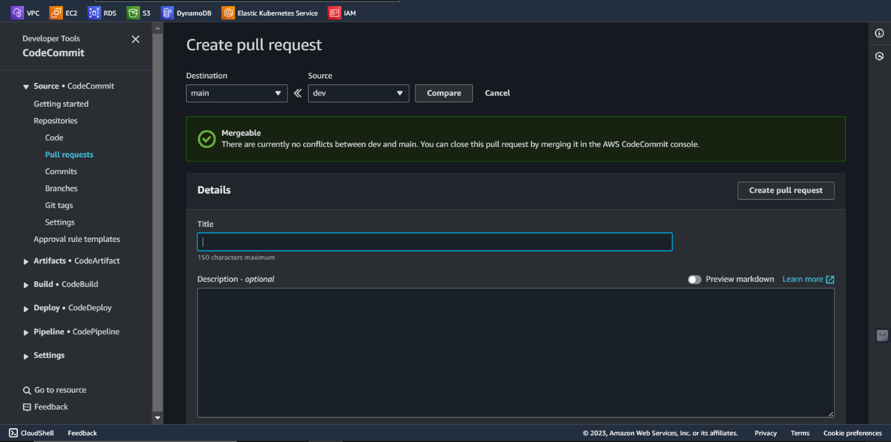  
  *Image 6: Creating pull request from dev branch to main*

Upon successfully pushing the code into the **dev** branch, initiate the pull request process by clicking on "**Create pull request**" Select the source as the **dev** branch and the destination as the **main** branch. Provide a pertinent title and description for the pull request, ensuring clarity and detail, and proceed by clicking on "**Create pull request**" to facilitate a structured and documented code merging process. The request will be received, and code reviews will be carried out and code will be successfully merged.  
  
(Admin)Click on “**Pull requests**” to check the open pull requests and click on created PR, and further click on “**merge”** and select the **merge strategy** and click on merge pull request.

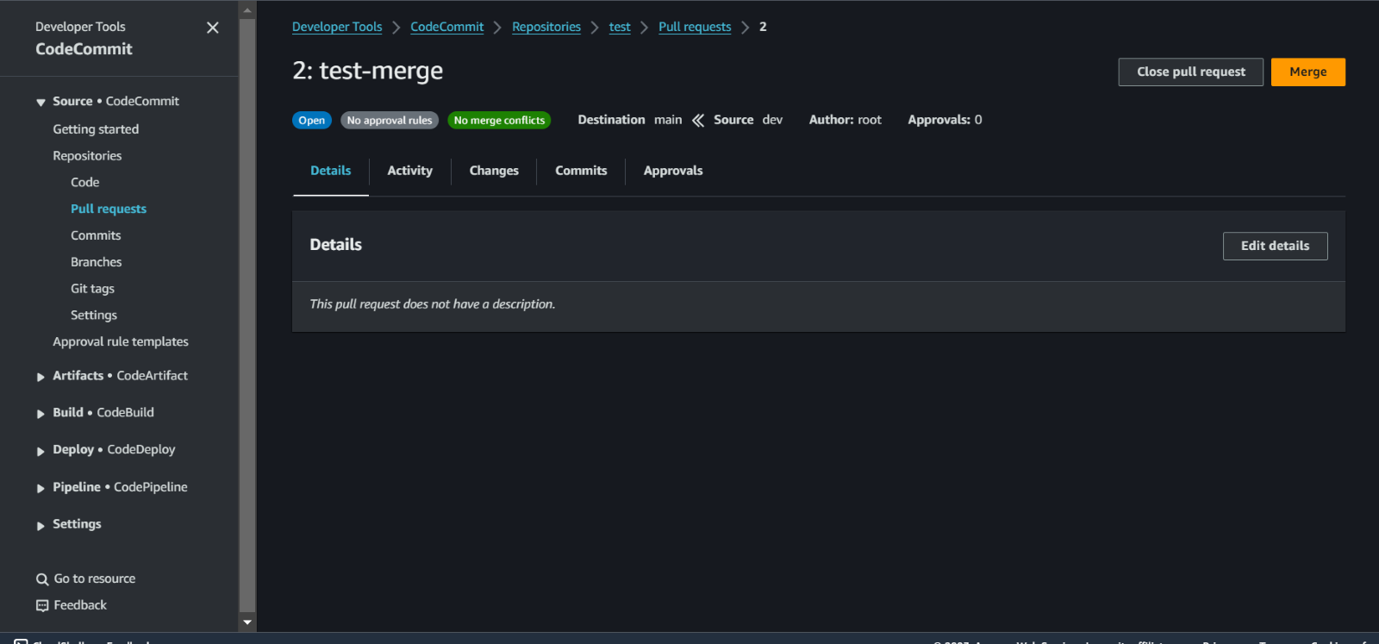  
  *Image 7: Merging the pull request*

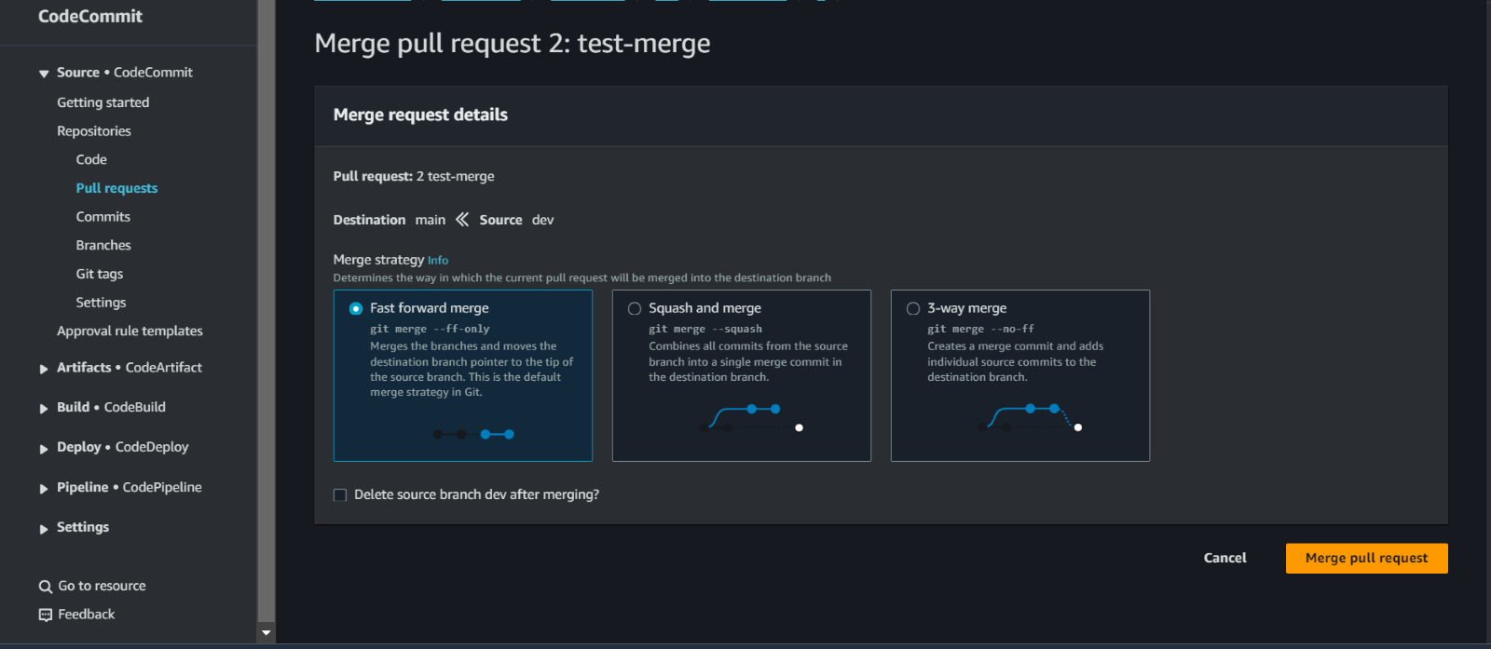  
  *Image 8: Merge strategy*

Upon successful merging of code from the development (dev) to the main branch, the system is poised for further automation workflow configurations, ensuring a streamlined and efficient software development process.

**2. S3 Backend for Terraform State Files:**

As the deployment will heavily rely on Terraform for infrastructure provisioning, setting up S3 bucket to serve as the backend for Terraform state files is important as part of our prep-work operations. These S3 bucket must be configured with the appropriate permissions and security measures to ensure the safe and efficient storage of Terraform state files.

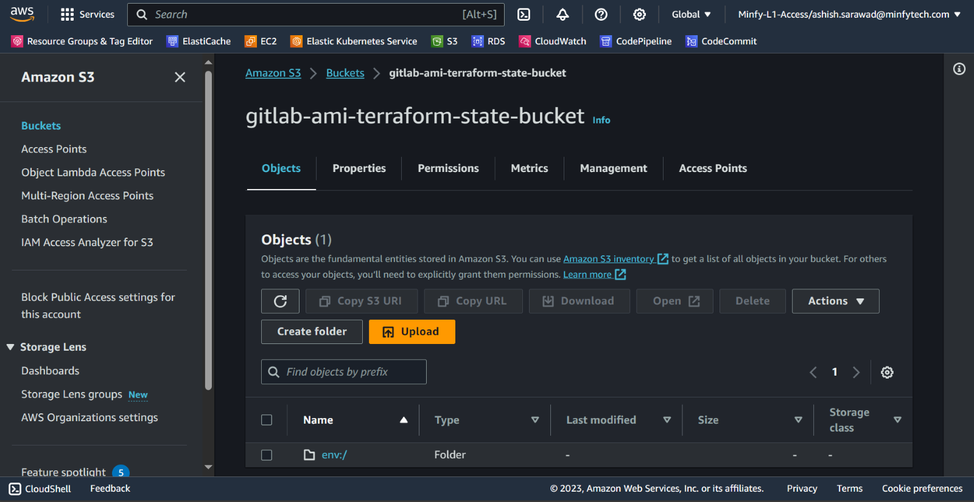  *Image 9: s3 Bucket for Terraform remote state*

To establish a secure S3 bucket, access the S3 console, initiate it by clicking "**Create bucket**" process, choose the preferred region, provide a distinctive name for the bucket, maintain default settings for the remaining configurations, and conclude the setup by selecting "**Create bucket**" This ensures a methodical approach to creating a secure storage environment in Amazon S3.

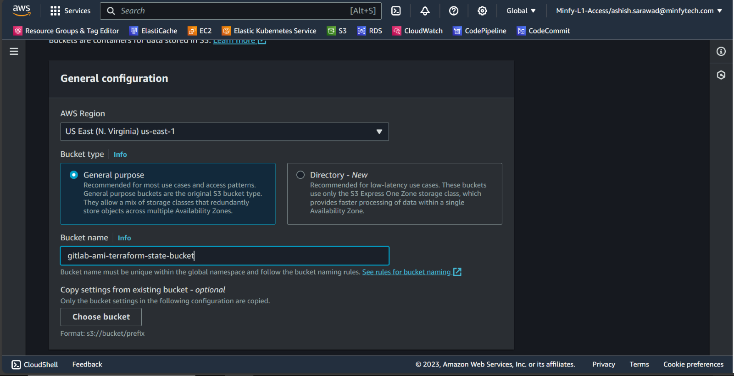  
  *Image 10: Creating S3 Bucket*

**3. Secrets Management:**  
Effective management of sensitive information is crucial for security and data protection. In our approach, we've developed a thorough strategy to securely store and handle critical details like Gitaly credentials, database access credentials, GitLab passwords, and various access tokens. AWS Secrets Manager is our preferred tool for this task.

Here's how it works: we securely store these secrets in AWS Secrets Manager, and when needed, we access and retrieve them for use within Kubernetes Secrets. This ensures that sensitive information is handled with the utmost care.  
Moreover, our strategy includes a well-defined process for secret rotation, adding an extra layer of security and safeguarding your data effectively. It's all part of our commitment to maintaining a secure and resilient environment for your valuable information.

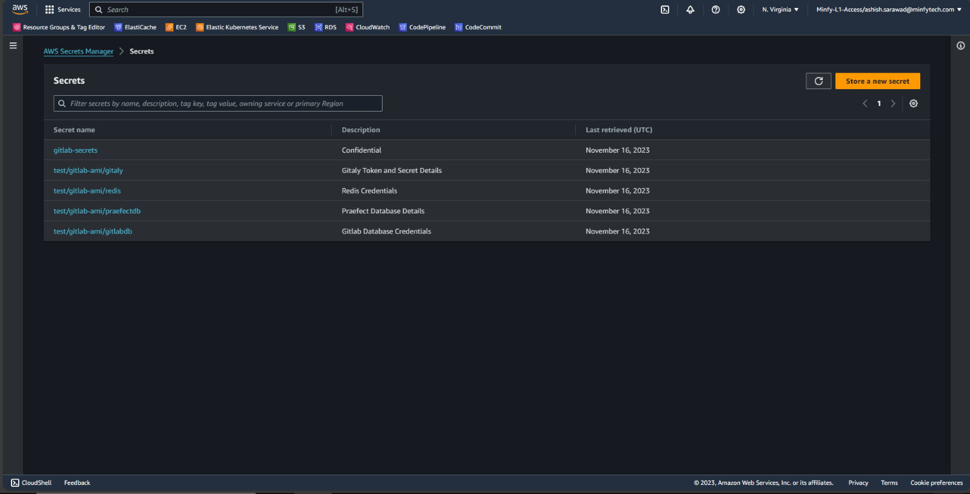  *Image 11: Secret Manager for secret store*

To securely store secrets in AWS Secret Manager, access the AWS Secret Manager console, initiate the process by selecting "**Store a new secret**" opt for the "**Other type of secret**" category, input the secrets in key/value pairs, proceed to the “**Next**” step. Assign a name for the secret, maintain default configurations, and finalize by clicking "**Store**" This ensures a secure and organized management of sensitive information within AWS Secret Manager.  
  
 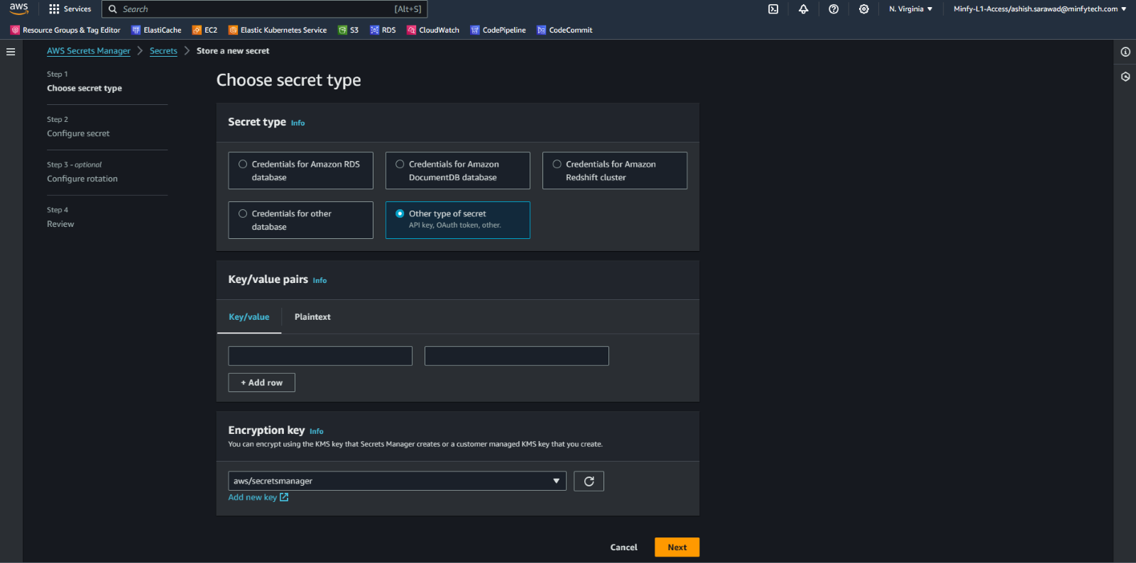  
  *Image 12: Storing a secret*

**4. IAM Roles and Permissions Definition:**

Creating IAM (Identity and Access Management) roles is essential to make sure that the right people and components have the proper permissions and access controls. We carefully define these roles to cater to different services and components within the GitLab environment. For instance, roles for CodeBuild, CodePipeline, and Terraform are precisely crafted to enable specific actions and responsibilities. It's all about ensuring that the right tasks are assigned to the right individuals and tools, maintaining a secure and well-organized environment.  
  
**Steps followed for creating IAM Roles in AWS IAM Console.**  
**I.** Codebuild Service Role

In IAM Console, click on “**Create role**” and select “**AWS Service**” and use “**Codebuild**” as Use case and click on “**Next**”. In “**Add permissions**” page click on “**Next**” and further specify a name and click on “**Create role**”.   
  
 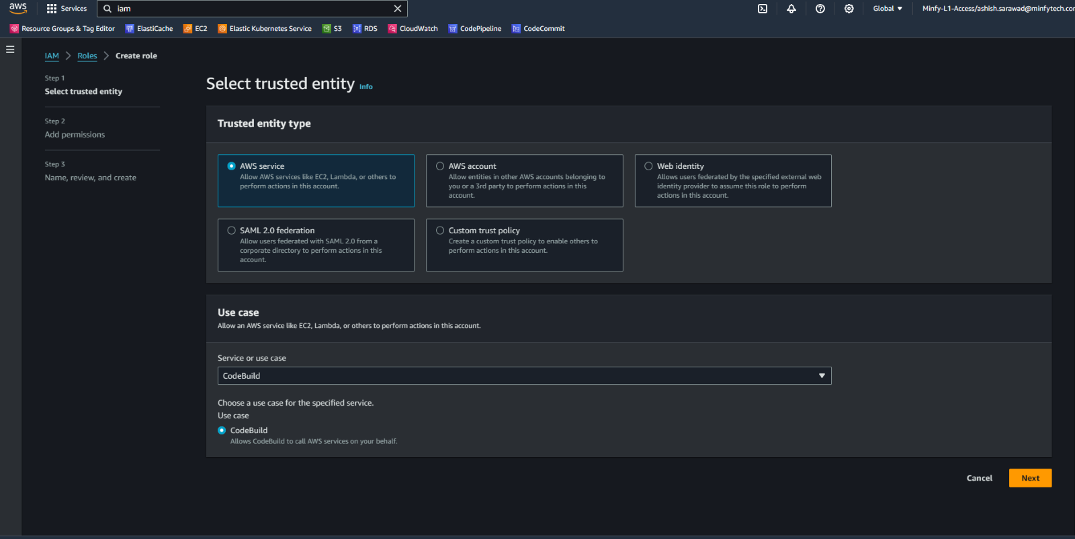  
  *Image 13: IAM Role Creation for Codebuild*

In Next step, for adding permissions to this Codebuild service Role, select “**AdministratorAccess**” for granting Administrator access for the codebuild service role as terraform will assume role on codebuild service role to provision the resources in the AWS Account

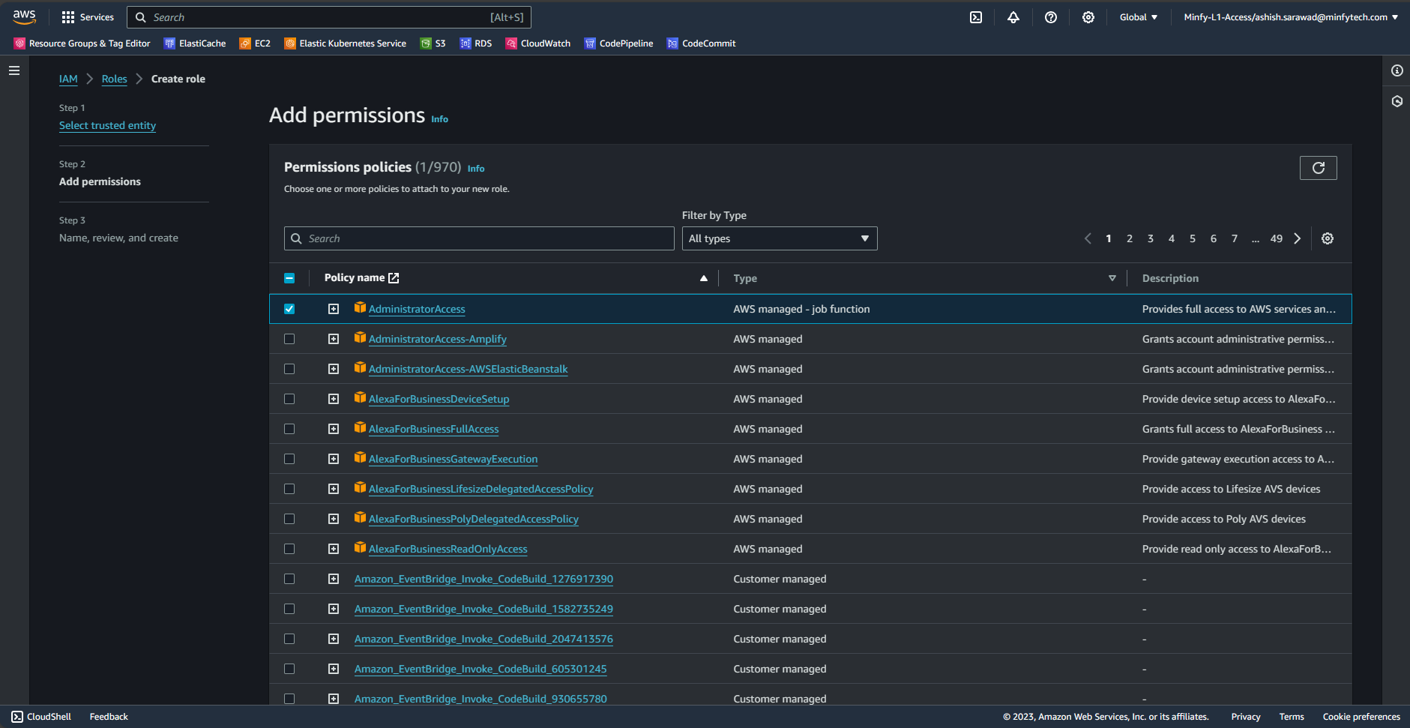  
  *Image 14: Add permissions for Codebuild role*

**II.** CodePipeline Service role  
In IAM Console, click on “**Create role**” and select “**Custom trust policy**” and insert the below trust policy and click on “**Next**”. In “**Add permissions**” page click on “**Next**” and further specify a name and click on “**Create role**”.

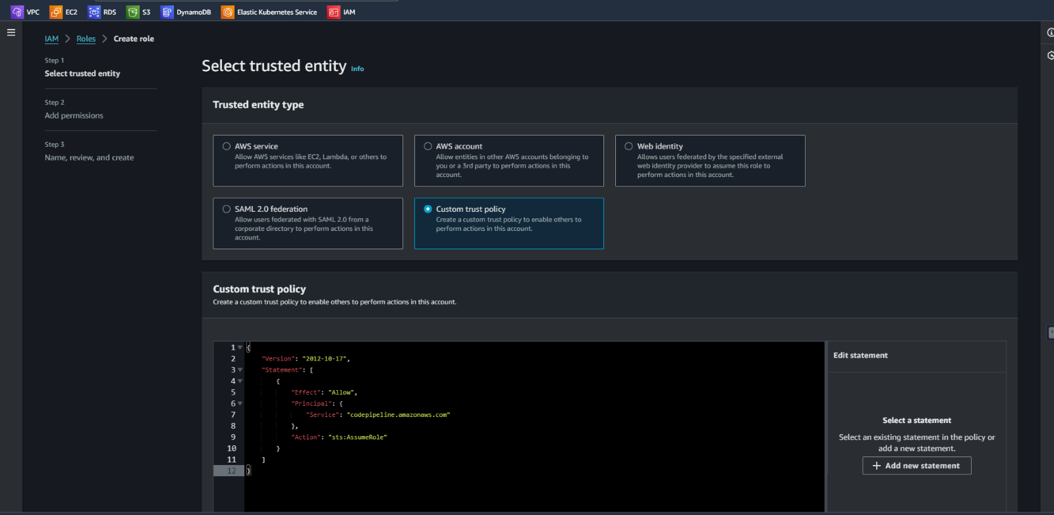  
  *Image 15: Custom trust policy for codepipeline role*

|  |
| --- |
| ***{***  ***"Version": "2012-10-17",***  ***"Statement": [***  ***{***  ***"Effect": "Allow",***  ***"Principal": {***  ***"Service": "codepipeline.amazonaws.com"***  ***},***  ***"Action": "sts:AssumeRole"***  ***}***  ***]***  ***}*** |

*Code: trust policy for codepipeline service role*  
  
For adding permissions to this Codepipeline service Role,   
Click onto the “**codepipelineservicerole**”

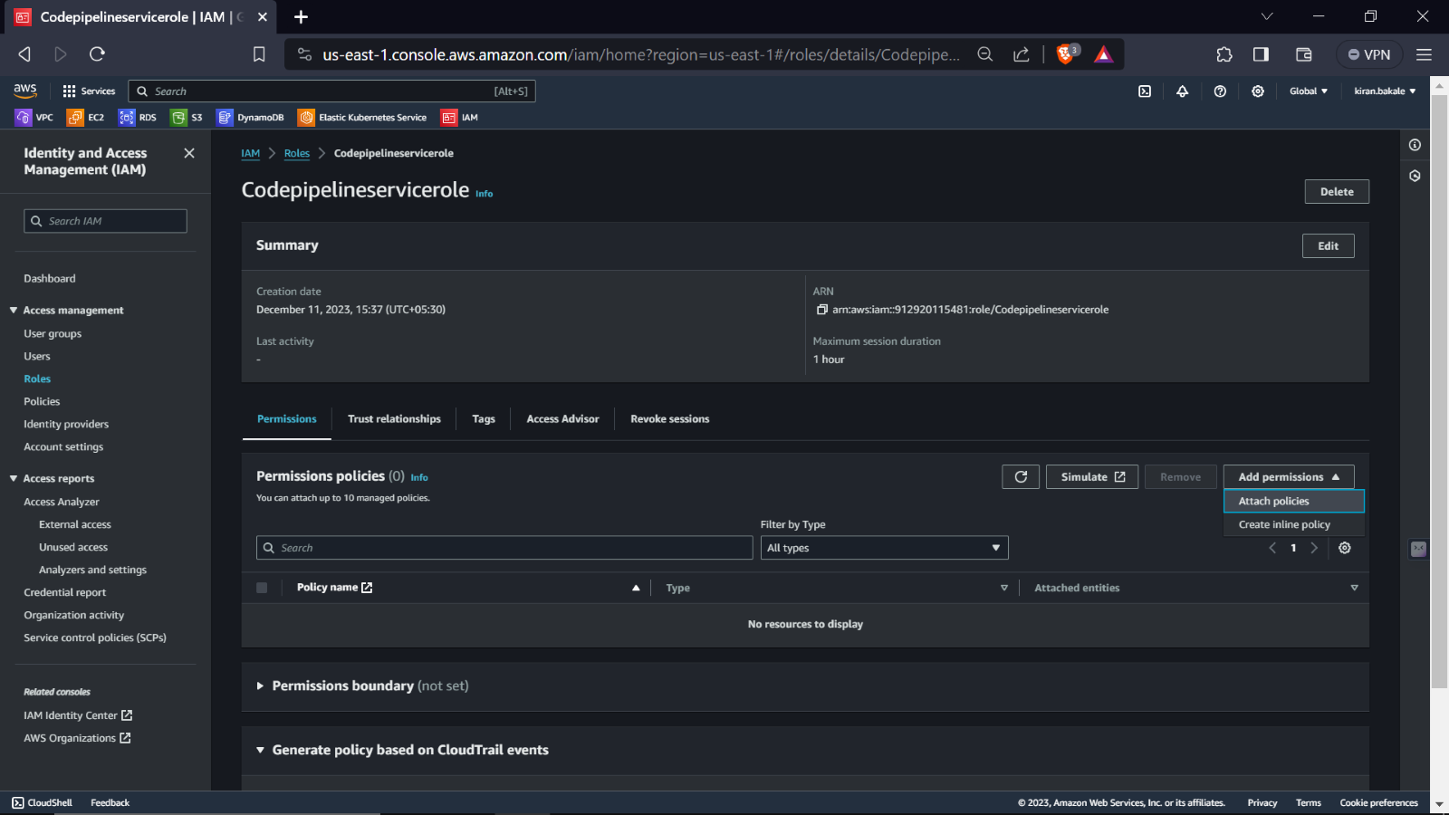  
 *Image 16: Add permissions for Codepipeline role*  
  
  
  
Switch from “**visual**” to “**Json**” editor and insert the below given policy which will give set of permissions for the following resources and further click on “**Next**” and “**Create policy**”

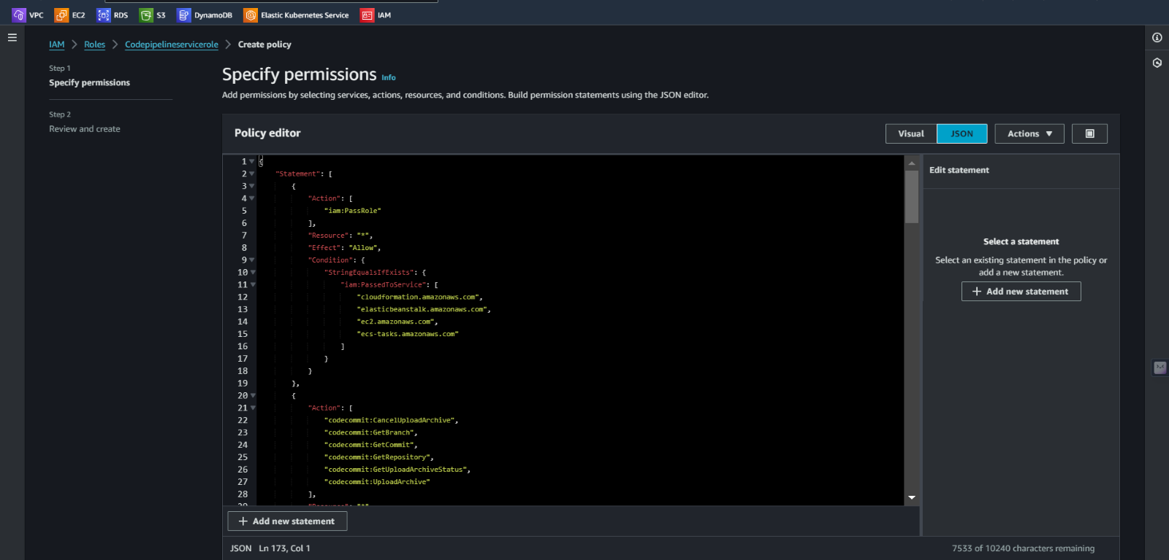  
  *Image 17: Inserting policy for Codepipeline role*

***Insert the below policy:***   
***Code : policy document for codepipeline service role***

|  |
| --- |
| ***{***  ***"Statement": [***  ***{***  ***"Action": [***  ***"iam:PassRole"***  ***],***  ***"Resource": "*",***  ***"Effect": "Allow",***  ***"Condition": {***  ***"StringEqualsIfExists": {***  ***"iam:PassedToService": [***  ***"cloudformation.amazonaws.com",***  ***"elasticbeanstalk.amazonaws.com",***  ***"ec2.amazonaws.com",***  ***"ecs-tasks.amazonaws.com"***  ***]***  ***}***  ***}***  ***},***  ***{***  ***"Action": [***  ***"codecommit:CancelUploadArchive",***  ***"codecommit:GetBranch",***  ***"codecommit:GetCommit",***  ***"codecommit:GetRepository",***  ***"codecommit:GetUploadArchiveStatus",***  ***"codecommit:UploadArchive"***  ***],***  ***"Resource": "*",***  ***"Effect": "Allow"***  ***},***  ***{***  ***"Action": [***  ***"codedeploy:CreateDeployment",***  ***"codedeploy:GetApplication",***  ***"codedeploy:GetApplicationRevision",***  ***"codedeploy:GetDeployment",***  ***"codedeploy:GetDeploymentConfig",***  ***"codedeploy:RegisterApplicationRevision"***  ***],***  ***"Resource": "*",***  ***"Effect": "Allow"***  ***},***  ***{***  ***"Action": [***  ***"codestar-connections:UseConnection"***  ***],***  ***"Resource": "*",***  ***"Effect": "Allow"***  ***},***  ***{***  ***"Action": [***  ***"elasticbeanstalk:*",***  ***"ec2:*",***  ***"elasticloadbalancing:*",***  ***"autoscaling:*",***  ***"cloudwatch:*",***  ***"s3:*",***  ***"sns:*",***  ***"cloudformation:*",***  ***"rds:*",***  ***"sqs:*",***  ***"ecs:*"***  ***],***  ***"Resource": "*",***  ***"Effect": "Allow"***  ***},***  ***{***  ***"Action": [***  ***"lambda:InvokeFunction",***  ***"lambda:ListFunctions"***  ***],***  ***"Resource": "*",***  ***"Effect": "Allow"***  ***},***  ***{***  ***"Action": [***  ***"opsworks:CreateDeployment",***  ***"opsworks:DescribeApps",***  ***"opsworks:DescribeCommands",***  ***"opsworks:DescribeDeployments",***  ***"opsworks:DescribeInstances",***  ***"opsworks:DescribeStacks",***  ***"opsworks:UpdateApp",***  ***"opsworks:UpdateStack"***  ***],***  ***"Resource": "*",***  ***"Effect": "Allow"***  ***},***  ***{***  ***"Action": [***  ***"cloudformation:CreateStack",***  ***"cloudformation:DeleteStack",***  ***"cloudformation:DescribeStacks",***  ***"cloudformation:UpdateStack",***  ***"cloudformation:CreateChangeSet",***  ***"cloudformation:DeleteChangeSet",***  ***"cloudformation:DescribeChangeSet",***  ***"cloudformation:ExecuteChangeSet",***  ***"cloudformation:SetStackPolicy",***  ***"cloudformation:ValidateTemplate"***  ***],***  ***"Resource": "*",***  ***"Effect": "Allow"***  ***},***  ***{***  ***"Action": [***  ***"codebuild:BatchGetBuilds",***  ***"codebuild:StartBuild",***  ***"codebuild:BatchGetBuildBatches",***  ***"codebuild:StartBuildBatch"***  ***],***  ***"Resource": "*",***  ***"Effect": "Allow"***  ***},***  ***{***  ***"Effect": "Allow",***  ***"Action": [***  ***"devicefarm:ListProjects",***  ***"devicefarm:ListDevicePools",***  ***"devicefarm:GetRun",***  ***"devicefarm:GetUpload",***  ***"devicefarm:CreateUpload",***  ***"devicefarm:ScheduleRun"***  ***],***  ***"Resource": "*"***  ***},***  ***{***  ***"Effect": "Allow",***  ***"Action": [***  ***"servicecatalog:ListProvisioningArtifacts",***  ***"servicecatalog:CreateProvisioningArtifact",***  ***"servicecatalog:DescribeProvisioningArtifact",***  ***"servicecatalog:DeleteProvisioningArtifact",***  ***"servicecatalog:UpdateProduct"***  ***],***  ***"Resource": "*"***  ***},***  ***{***  ***"Effect": "Allow",***  ***"Action": [***  ***"cloudformation:ValidateTemplate"***  ***],***  ***"Resource": "*"***  ***},***  ***{***  ***"Effect": "Allow",***  ***"Action": [***  ***"ecr:DescribeImages"***  ***],***  ***"Resource": "*"***  ***},***  ***{***  ***"Effect": "Allow",***  ***"Action": [***  ***"states:DescribeExecution",***  ***"states:DescribeStateMachine",***  ***"states:StartExecution"***  ***],***  ***"Resource": "*"***  ***},***  ***{***  ***"Effect": "Allow",***  ***"Action": [***  ***"appconfig:StartDeployment",***  ***"appconfig:StopDeployment",***  ***"appconfig:GetDeployment"***  ***],***  ***"Resource": "*"***  ***}***  ***],***  ***"Version": "2012-10-17"***  ***}*** |

**5. CodeBuild Project Configuration:**

The CodeBuild project is technically configured to automate build and deployment processes. This includes specifying build environment parameters, setting up source code integration with Git repositories, configuring build specifications using buildspec commands and CodePipelines. Technical details encompass the choice of build runtime, build phases, and environment variables.  
  
In this automated workflow, we've implemented **two** CodeBuild projects to facilitate efficient infrastructure provisioning and application deployments. These Two Build projects will manage Terraform operations—one for planning and another for applying changes which are linked to the **Four** Codepipelines. A manual approval step follows the plan, ensuring a controlled deployment process.  
  
we have streamlined the process by consolidating the deployment into two CodeBuild projects, optimizing efficiency across four pipelines. The first pipeline handles infrastructure provisioning, while the second pipeline caters to both common EKS components and GitLab application provisioning. The third pipeline is dedicated to GitLab application provisioning, and the fourth pipeline is designed for Keycloak provisioning. This setup enhances simplicity and maintains flexibility for future additions, with the two CodeBuild projects supporting all four pipelines seamlessly.

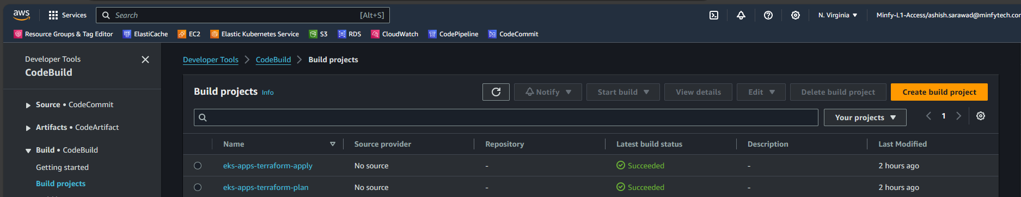  *Image 18: Code Build Projects*

**Steps to configure a 2 CodeBuild projects with each use case follow the below steps**  
**I. CodeBuild Project Setup for Terraform Plan:** Access the CodeBuild Console, initiate the process by selecting "**Create build project**" and proceed by entering a name “**eks-apps-terraform-plan**” along with relevant tags based on specific project requirements.  
   
 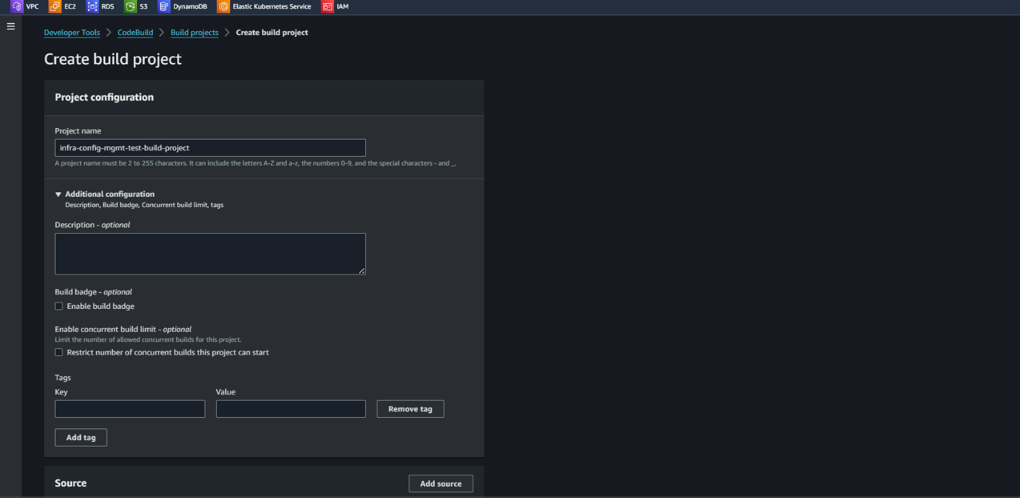  
 *Image 19: Creating Code Build project – Project Configuration*

In Source section, choose "**No source**”

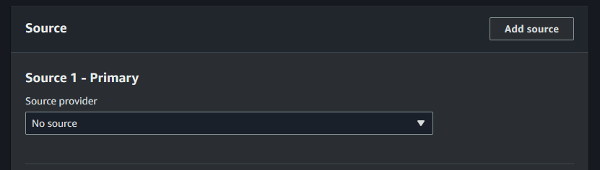  
   *Image 20: Creating Code Build project – Source*

In Environment section, Choose Environment image as “**Managed image**”, Compute as “**EC2**”, Operating system as “**Amazon Linux**”, Runtime(s) as “**Standard**”, Image as “**aws/codebuild/amazonlinux2-x86_64-standard5.0**”, image version as “**aws/codebuild/amazonlinux2-x86_64-standard5.0-23.05.22”.** Enable the “**Privileged**” to allow codebuild to build docker images. For service role Choose “**Existing service role**” and in Role ARN choose the previously created “**codebuildservicerole**”

Note: The image versions will keep on updating make sure to always choose the latest version  
  
 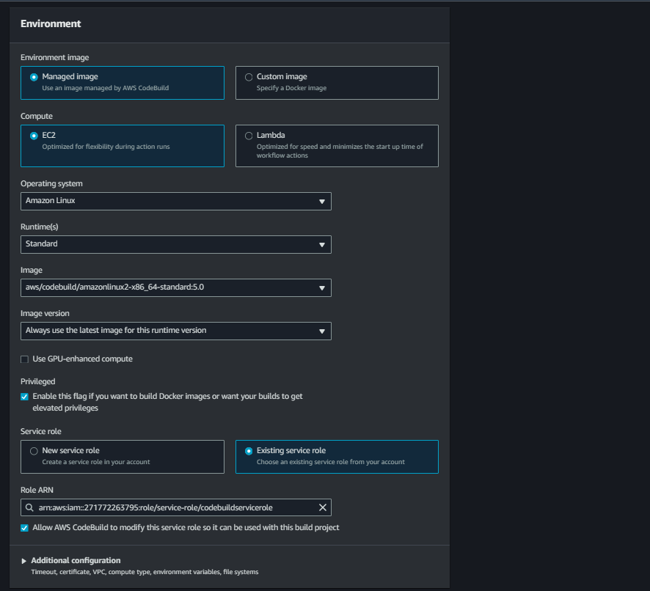  
  *Image 21: Creating Code Build project – Environment*

keep Additional Configuration at its default settings. In Buildspec section, choose “**Insert build commands**” and insert the below buildspec code in it. This assignment ensures that the buildspec commands executes the necessary Terraform plan operations.

|  |
| --- |
| ***version: 0.2***  ***env:***  ***variables:***  ***TF_IN_AUTOMATION: true***  ***phases:***  ***install:***  ***commands:***  ***- echo "Install phase..."***  ***- |***  ***# Install Terraform***  ***TERRAFORM_VERSION="1.5.2" # Replace this with the desired Terraform version***  ***TERRAFORM_URL="https://releases.hashicorp.com/terraform/${TERRAFORM_VERSION}/terraform_${TERRAFORM_VERSION}_linux_amd64.zip"***  ***TERRAFORM_DIR="/usr/local/bin"***  ***curl -o /tmp/terraform.zip ${TERRAFORM_URL}***  ***unzip -o /tmp/terraform.zip -d ${TERRAFORM_DIR}***  ***chmod +x ${TERRAFORM_DIR}/terraform***  ***terraform --version***  ***- curl -fsSL -o get_helm.sh https://raw.githubusercontent.com/helm/helm/main/scripts/get-helm-3 #helm install***  ***- chmod 700 get_helm.sh***  ***- ./get_helm.sh***  ***- helm version***  ***pre_build:***  ***on-failure: ABORT***  ***commands:***    ***- |***  ***if [ "$APP" == "gitlab" ]; then***  ***ls***  ***echo "Fetching the latest code..."***  ***git config --global credential.helper '!aws codecommit credential-helper $@'***  ***git config --global credential.UseHttpPath true***  ***git clone https://git-codecommit.us-east-1.amazonaws.com/v1/repos/eks-apps > /dev/null 2>&1***  ***cd eks-apps***  ***git diff HEAD HEAD~ --name-only***  ***CHANGED_FILES=$(git diff HEAD HEAD~ --name-only)***  ***echo $CHANGED_FILES***  ***### getting the gitlab version***  ***gitlab_version=$(awk -v RS='}' '/variable\s+"gitlabversion"/{print $0}' $APP/variables.tf | grep -oP 'default\s+=\s+"\K[^"]+')***  ***echo $gitlab_version***    ***if echo "$CHANGED_FILES" | grep -q "$APP/webservice-custom-build/"; then***  ***echo "Building Docker image as changes detected in 'webservice-custom-build' folder."***  ***ecr_repo_url="271772263795.dkr.ecr.us-east-1.amazonaws.com/gitlab-webservice-ce"***  ***cd gitlab/webservice-custom-build***  ***pwd***  ***docker build -t $ecr_repo_url:v$gitlab_version --build-arg gitlabversion=v$gitlab_version .***  ***aws ecr get-login-password | docker login --username AWS --password-stdin $ecr_repo_url***  ***docker push $ecr_repo_url:v$gitlab_version***  ***ls***  ***cd ..***  ***ls***  ***cd ../..***  ***pwd***  ***rm -rf eks-apps***  ***else***  ***echo "No changes detected in 'webservice-custom-build' folder. Skipping Docker image build."***  ***ls***  ***cd ..***  ***rm -rf eks-apps***  ***fi***    ***### Workhorse***    ***if echo "$CHANGED_FILES" | grep -q "$APP/workhorse-custom-build/"; then***  ***echo "Building Docker image as changes detected in 'workhorse-custom-build' folder."***  ***workhorse_ecr_repo_url="271772263795.dkr.ecr.us-east-1.amazonaws.com/gitlab-workhorse-ce"***  ***cd gitlab/workhorse-custom-build***  ***docker build -t $workhorse_ecr_repo_url:v$gitlab_version --build-arg gitlabversion=v$gitlab_version .***  ***aws ecr get-login-password | docker login --username AWS --password-stdin $workhorse_ecr_repo_url***  ***docker push $workhorse_ecr_repo_url:v$gitlab_version***  ***cd ../..***  ***pwd***  ***ls***  ***rm -rf eks-apps***  ***else***  ***echo "No changes detected in 'workhorse-custom-build' folder. Skipping Docker image build."***  ***rm -rf eks-apps***  ***ls***  ***fi***  ***else***  ***echo "Not a gitlab directory."***  ***fi***  ***- ls***    ***build:***  ***on-failure: ABORT***  ***commands:***  ***- echo $APP***  ***- echo $PWD***  ***- ls***  ***- cd $PWD/$APP***  ***- rm -rf .terraform/***  ***- ls***  ***- terraform init --input=false***  ***- echo "Terraform Plan for $TAG"***  ***- terraform plan --out=tfplan --input=false***    ***artifacts:***  ***files:***  ***- '**/*'***  ***name: TFPLAN*** |

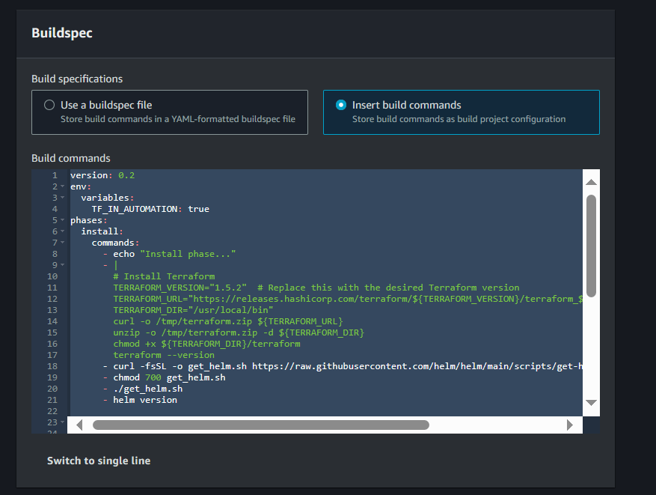  
  *Image 22: Creating Code Build project – Buildspec (Plan)*

Maintain default configurations for "**Artifacts**" and "**Logs**" allowing for seamless processes. Optionally, input a custom "**Group name**" if needed otherwise, the system will utilize the Build project's name, generating a corresponding log group in CloudWatch.

**II. CodeBuild Project Setup for Terraform Apply:** Proceed with creating another build project named "**eks-apps-terraform-apply**" to handle Terraform apply operations. In the buildspec section, choose “**insert build commands**” and insert the script given below. Once these steps are completed, the build projects for infrastructure provisioning and application deployment will be set up and ready to use.

|  |
| --- |
| ***version: 0.2***  ***env:***  ***variables:***  ***TF_IN_AUTOMATION: true***  ***phases:***  ***install:***  ***commands:***  ***- echo "Install phase..."***  ***- |***  ***# Install Terraform***  ***TERRAFORM_VERSION="1.5.2" # Replace this with the desired Terraform version***  ***TERRAFORM_URL="https://releases.hashicorp.com/terraform/${TERRAFORM_VERSION}/terraform_${TERRAFORM_VERSION}_linux_amd64.zip"***  ***TERRAFORM_DIR="/usr/local/bin"***  ***curl -o /tmp/terraform.zip ${TERRAFORM_URL}***  ***unzip -o /tmp/terraform.zip -d ${TERRAFORM_DIR}***  ***chmod +x ${TERRAFORM_DIR}/terraform***  ***terraform --version***  ***- curl -fsSL -o get_helm.sh https://raw.githubusercontent.com/helm/helm/main/scripts/get-helm-3 #helm install***  ***- chmod 700 get_helm.sh***  ***- ./get_helm.sh***  ***- helm version***  ***build:***  ***on-failure: ABORT***  ***commands:***  ***# - echo "Fetching the latest code..."***  ***# - git config --global credential.helper '!aws codecommit credential-helper $@'***  ***- echo "Fetching the latest code..."***  ***- echo $APP***  ***- echo $PWD***  ***- ls***  ***- cd $PWD/$APP***  ***- terraform apply tfplan*** |

  
  *Image 23: Creating Code Build project – Buildspec (apply)*

**6. CodePipeline Automation:**

CodePipeline is established with a technical focus on orchestrating the deployment workflow. The pipeline is created to define stages, manual approval actions, and transitions between stages. Technical details include specifying source, build, test, and deployment actions within the pipeline. Integration with Git repositories and AWS services is finely tuned to automate the deployment process.

These pipelines will be triggered through tag-based pushing, providing a systematic and version-controlled approach to initiating the deployment processes. By associating specific tags with commits, we ensure a deliberate and organized trigger mechanism for the pipelines, enhancing control and visibility over the deployment lifecycle.  
  
We have implemented totally **Four** CodePipelines for infrastructure & Application deployment is designed with four distinct stages.  
Firstly, in the **Source Stage**, the CodePipeline initiates by checking out the source code from the designated repository.  
Moving on to the second stage, the **Terraform Plan Stage**, a CodeBuild project is triggered to execute the **Terraform Plan.** This stage provides detailed insights in the build logs, outlining the resources that will be either deployed or updated.  
The third stage introduces a critical **Manual Approval** Step. Here, an **SNS topic** is triggered to notify stakeholders, prompting them to review the **Terraform plan**. Upon their approval, the pipeline proceeds to the next stage.  
  
In the final stage, the **Terraform Apply Stage**, the pipeline executes the **Terraform Apply** automatically applying the Terraform configurations. This results in the creation of the specified infrastructure and Application deployment depending upon the tag pushed to the repository as per the approved plan.  
  
This structured pipeline ensures a comprehensive and controlled approach to infrastructure provisioning.

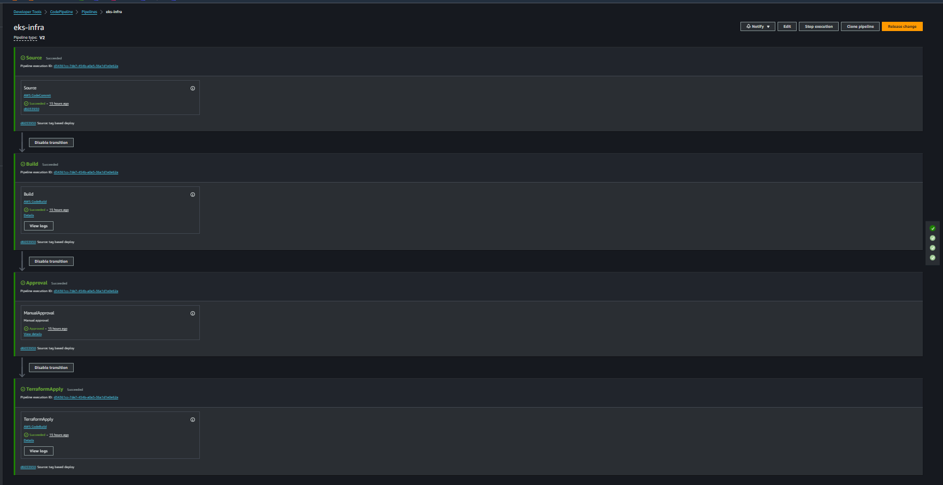  *Image 24: Code Pipeline for infrastructure provisioning*

**I. Codepipeline Infrastructure Provisioning:**  
For setting up a robust pipeline, access the CodePipline Console in Developers Tools. Click “**Create codepipeline**”. Enter a suitable name for the pipeline we have named it as “**eks-infra**” and choose pipeline type as “**V2**” and in Service Role, select “**Existing service role**” then choose previously created **codepipeline service role** and click on “**Next**”.  
  
 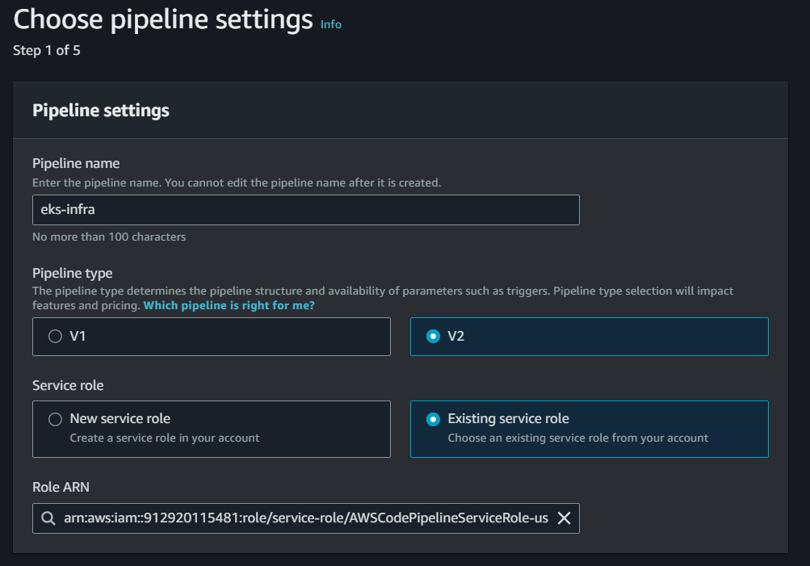  
  *Image 25: Creating Code Pipeline - Pipeline settings*

In Add Source stage, Choose **Source provider** as “**AWS CodeCommit**” in Repository name choose the previously created repository name i.e. “**eks-infra**” and Branch name as “**main**” then click on “**Next**”.

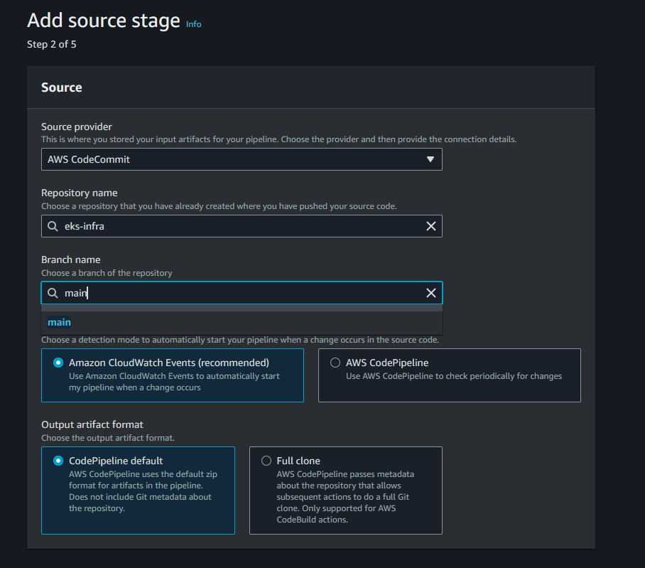  
  *Image 26: Creating Code Pipeline - Source Stage*  
  
In Build stage, Choose **Build provider** as “**AWS CodeBuild**” let the region be as default region, in Project name choose the project name created previously “**eks-apps-terraform-plan”** and click on “**Next**”

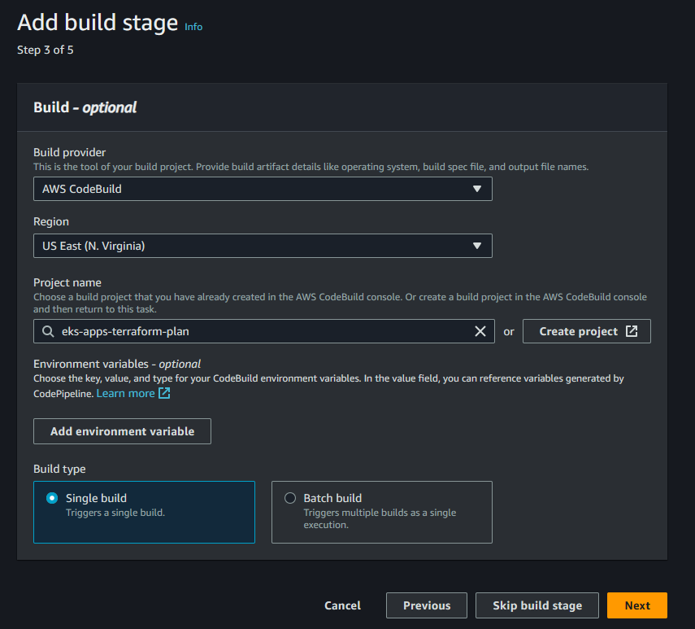  
  *Image 27: Creating Code Pipeline - Build Stage*

In the "**Deploy**" stage, opt to "**Skip deploy stage**" as it's unnecessary for our setup. Proceed to the **Review page** and select "**Create Pipeline**" Now Navigate inside the pipeline and click onto "**Edit**" then click on "**+ Add Stage**" following the **build stage** to introduce a new one stage.

Name this stage as "**Approval Stage**" and add an action by clicking on "**Add action**" Label it "**ManualApproval**" and choose "**Manual approval**" as the action provider. Paste the ARN of the SNS topic for integration then Click on “**Done**”

***Follow this AWS Document for creating SNS topic and Subscribe to the topic***  
[Creating an Amazon SNS topic - Amazon Simple Notification Service](https://docs.aws.amazon.com/sns/latest/dg/sns-create-topic.html)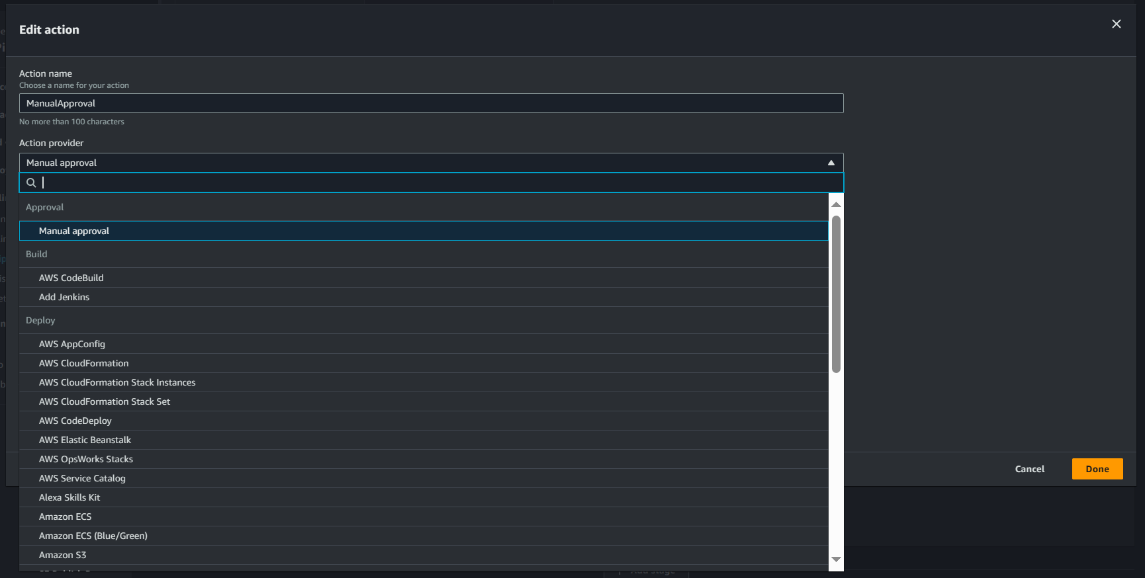  
*Image 28: CodePipeline Adding manual approval stage*  
  
 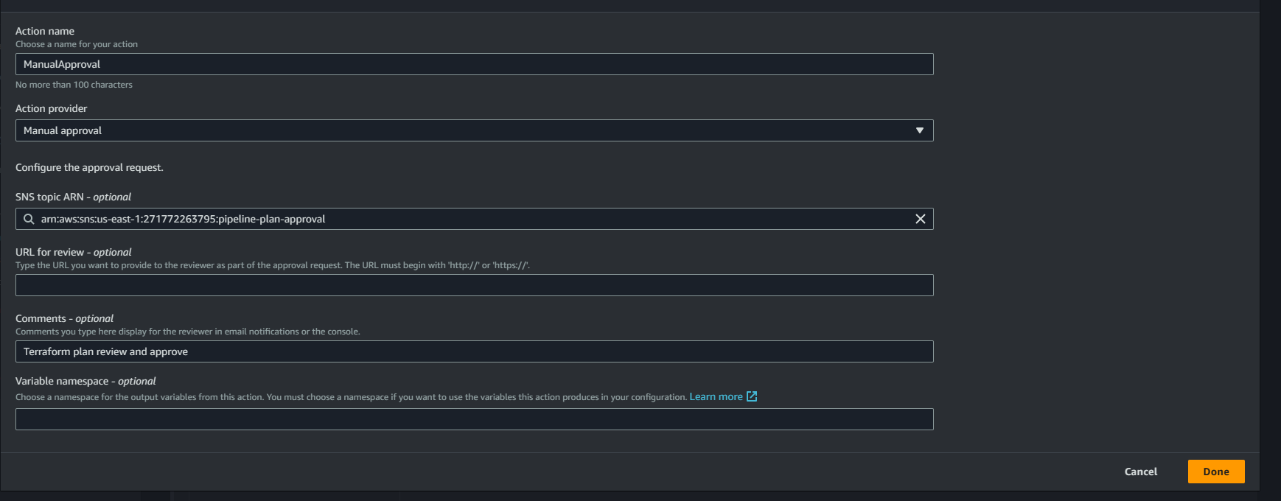  
  *Image 29: CodePipeline Adding manual approval stage*  
  
  
Next, add another stage by clicking on "**+ Add Stage**" after the manual approval stage. Name it "**Terraform Apply**" and include an action named "**TerraformApply**" For the **Action provider**, choose "**AWS CodeBuild**" and set the region as "**US-East (N.virginia)**" In Input artifacts, select "**SourceArtifact**" click on "**Add**" choose "**BuildArtifact**" and specify the project name as "**eks-apps-terraform-apply**" created earlier. Set "**Primary source**" as "**BuildArtifact**" and click on "**Done**" And lastly **save** the pipeline.  
  
 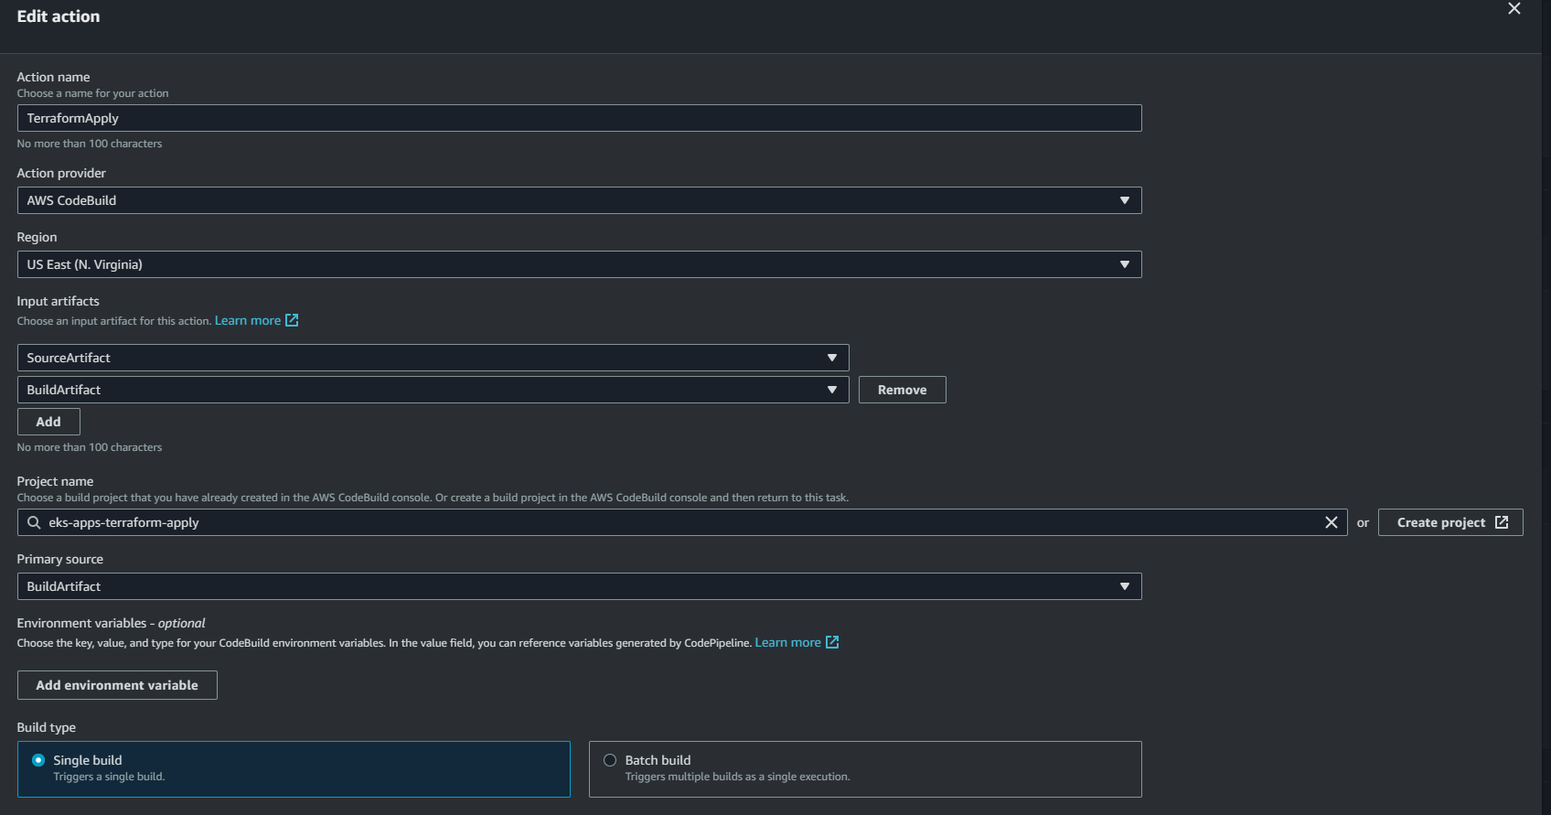  
 *Image 30: CodePipeline Adding Terraform Apply stage*

**II. Codepipeline Applications Provisioning:**

Expanding the automated deployment workflows to application-specific pipelines involves the creation of three dedicated CodePipelines, each tailored to handle distinct directories within the eks-apps repository. The goal is to achieve precise deployments by incorporating environment variables that specify the target application directory whenever there is a change in specific directory.  
**For Eks Common components pipeline**:  
In **Choose pipeline settings** we have designated the pipeline as **eks-common-app.**  
In Variables, add a variable called **APP** and its value as **common.** This variable, set to "**common**" directs the pipeline to the common directory within the eks-apps repository. The pipeline orchestrates the deployment of fundamental EKS components, including kube Prometheus stack, fluentbit, cluster-autoscaler, AWS load balancer controller, metrics-server, and authentication mechanisms. The inclusion of the APP variable ensures a focused execution of Terraform plan and apply operations in **common** directory present in **eks-apps** repository. Further follow the same steps as followed in the infrastructure provisioning pipeline i.e.**eks-infra.**

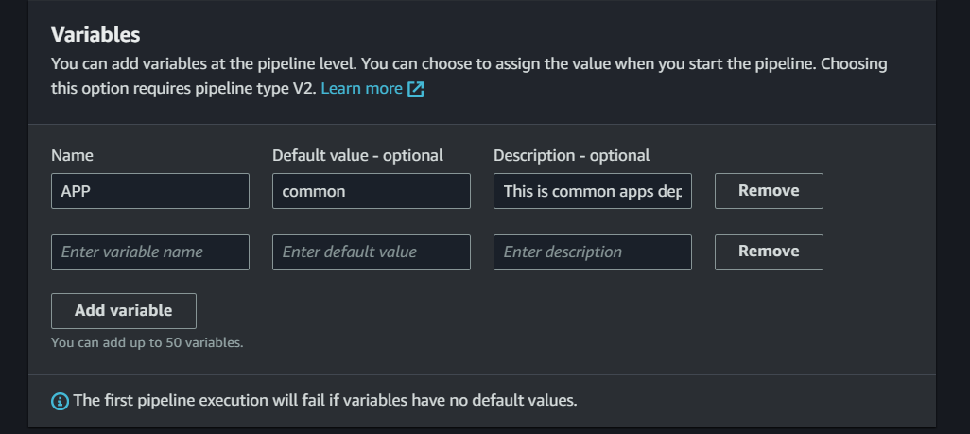  
  *Image 31: Adding variables in eks-common pipeline*

**For Gitlab Application deployment pipeline**:  
In **Choose pipeline settings** we have designated the pipeline as **eks-gitlab-app.**  
In Variables, add a variable called **APP** and its value as **gitlab.** This variable, set to "**gitlab**" directs the pipeline to the common directory within the eks-apps repository. This pipeline specializes in deploying the GitLab application onto the EKS cluster. By utilizing the APP variable, the pipeline navigates to the gitlab directory in the eks-apps repository, seamlessly executing the necessary Terraform operations in **gitlab** directory present in **eks-apps** repository for GitLab deployment. Further follow the same steps as followed in the infrastructure provisioning pipeline i.e.**eks-infra**

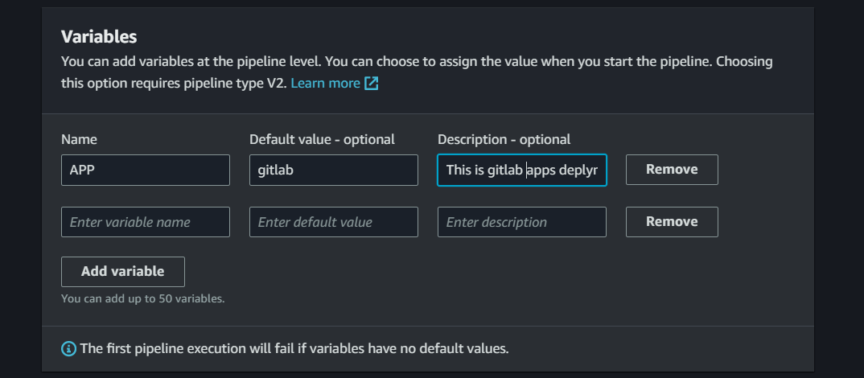  
  *Image 32: Adding variables in eks-gitlab pipeline*

**For Keycloack Application deployment pipeline**:  
In **Choose pipeline settings** we have designated the pipeline as **eks-keycloack-app.**  
In Variables, add a variable called **APP** and its value as **keycloak.** This variable, set to "**keycloak**" directs the pipeline to the common directory within the eks-apps repository. This pipeline specializes in deploying the GitLab application onto the EKS cluster. By utilizing the APP variable, the pipeline navigates to the gitlab directory in the eks-apps repository, seamlessly executing the necessary Terraform operations in **keycloak** directory present in **eks-apps** repository for GitLab deployment. Further follow the same steps as followed in the infrastructure provisioning pipeline i.e.**eks-infra.**

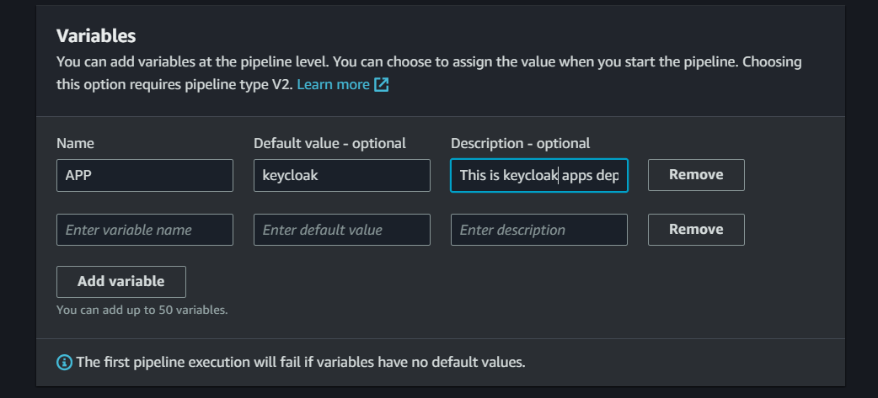   
 *Image 33: Adding variables in eks-keycloak pipeline*

With these configurations, the pipeline is now set up, ensuring a seamless flow from source to manual approval and finally to the Terraform apply stage.

**7. Requesting an SSL Certificate in AWS Certificate Manager**:

Acquiring an SSL certificate from AWS Certificate Manager is a pivotal step in our deployment process. This certificate serves as a digital credential that authenticates the identity of our domain, ensuring secure and encrypted communication between users and our infrastructure. By attaching this SSL certificate to our domain, we establish a foundation of trust and safeguard sensitive data exchanged over the network. This not only enhances the security posture of our applications but also instils confidence among users by signalling a commitment to the highest standards of data protection. The AWS Certificate Manager's seamless integration simplifies the certificate management process, allowing us to focus on delivering a secure and reliable experience to our users.  
  
To request a certificate from ACM, click on “**Request certificate”** in **AWS Certificate Manager** console. **Request a public certificate** will be default select as there’s no private CA created in aws account click on “**Next**”

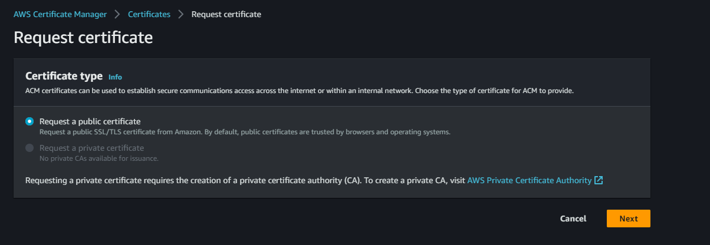  
 *Image 34: Requesting SSL Certificate from ACM*

Add the fully qualified domain name for the validation and authorization for the domain name with the certificate and click on “**Request” (**it takes around 30mins to 1hour for AWS to provide the certificate)

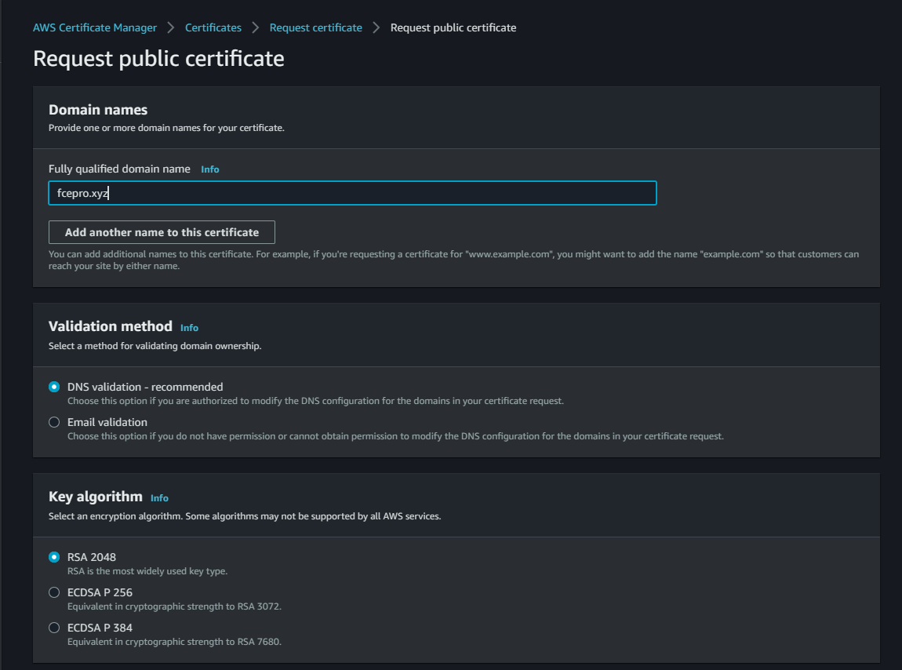  
 *Image 35: Requesting SSL Certificate from ACM*

**8. Lambda Function for Application Deployment Trigger:**

In our deployment architecture, a Lambda function plays a pivotal role in automating the initiation of Codepipeline tailored for application deployments. This Lambda function is designed to respond to tag pushes within distinct folders, such as "common," "gitlab," and "keycloak," within our source code repository i.e.**eks-apps**. When a commit occurs in any of these specific folders, the Lambda function is promptly invoked by event bridge rule which is configured to be triggered to respond on tag-based pushes. Subsequently, it orchestrates the seamless execution of corresponding Codepipelines, ensuring that updates in each application segment are efficiently and independently deployed. This streamlined approach optimizes our deployment pipeline, allowing for agile and targeted application updates triggered by specific code changes.

To Create lambda function, click on “**Create function**” in **Lambda Console.** Choose a name, we named it as **“eks-apps-trigger"** and Runtime as **Python 3.12** and click on “**Create function”**  
  
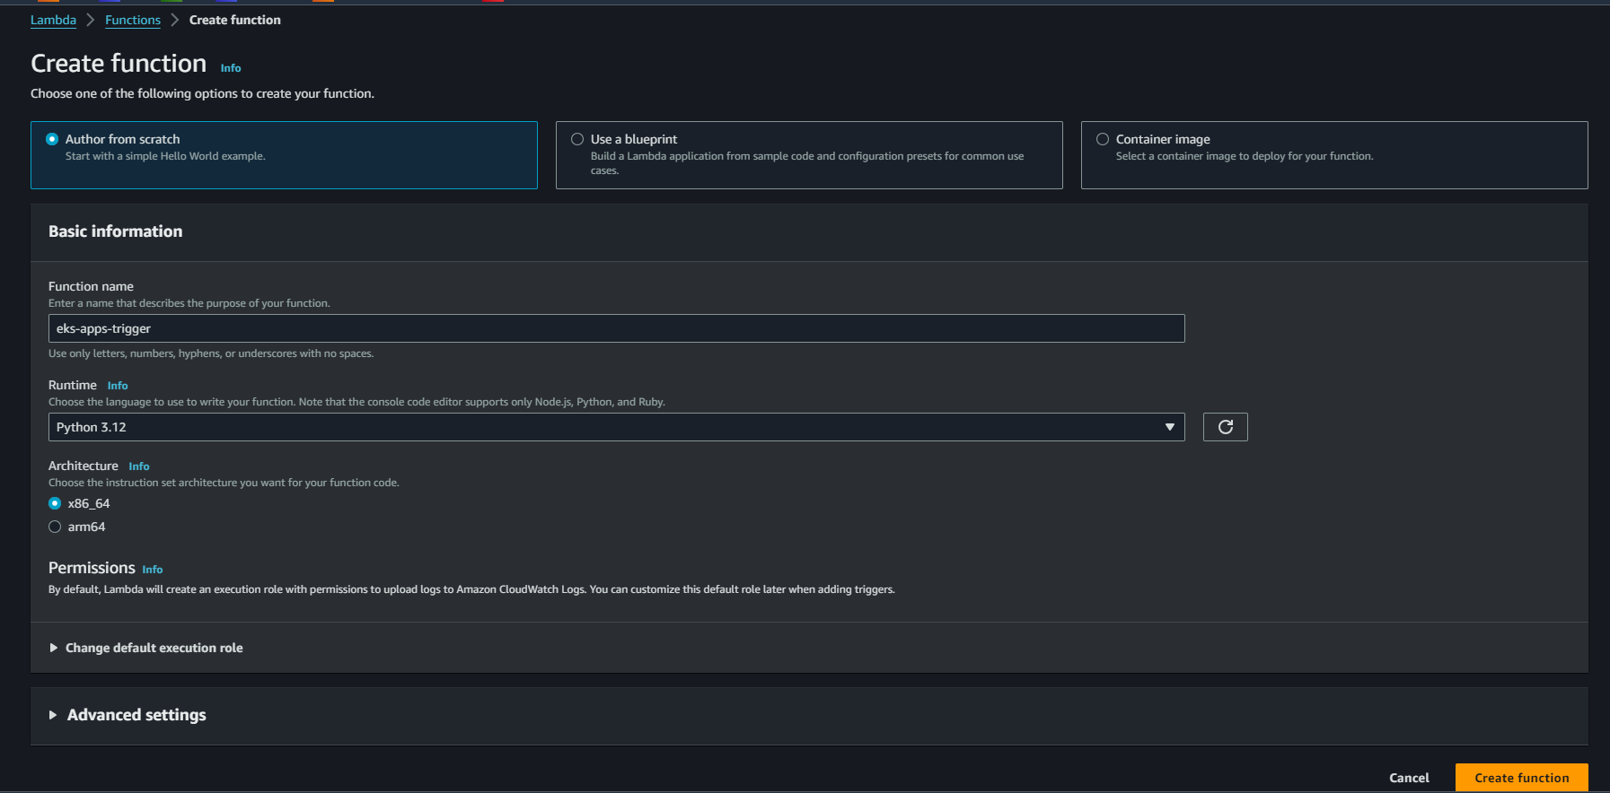  
*Image 36: Create lambda Function*

Post creating the function insert the python code residing in **Python** directoryin **eks-infa** repository.

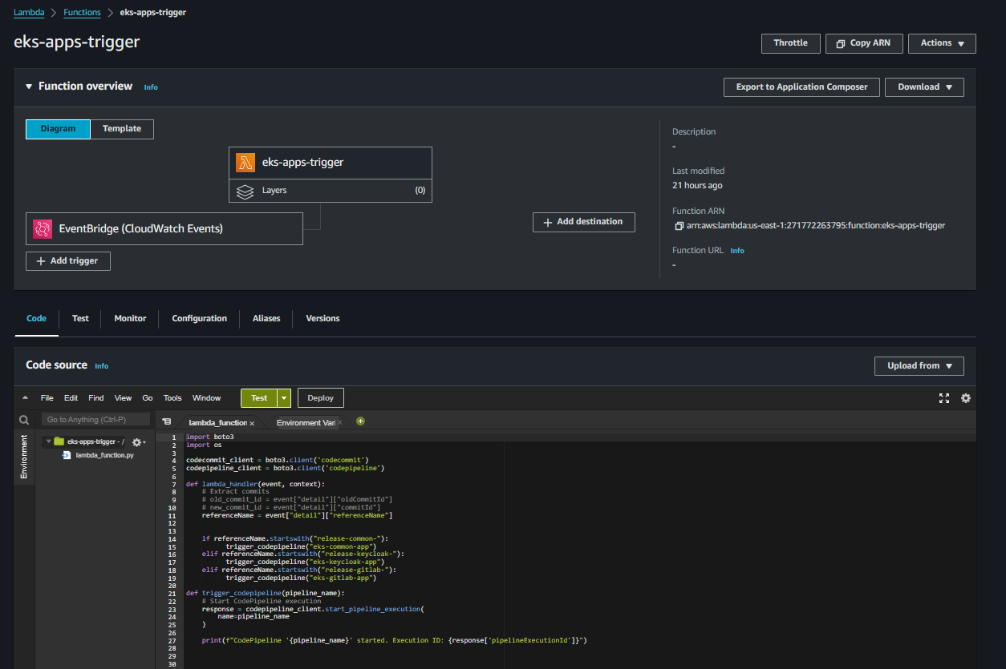  
 *Image 37: Lambda Function*

And Attach navigate to **IAM Console** and find an IAM role created with the name of the lambda function created and attach two permissions to that role. One is of “**AWSCodePipelineFullAccess**” and “**AWSCodeCommitPowerUser**”. Now lambda function is ready to be set the event trigger.

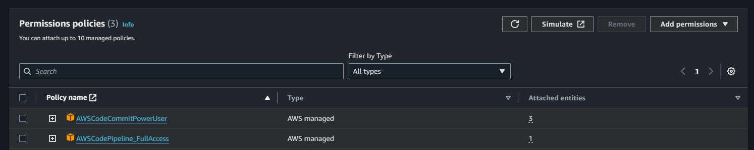   
 *Image 38: Permissions for Lambda Function*

**9. Creating EventBridge Rules for Pipeline Triggers:**

Our deployment pipeline incorporates an EventBridge rule, a key component that orchestrates automated actions based on specific events. This rule is configured to monitor commits within source code repositories. When a commit and tag push is detected, EventBridge seamlessly triggers a Lambda function and Infra pipeline. This Lambda function, acting as a catalyst, then initiates dedicated Codepipeline responsible for deploying the applications and for infrastructure it directly triggers the codepipeline. This automated event-driven mechanism ensures that any code changes are promptly and systematically translated into deployment actions, streamlining the continuous integration and delivery (CI/CD) process. By leveraging this cohesive integration of EventBridge, Lambda, and Codepipeline, we enhance the efficiency of our deployment workflow, promoting agility and responsiveness to code updates.  
  
**Prior to the creation** of new EventBridge rules, it is imperative to temporarily disable the existing rules automatically generated by CodePipelines. Navigate to the EventBridge rules section, and identify the rules associated with the pipeline names. Disable these rules to prevent them from triggering the pipelines upon each repository change. This precautionary step ensures a controlled setup for the upcoming EventBridge rules, allowing for seamless integration without interference from the pre-existing rules.

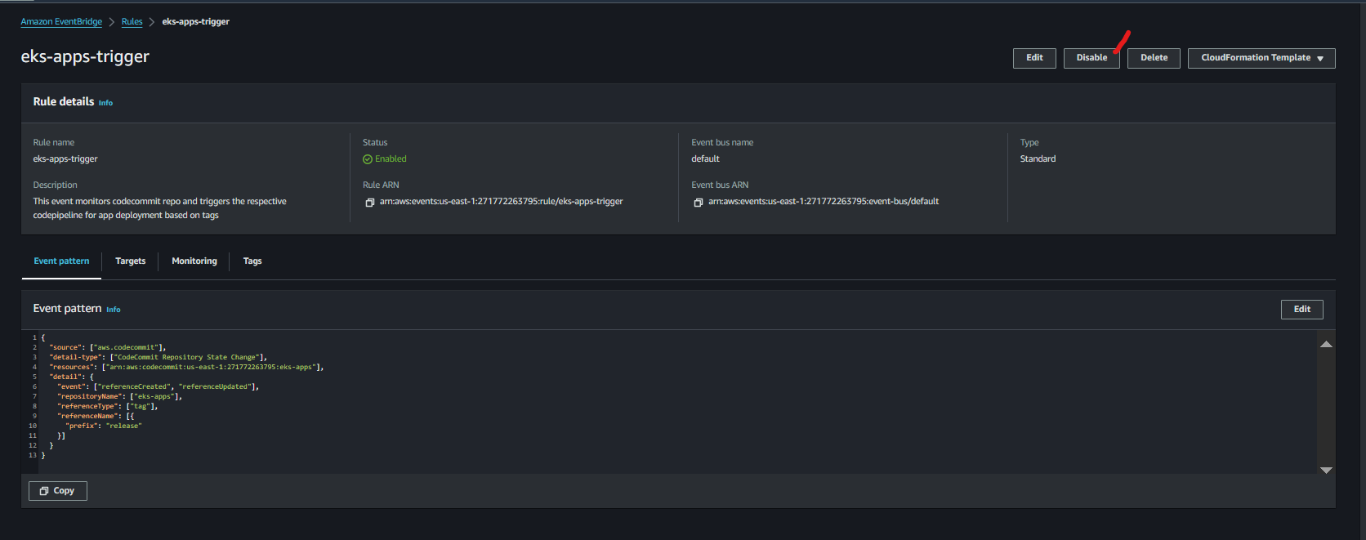  
 *Image 39: Disable Existing Event Rules*

**EventBridge Rule for Application Deployment:**  
To create eventbridge event rule click on “**Create rule**” in Amazon Eventbridge console  
specify a name to it, we have given “**eks-apps-trigger**" and click on “**Next**”. In **Build event pattern** scroll to last and click on **“Edit pattern”** insert the below event pattern and click on “**Next**”.

|  |
| --- |
| ***{***  ***"source": ["aws.codecommit"],***  ***"detail-type": ["CodeCommit Repository State Change"],***  ***"resources": ["arn:aws:codecommit:us-east-1:271772263795:eks-apps"],***  ***"detail": {***  ***"event": ["referenceCreated", "referenceUpdated"],***  ***"repositoryName": ["eks-apps"],***  ***"referenceType": ["tag"],***  ***"referenceName": [{***  ***"prefix": "release"***  ***}]***  ***}***  ***}*** |

*Code: Tag-based Event pattern for lambda trigger*

This EventBridge event pattern is designed to capture changes in the state of a CodeCommit repository, specifically targeting the "eks-apps" repository in the US East (N. Virginia) region. The pattern focuses on events related to the creation or update of references, specifically when dealing with tags in the repository. The events of interest include "referenceCreated" and "referenceUpdated." Furthermore, it filters for references with the name prefix "release" within the "eks-apps" repository. In essence, this event pattern is finely tuned to detect changes to tagged references with a "release" prefix in the specified CodeCommit repository, enabling streamlined triggering of subsequent actions in response to these events.

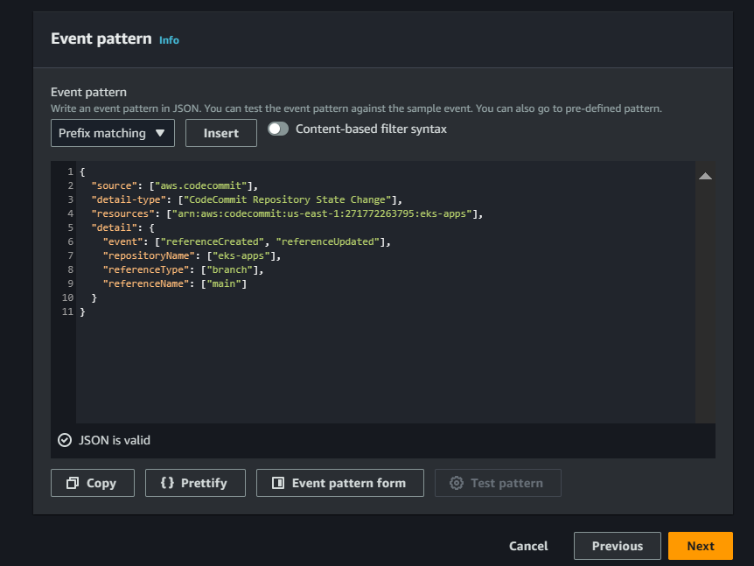  
*Image 40: Event Pattern for lambda trigger*

In **Select targets,**

Select **AWS service** and in **Select a target** choose lambda function and in Function choose the function which is created previously **“eks-apps-trigger"** and click on **“Next”.**  
Click on “**Next**” in **tags** section and click on “**Create rule**” to create the event rule.  
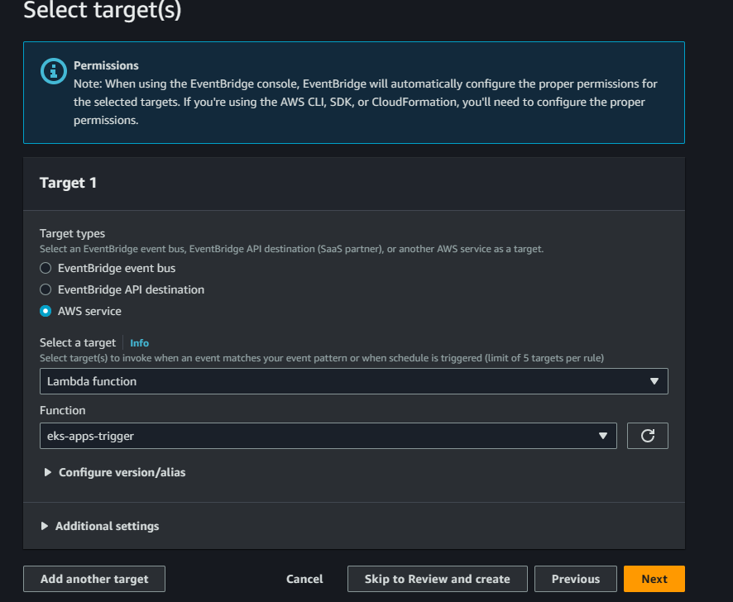  
*Image 41: Targets for Event rule*

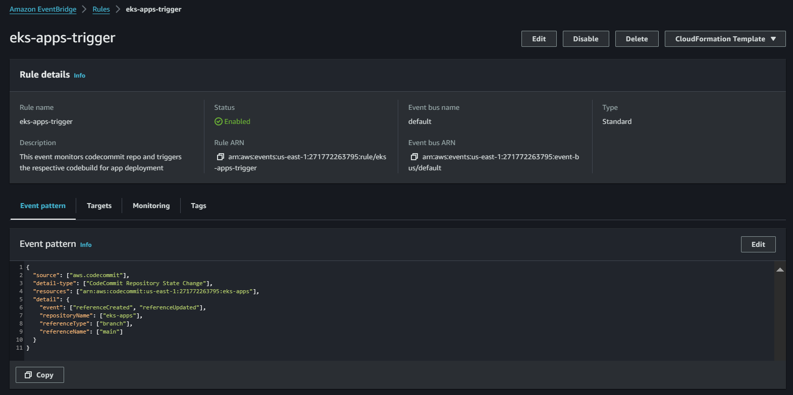  
 *Image 42: Event rule*

Now the event rule is ready to trigger the lambda function based on the tag pushes occurring in the “**eks-apps**” repository

**EventBridge Rule for Infrastructure Provisioning:**   
To create eventbridge event rule click on “**Create rule**” in Amazon Eventbridge console   
specify a name to it, we have given “**eks-infra-trigger**" and click on “**Next**”. In Build event pattern scroll to last and click on “**Edit pattern**” insert the below event pattern and click on “**Next**”.

|  |
| --- |
| ***{***  ***"source": ["aws.codecommit"],***  ***"detail-type": ["CodeCommit Repository State Change"],***  ***"resources": ["arn:aws:codecommit:us-east-1:271772263795:eks-infra"],***  ***"detail": {***  ***"event": ["referenceCreated", "referenceUpdated"],***  ***"repositoryName": ["eks-infra"],***  ***"referenceType": ["tag"],***  ***"referenceName": [{***  ***"prefix": "release"***  ***}]***  ***}***  ***}*** |

*Code: Tag-based Event pattern for Codepipeline trigger*

This EventBridge event pattern is tailored for monitoring changes in the state of a CodeCommit repository, specifically focusing on the "**eks-infra**" repository in the US East (N. Virginia) region. The pattern is designed to capture events related to the creation or update of references, with a specific emphasis on tags within the repository. The events of interest include "**referenceCreated**" and "**referenceUpdated**" The pattern further filters events to specifically target references with the name prefix "**release**" within the "**eks-infra**" repository. In essence, this event pattern is finely tuned to detect changes to tagged references with a "**release**" prefix in the specified CodeCommit repository, facilitating precise triggering of subsequent actions in response to these events.

In **Select targets,**  
Select **AWS service** and in **Target types,** In **Select a target** choose CodePipeline and in **pipeline ARN** insert the pipeline arn of **eks-infra pipeline.** Choose **Use existing role** in **Execution role** and select **Invoke Codepipeline role** which is created previously and click on **“Next”.**  
Click on “**Next**” in **tags** section and click on “**Create rule**” to create the event rule.  
  
 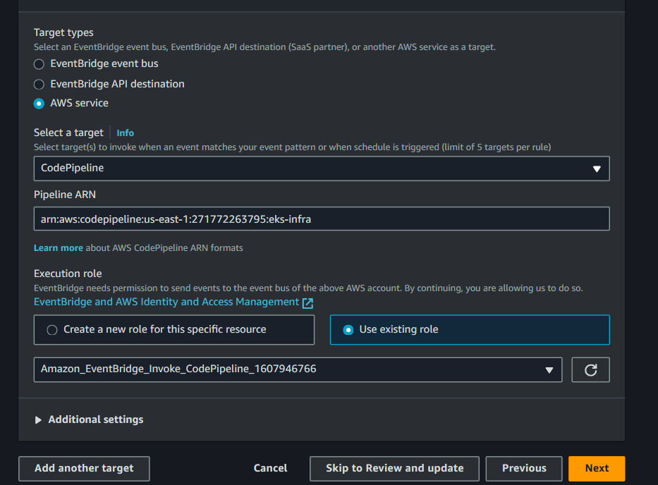  
 *Image 43: Target for Event rule*

Now the event rule is ready to trigger the CodePipeline based on the tag pushes occurring in the “**eks-infra**” repository

This detailed technical prep-work serves as the bedrock for the subsequent implementation phases, ensuring that every technical aspect is configured and secured to support the GitLab deployment in the AWS cloud.

**Deployment Flow:**

The deployment process in GitLab modernization project is orchestrated with precision and efficiency. It leverages a well-integrated workflow that capitalizes on AWS services to automate the provisioning and deployment of infrastructure and application components.  
  
**1. CodeCommit as the Code Repository:**   
The deployment process centre around the CodeCommit repository, a core hub for version control. It houses key elements like Terraform code and essential deployment artifacts. This repository plays a crucial role in managing infrastructure-as-code and application deployment configurations with precision and control.  
  
**2. Infrastructure Provisioning Automation Through CodePipeline :**   
The deployment orchestration is seamlessly managed through AWS CodePipeline, streamlining the code flow from CodeCommit through various stages to establish a well-defined and automated workflow. This process serves as the backbone for executing critical Terraform commands, crucial for configuring infrastructure within your AWS environment.  
The initiation is automated, triggered by changes & **tag pushes** in the **eks-infra** code repository. CodePipeline takes charge, instigating Terraform plan and apply operations. The plan operation outlines the proposed infrastructure changes, generating detailed plan logs. To ensure precision and alignment with project goals, a thorough review of these logs is conducted. Once approved through a manual review process, the pipeline advances to the apply stage, executing the necessary steps to provision and configure essential infrastructure components. This includes networking resources, security groups, compute resources, and other key AWS services. This orchestrated process lays the groundwork for establishing a resilient and efficient GitLab environment, ensuring that infrastructure evolves in tandem with project requirements.  
   
**3. Application Deployment with the Terraform:**  
We've established three distinct AWS CodePipeline dedicated to deploying applications within the EKS environment. These pipelines are associated with the "eks-apps" repository, which is organized into three folders: "gitlab," "keycloak," and "common."

The "common" directory houses terraform templates essential EKS components such as the Prometheus stack, Grafana, and autoscaler, while the "gitlab" and "keycloak" folders contain Terraform templates for deploying GitLab and Keycloak applications, respectively. To streamline the deployment process, we've implemented an event rule that, upon any tag pushed in the "eks-apps" repository, triggers a Lambda function.

This Lambda function plays a pivotal role in detecting the specific folder impacted by the commit & reference as tag push. In the event of a commit & tag pushed with reference “**release-common**\*” the "common" folder, the Lambda function initiates a Codepipeline tailored for deploying common components within the EKS cluster. Similarly, commits & tag pushed with reference “**release-gitlab\***” the "**gitlab**" and tag pushed with reference “**release-keycloak\***” "**keycloak**" folder trigger their respective Codepipeline, orchestrating the deployment of GitLab and Keycloak applications in the EKS environment.

This organized approach ensures that each application deployment is independently managed, fostering a streamlined and efficient development lifecycle within the AWS ecosystem.

**CodePipeline Operations:**

This CodePipeline orchestrates the deployment of GitLab application environment within the AWS ecosystem. It encompasses different pipeline stages, each executing specific tasks to ensure a seamless and automated deployment process.

**Infrastructure Deployment workflow**   
**eks-infra** CodePipeline consists of Four Stages:  
**1**. **Source stage**  
**2**. **Build Stage (Terraform Plan Stage)**  
**3. Manual Approval**  
**4. Terraform Apply Stage**

**1**. **Source stage**  
In the source stage, upon detecting changes in the CodeCommit repository, CodePipeline initiates its execution. During this phase, the repository is cloned, and the cloned data is subsequently utilized in CodeBuild to perform the requisite build operations, facilitating a seamless integration process.  
  
**2**. **Build Stage (Terraform Plan Stage)**  
During the Build stage, the execution of build operations commences utilizing a pipeline script, specifically the buildspec. This script is structured into three pivotal stages:  
**I. Install phase**  
**II. Build phase**

Detailed descriptions of the operations within each stage are provided below, offering a comprehensive understanding of the purpose and functions of each stage in the build operations.  
  
**I. Install phase**  
The build process begins with an Install Phase where the objective is to set up the build environment. This involves installing Terraform and Helm. Terraform, a tool for infrastructure as code, is fetched from a specific version, ensuring consistency across the environment. Helm, a Kubernetes package manager, is also installed during this phase to manage Kubernetes applications effectively.

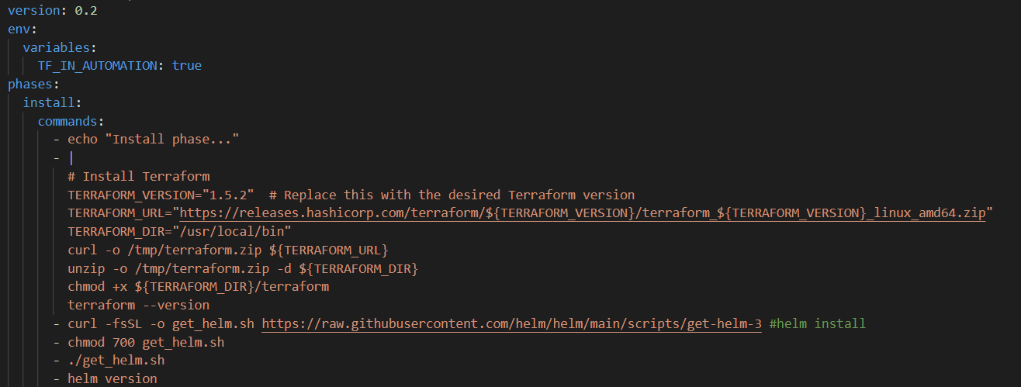  
 *Image 44: Pipeline Stage:* *Install Stage*

**II. Build phase**  
Following the Install Phase, the **Build Phase** is initiated to execute Terraform commands and generate artifacts. Initially, the script begins by echoing messages to provide visibility into the ongoing processes. It then navigates to the application directory indicated by the $APP environment variable (As there is not variable value stored in the infra pipeline so it will be empty) and performs routine tasks such as cleaning up previous Terraform configurations (.terraform/ directory) to ensure a fresh start. After initializing Terraform without user input, the script proceeds to execute a Terraform plan operation. This plan, outlining the proposed infrastructure changes, is saved as "tfplan."

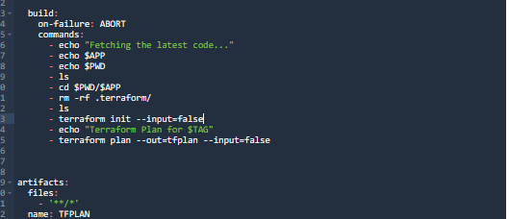  
 *Image 45: Pipeline Stage:* *Install Stage*

In terms of Artifact Creation, the build process ensures that all files are included in the artifact, covering the entirety of the build. The naming convention for the artifact, "TFPLAN," is chosen for clarity and easy identification in subsequent stages of the deployment pipeline.

**3. Approval**

Following the Terraform plan stage, a critical Manual Approval Stage is introduced to ensure a human checkpoint in the deployment pipeline. At this juncture, an SNS service is configured to promptly notify stakeholders via email, providing them with detailed information regarding the proposed infrastructure changes outlined in the Terraform plan. The stakeholder, after thorough review, has the authority to either approve or reject the proposed changes.  
  
This manual approval mechanism serves as a pivotal control point, aligning with best practices in change management. Upon obtaining the stakeholder's approval, the pipeline seamlessly progresses to the subsequent stage, executing the Terraform apply operation to implement the proposed infrastructure modifications. This orchestrated approach not only fosters transparency but also integrates human judgment, adding an extra layer of validation to the deployment process.  
  
 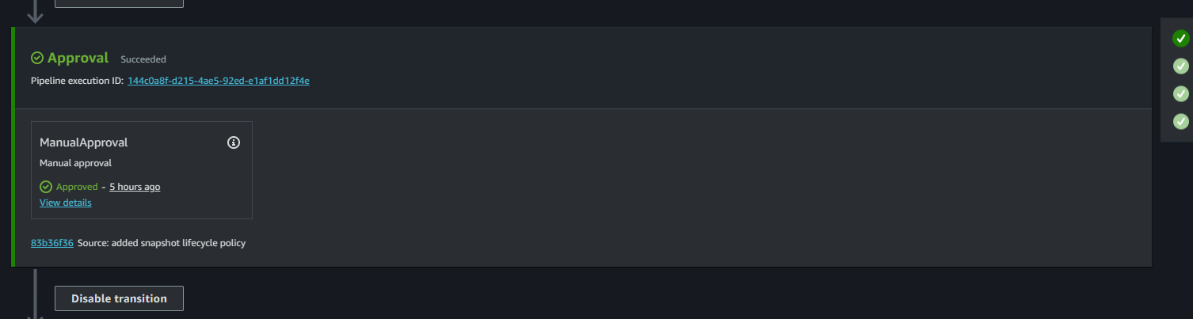  
 *Image 46: Pipeline Stage:* *Install Stage*

**4. TerraformApply**

During the Build stage, the execution of build operations commences utilizing a pipeline script, specifically the buildspec. This script is structured into three pivotal stages:  
**I. Install phase**  
**II. Build phase**  
Detailed descriptions of the operations within each stage are provided below, offering a comprehensive understanding of the purpose and functions of each stage in the build operations.

**I. Install phase**  
In the "install" phase, the script begins by echoing a message to indicate the commencement of the installation process. Subsequently, it executes a series of commands to install Terraform and Helm, crucial components for infrastructure provisioning. The script dynamically fetches the desired Terraform version, downloads it, and places the executable in the designated directory. Similarly, Helm, a Kubernetes package manager, is acquired and configured. The result is a prepared environment with Terraform and Helm ready for use.

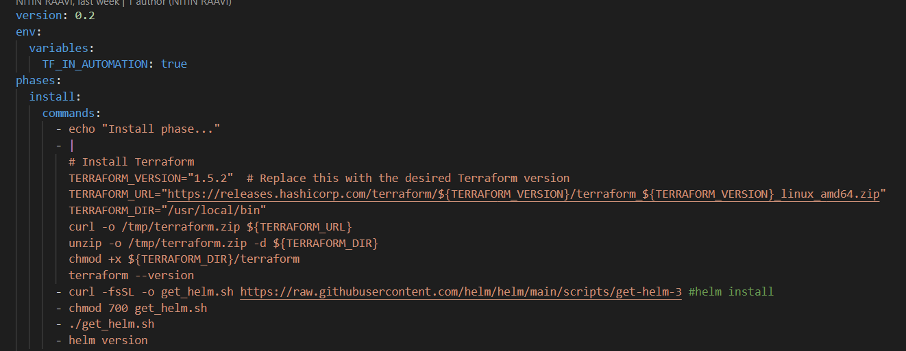  
 *Image 47: Pipeline Stage:* *Install Stage*

**II. Build Phase**  
In this build phase, crucial steps are executed to deploy infrastructure changes. The script logs application details, directory content, and navigates to the specified application directory, even though $APP is intentionally empty in the infrastructure pipeline so control will be in the root directory of the repository. The key command, "terraform apply tfplan," implements planned infrastructure modifications, using the "tfplan" file generated earlier. The "on-failure: ABORT" directive ensures immediate termination on encountering errors, preserving deployment reliability. This phase concludes the pipeline, applying Terraform changes accurately.

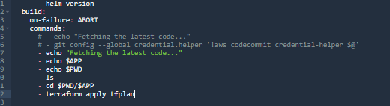  
 *Image 48: Pipeline Stage:* Build *Stage*

  
  *Image 49: Infrastructure Pipeline*

**Application Deployment workflow**

Within our deployment framework, an integral component is a Lambda function designed to initiate specific CodePipelines based on repository commits & Tag pushes with references. The trigger for this Lambda function is an Event Rule, meticulously configured to respond to changes in the designated repository—our Apps repository. Upon any tag push with reference prefix “**release**”, the Lambda function springs into action, scrutinizing the reference tag for specific keywords: "**gitlab**" "**common**" or "**keycloak**" which in turn will start the execution of the particular Codepipelines according to the reference tag prefix. If the tag consists of “**gitlab”** keyword “**eks-gitlab-app**" pipeline will be triggered which will deploy the changes in the EKS. And similarly, if the tag consists of “**common**” or “**keycloak**” keyword then “**eks-common-app**" or “**eks-keycloak-app**" pipeline will be triggered respectively up the tag reference.  
  
**Application CodePipelines consists of Four Stages:**  
**1**. **Source stage**  
**2**. **Build Stage (Terraform Plan Stage)**  
**3. Manual Approval**  
**4. Terraform Apply Stage**

**1**. **Source stage**  
In the source stage, upon detecting changes in the CodeCommit repository, CodePipeline initiates its execution. During this phase, the repository is cloned, and the cloned data is subsequently utilized in CodeBuild to perform the requisite build operations, facilitating a seamless integration process.

**2**. **Build Stage (Terraform Plan Stage)**  
During the Build stage, the execution of build operations commences utilizing a pipeline script, specifically the buildspec. This script is structured into three pivotal stages:  
**I. Install phase**  
**II. Build phase**

Detailed descriptions of the operations within each stage are provided below, offering a comprehensive understanding of the purpose and functions of each stage in the build operations.  
**I. Install phase**  
The build process begins with an Install Phase where the objective is to set up the build environment. This involves installing Terraform and Helm. Terraform, a tool for infrastructure as code, is fetched from a specific version, ensuring consistency across the environment. Helm, a Kubernetes package manager, is also installed during this phase to manage Kubernetes applications effectively.

  
 *Image 50: Pipeline Stage:* *Install Stage*

**II. Build phase**  
After the Install Phase, the Build Phase orchestrates essential Terraform tasks, offering insights through echoed messages. It dynamically adapts to different application scenarios based on the $APP variable. When the "**eks-common-app**" pipeline triggers, **$APP** is set to "**common**" for "**eks-gitlab-app**" it becomes "**gitlab**" and for "**eks-keycloak-app**" it becomes "**keycloak**" The script navigates to the corresponding directory, ensuring accurate Terraform plan operations aligned with the specific application. This meticulous process culminates in the creation of a "**tfplan**" file, encapsulating the proposed infrastructure changes.

  
 *Image 51: Pipeline Stage:* *Install Stage*

In terms of Artifact Creation, the build process ensures that all files are included in the artifact, covering the entirety of the build. The naming convention for the artifact, "TFPLAN," is chosen for clarity and easy identification in subsequent stages of the deployment pipeline.

**3. Approval**

Following the Terraform plan stage, a critical Manual Approval Stage is introduced to ensure a human checkpoint in the deployment pipeline. At this juncture, an SNS service is configured to promptly notify stakeholders via email, providing them with detailed information regarding the proposed infrastructure changes outlined in the Terraform plan. The stakeholder, after thorough review, has the authority to either approve or reject the proposed changes.  
  
This manual approval mechanism serves as a pivotal control point, aligning with best practices in change management. Upon obtaining the stakeholder's approval, the pipeline seamlessly progresses to the subsequent stage, executing the Terraform apply operation to implement the proposed infrastructure modifications. This orchestrated approach not only fosters transparency but also integrates human judgment, adding an extra layer of validation to the deployment process.

  
 *Image 52: Pipeline Stage:* *Approval*

**4. TerraformApply**

During the Build stage, the execution of build operations commences utilizing a pipeline script, specifically the buildspec. This script is structured into three pivotal stages:  
**I. Install phase**  
**II. Build phase**

Detailed descriptions of the operations within each stage are provided below, offering a comprehensive understanding of the purpose and functions of each stage in the build operations.

**I. Install phase**  
In the "install" phase, the script begins by echoing a message to indicate the commencement of the installation process. Subsequently, it executes a series of commands to install Terraform and Helm, crucial components for infrastructure provisioning. The script dynamically fetches the desired Terraform version, downloads it, and places the executable in the designated directory. Similarly, Helm, a Kubernetes package manager, is acquired and configured. The result is a prepared environment with Terraform and Helm ready for use.

  
 *Image 53: Pipeline Stage:* *Install Stage*

**II. Build Phase**  
After the Install Phase, the Build Phase orchestrates essential Terraform tasks, offering insights through echoed messages. It dynamically adapts to different application scenarios based on the $APP variable. When the "**eks-common-app**" pipeline triggers, **$APP** is set to "**common**" for "**eks-gitlab-app**" it becomes "**gitlab**" and for "**eks-keycloak-app**" it becomes "**keycloak**" The script navigates to the corresponding directory, ensuring accurate Terraform Apply operations aligned with the specific application. This process deploys all the application changes in the code to EKS.

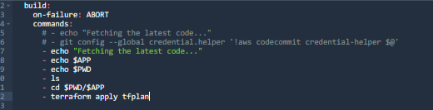  
 *Image 54: Pipeline Stage:* Build *Stage*

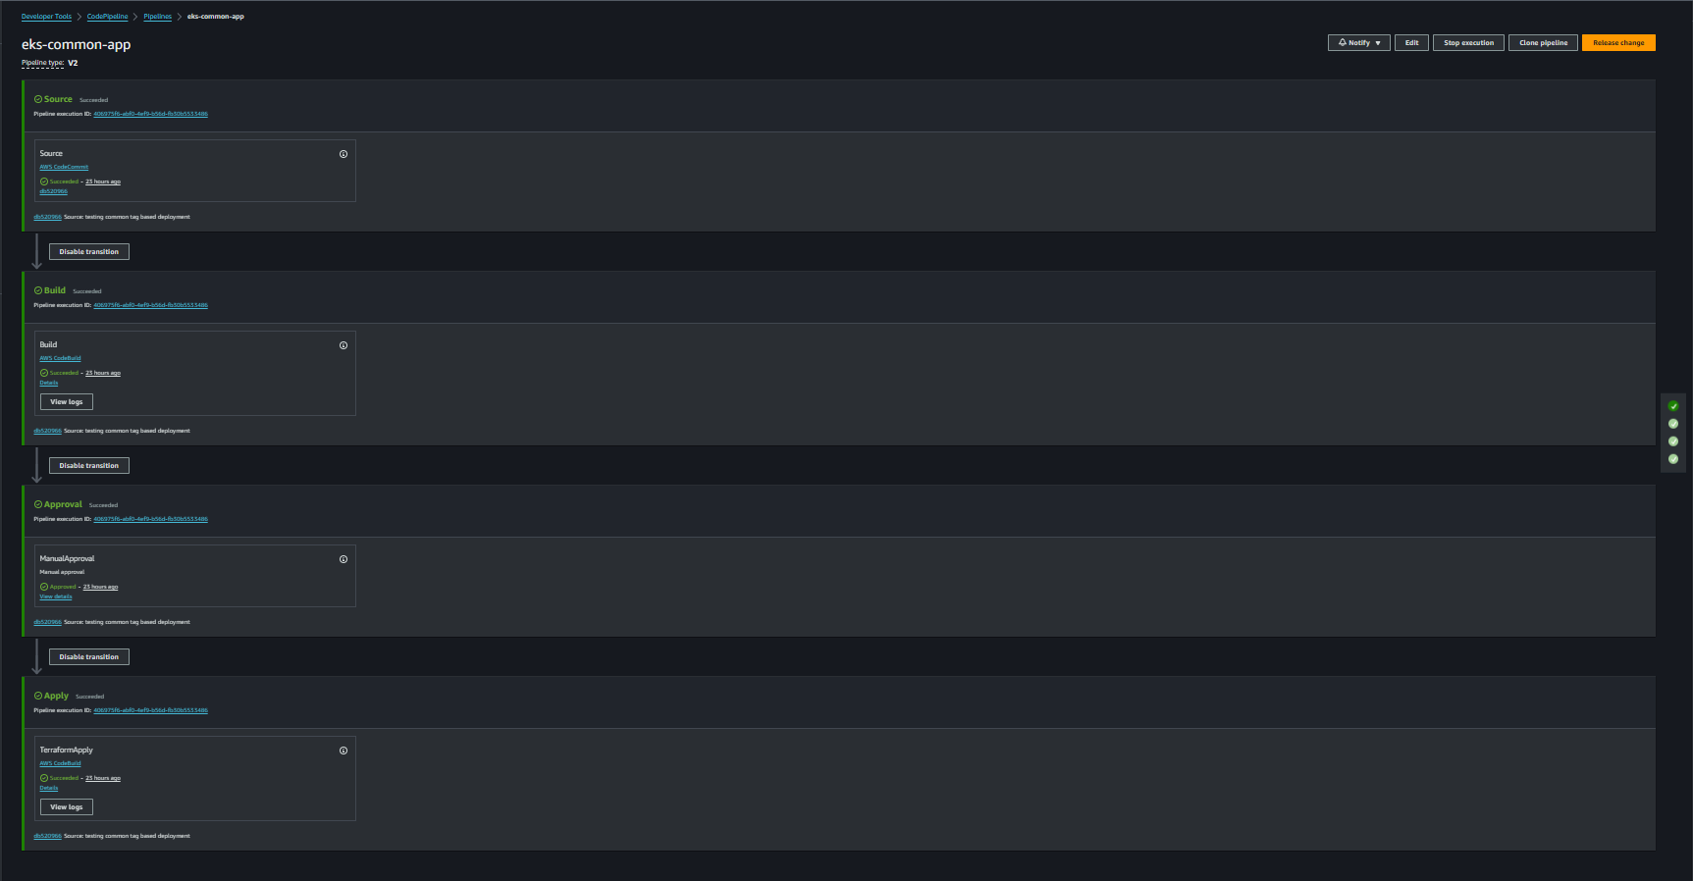  
  *Image 55: eks-common-app Pipeline*

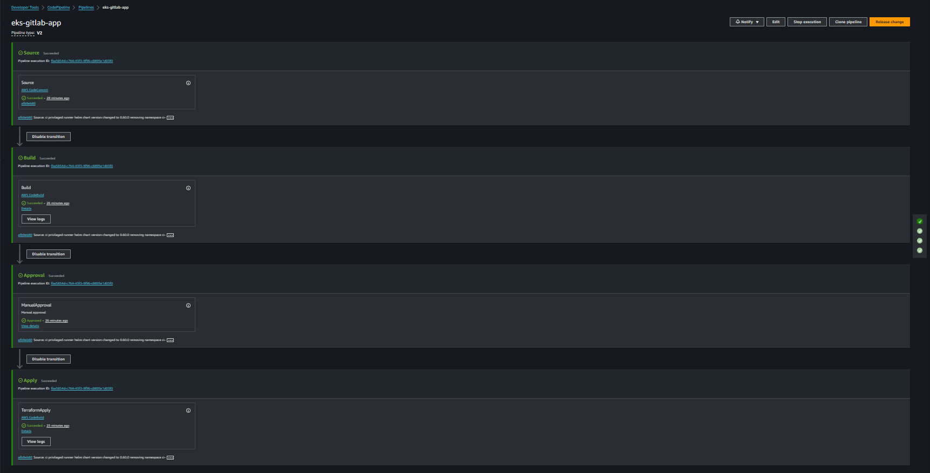  
  *Image 56: eks-gitlab-app Pipeline*

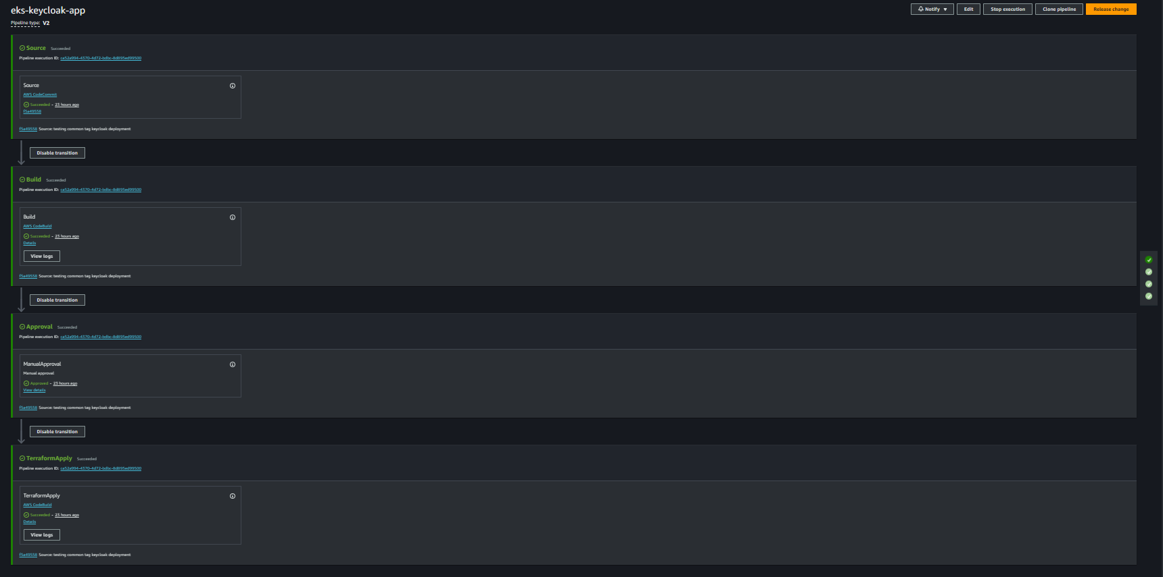  
 *Image 57: eks-keycloak-app Pipeline*

In essence, our deployment process, driven by Lambda intelligence, adapts dynamically to repository tags, efficiently deploying applications and common components within our AWS EKS environment.

**Resource Inventory Provisioned**

Below is comprehensive list of resources provisioned by Terraform (Test Env), showcasing the foundational components that compose your GitLab environment within AWS.

**Network & Security Inventory**

|  |  |  |  |
| --- | --- | --- | --- |
| Si No. | AWS Resource | Description | Count |
| 1 | VPC | GitLab's AWS networking hub for secure deployment. | 1 |
| 2 | Subnet | Segmented space for GitLab components, enhancing security. | 10 |
| 3 | Route Table | Directs traffic efficiently in GitLab's AWS network. | 6 |
| 4 | Internet gateway | Connects GitLab's VPC to the internet seamlessly. | 1 |
| 5 | Nat Gateway | Enables secure internet access for GitLab's private subnets. | 1 |
| 6 | VPC Endpoints | Streamlines GitLab's access to AWS services privately. | 1 |
| 7 | Security Group | GitLab's virtual firewall, controls inbound and outbound traffic at resource level. | 4 |
| 8 | Network ACL | Subnet-level security, a key defence for GitLab's deployment. | 1 |
| 9 | IAM Roles | AWS Identity and Access Management to manage GitLab's AWS resource permissions. | 15 |

**Compute Inventory**

|  |  |  |  |
| --- | --- | --- | --- |
| Si No. | AWS Resource | Description | Count |
| 1 | EC2 Instance | GitLab-hosted environment virtual servers for Autoscaling Groups. | 6 |
| 2 | EKS Cluster | GitLab's managed Kubernetes cluster for container orchestration. | 1 |
| 3 | EKS Node Group | Worker nodes in GitLab's EKS cluster. | 3 |
| 4 | EKS Fargate Profile | GitLab's serverless capacity for Linux-based Runner Workers. | 1 |
| 5 | RDS (DB Instance) | Managed relational database for GitLab (PostgreSQL) | 1 |
| 6 | ElastiCache (Redis Cluster) | GitLab's Redis-based caching solution. | 1 |
| 7 | Autoscaling Group | Automatically adjusts GitLab's compute capacity based on demand. | 4 |

**Storage Inventory**

|  |  |  |  |
| --- | --- | --- | --- |
| Si No. | AWS Resource | Description | Count |
| 1 | S3 Bucket | Central storage for GitLab Objects. | 8 |
| 2 | Elastic Container Registry | Hosts Custom Docker images for GitLab’s Workhorse & Webservice | 2 |

**Helm Deployments**

|  |  |  |  |
| --- | --- | --- | --- |
| Si No. | Deployment | Description |  |
| 1 | Gitlab Components | GitLab application hosted in AWS for version control and collaboration | 1 |
| 2 | AWS Load Balancer Controller | Manages load balancing to ensure GitLab's high availability. | 1 |
| 3 | Prometheus CloudWatch Exporter | CloudWatch Metrics shipping to Prometheus for AWS Resources Monitoring. | 1 |
| 4 | Fluent-Bit Deployment | Fluent-Bit for shipping GitLab logs to AWS CloudWatch for centralized logging. | 1 |
| 5 | C-Advisor Deployment | Used for collecting container-level performance data within your GitLab environment | 1 |
| 6 | Grafana Deployment | Grafana for in-depth visualization and monitoring of GitLab's performance and data | 1 |
| 7 | Cluster Autoscaler | Cluster Autoscaler for GitLab on Amazon EKS, adjusting node capacity based on workload demands | 1 |

**DEPLOYMENT NOTE:** In deviation from Gitaly's EC2 cluster recommendation by Gitlab’s official documentation, Gitaly is deployed singularly in an EKS pod, confined to one Availability Zone (AZ) as per client directive. This simplifies architecture but introduces single-point failure risks. Potential challenges include network outages, pod disruptions, and out-of-memory cases. Mitigating these requires robust monitoring, swift incident response, and alignment with application availability goals. EKS-specific considerations, such as AZ reliability, should guide the overall deployment strategy for comprehensive risk management.

GITLAB RUNNER CONFIGURATION

GitLab Runner Configuration Management for Linux-based Jobs:  
  
  
 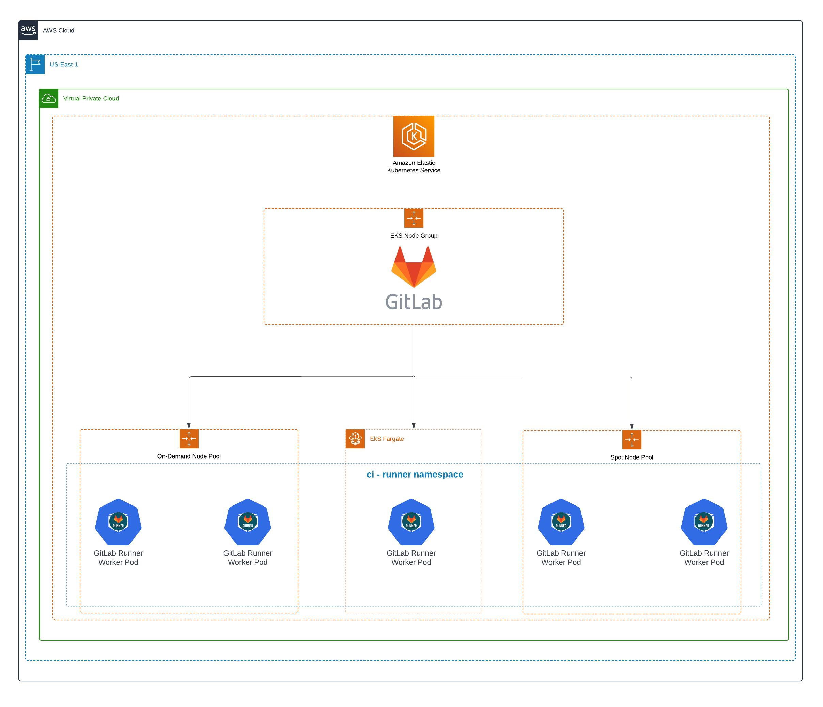  
  *Image 58: Gitlab Runner Configuration for Linux Jobs*

In the AWS EKS-based GitLab environment, seamless integration of the GitLab Runner for Linux-based jobs is achieved through the GitLab Helm chart. Leveraging the Kubernetes executor, the configuration for the Kubernetes executor is managed through the 'config.toml' file, which is specified in the values template file supplied to the Helm chart during runner provisioning (helm deployment). The GitLab Runner pod efficiently handles Linux jobs by dynamically creating and terminating pods within the 'ci-runner' namespace.

To optimize resource allocation and manage costs effectively, a Fargate profile has been configured, ensuring the Kubernetes scheduler utilizes AWS Fargate for job execution. Fargate's serverless compute engine launches pods on-demand and scaling down to zero during idle periods, minimizing operational overhead. Additionally, to further optimize costs, we have also implemented on-demand and spot runners, utilizing EC2 on-demand and spot instances with EC2 Savings Plan enabled. This strategic combination balances cost and performance, ensuring efficient resource utilization while minimizing expenses.

The Fargate profile, specifically tied to the 'ci-runner' namespace, adheres to GitLab's CI/CD best practices, providing a secure and isolated environment for Linux-based job execution. This comprehensive setup ensures high performance, cost-effectiveness, and scalability for the CI/CD workflow, enabling efficient software delivery in the AWS EKS environment.

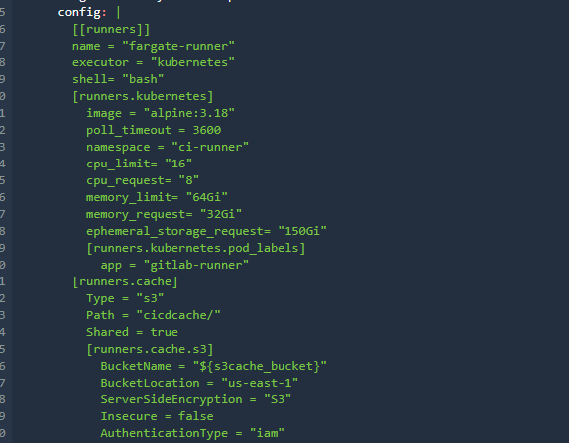  
 *Image 59: config.toml for Kubernetes executor for Linux Jobs*

Moreover, to expedite the process, pods provisioned in the 'ci-runner' namespace via Fargate utilize an S3 cache for retrieving large Docker images. By storing these images in the cache, the time-consuming process of pulling Docker images is significantly reduced, optimizing overall efficiency.

**GitLab Runner Configuration Management for Windows-based Jobs:**

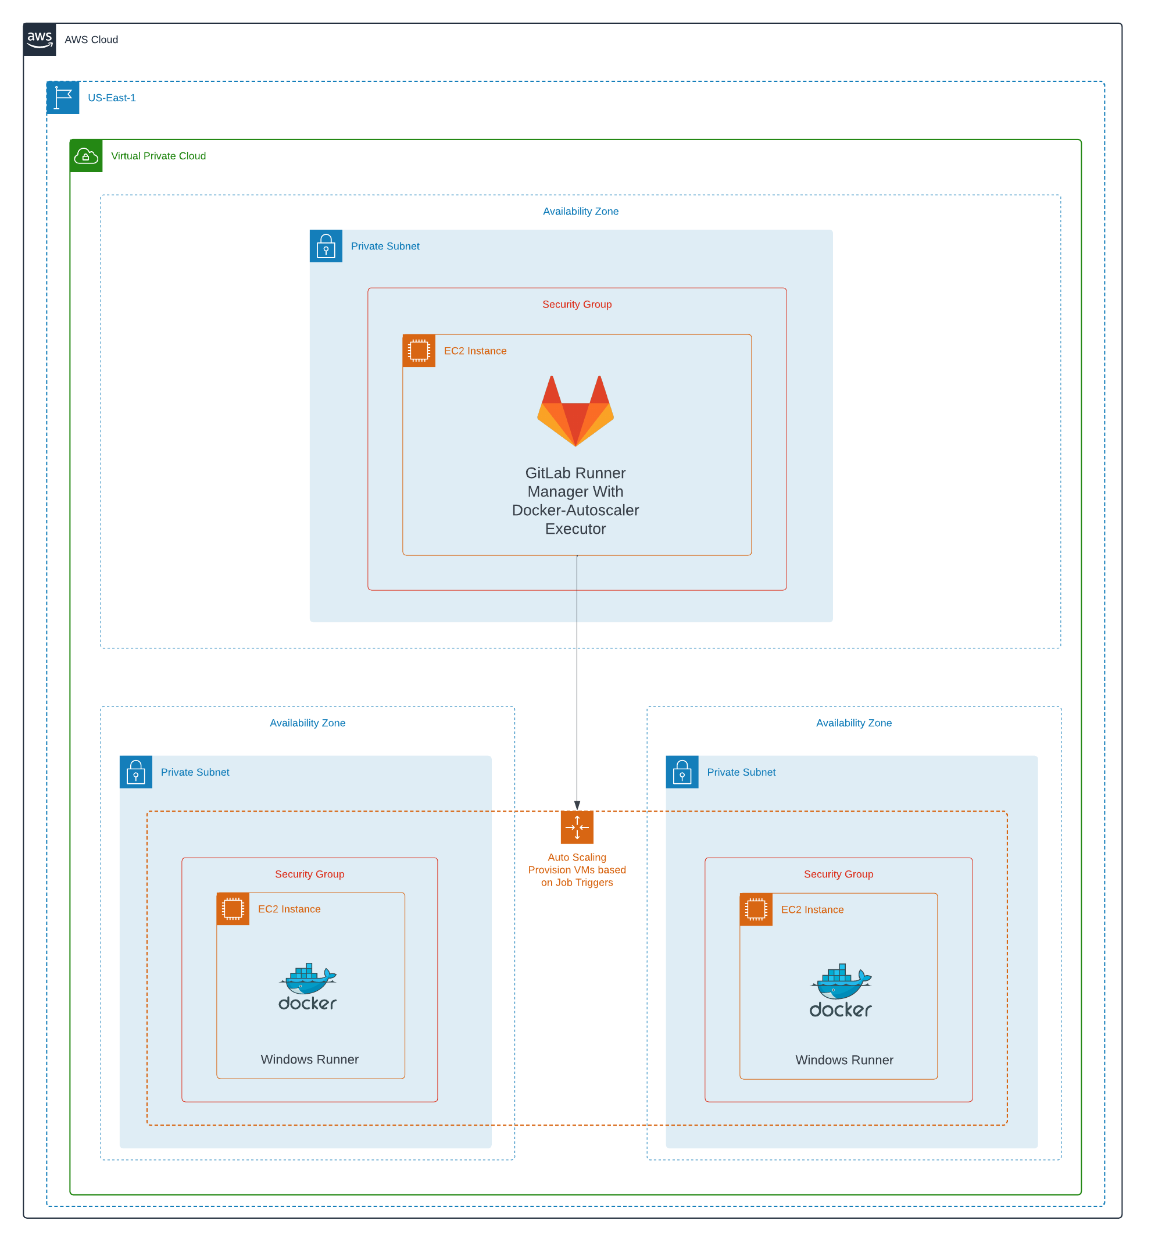  
  *Image 60: Gitlab Runner Configuration for Windows Jobs*

GitLab Windows CI/CD infrastructure is strategically deployed on Amazon Web Services (AWS), utilizing a combination of services to optimize performance and efficiency. The core of this setup revolves around the GitLab Runner Manager, which is deployed on an EC2 instance running **Ubuntu**. This instance serves as the control point for managing Windows-based CI/CD jobs and orchestrating the provisioning of instances dedicated to job execution.

To facilitate Windows-based CI/CD job execution, a custom Amazon Machine Image (AMI) has been constructed. This AMI incorporates essential dependencies, including the Docker engine and Winrm, ensuring a standardized and reliable environment for executing Windows-based tasks.

For dynamic and efficient scaling, a launch template is crafted from the custom Windows AMI. This template encapsulates the necessary configuration details for launching instances within the AWS infrastructure. Utilizing this launch template, an autoscaling group is established, operating within private subnets across two distinct Availability Zones to enhance both security and availability.

The GitLab Runner Manager, configured with the **Docker-autoscaler executor** uses a config.toml, references this autoscaling group. This configuration enables the GitLab Runner to dynamically scale by provisioning and managing runner instances based on the workload.

Importantly, the autoscaling group employs a mixed strategy, combining both on-demand instances for stability and spot instances for cost efficiency. This strategy optimizes costs without compromising the reliability and performance required for CI/CD workflows.

The dynamic scaling capabilities of the autoscaling group are orchestrated by the GitLab Runner Manager, providing the infrastructure with the flexibility to adapt seamlessly to varying CI/CD workloads. This dynamic scaling ensures resource utilization is optimized, preventing over-provisioning or underutilization of instances.   
  
 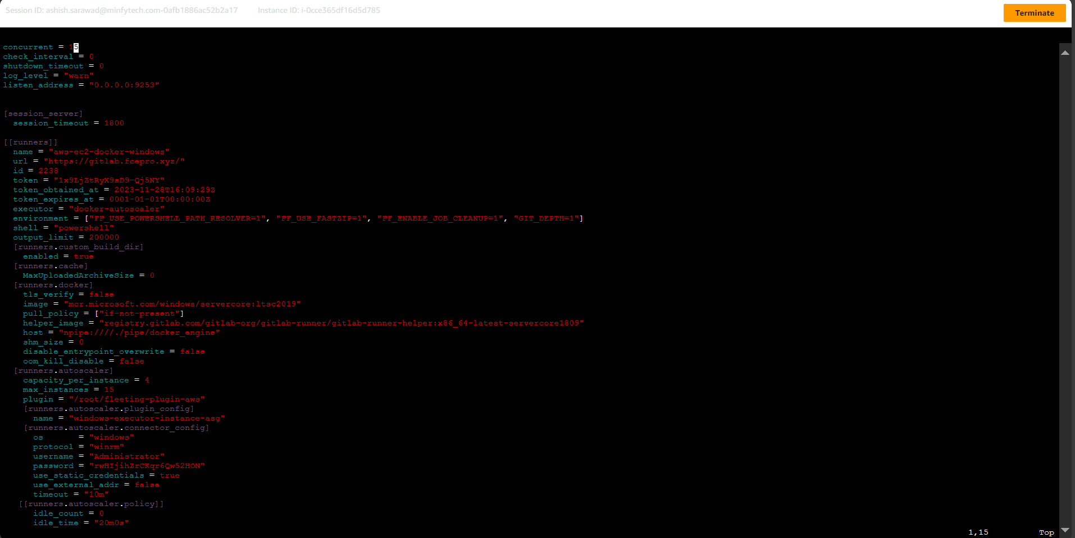  
  *Image 61: config.toml for docker-autoscaler executor for Windows Jobs*

**Why Docker Autoscaler Executor?**   
   
To address these challenges and enhance the overall reliability and cost-effectiveness of our GitLab Runner system, we have transitioned to the Docker Autoscaler executor.

1. Decoupling Runner Manager from Worker:

Docker Autoscaler separates the role of the runner manager from the worker, providing a more scalable and resilient architecture. The main runner manager now resides in an Kubernetes pod in EKS Cluster, decoupling it from individual worker instances.

2. Dynamic Autoscaling for Worker Runners:

Leveraging an autoscaling group, Docker Autoscaler enables dynamic provisioning and de-provisioning of GitLab Runner workers based on real-time demand. This ensures optimal resource utilization and cost savings by scaling workers up or down as needed.

3. Efficient Resource Management:

With Docker Autoscaler, resources are allocated efficiently, aligning with the demands of GitLab Runner, leveraging GitLab Runner capabilities to spawn worker instances as needed. This not only enhances the reliability of CI/CD processes but also optimizes costs by scaling resources up or down dynamically.

4. Eliminating Tag Conflicts:

By adopting a more sophisticated runner management approach, Docker Autoscaler eliminates the issues related to tag conflicts. Each worker instance is now uniquely identifiable, reducing the chances of pipeline failures due to tag conflicts.

MONITORING

Overview

The monitoring stack for GitLab on Amazon EKS is designed to provide a robust and comprehensive solution for collecting, storing, and visualizing metrics. Leveraging a combination of Prometheus, Prometheus CloudWatch Exporter, Node Exporter and Grafana, this monitoring architecture ensures a thorough understanding of system health, resource utilization, and AWS CloudWatch metrics. A strategic ensemble of tools has been chosen and integrated, aligning seamlessly with GitLab's operational dynamics.

Now, let's delve into the details of the monitoring stack deployed in the GitLab on Amazon EKS environment.

**Architecture**  
  
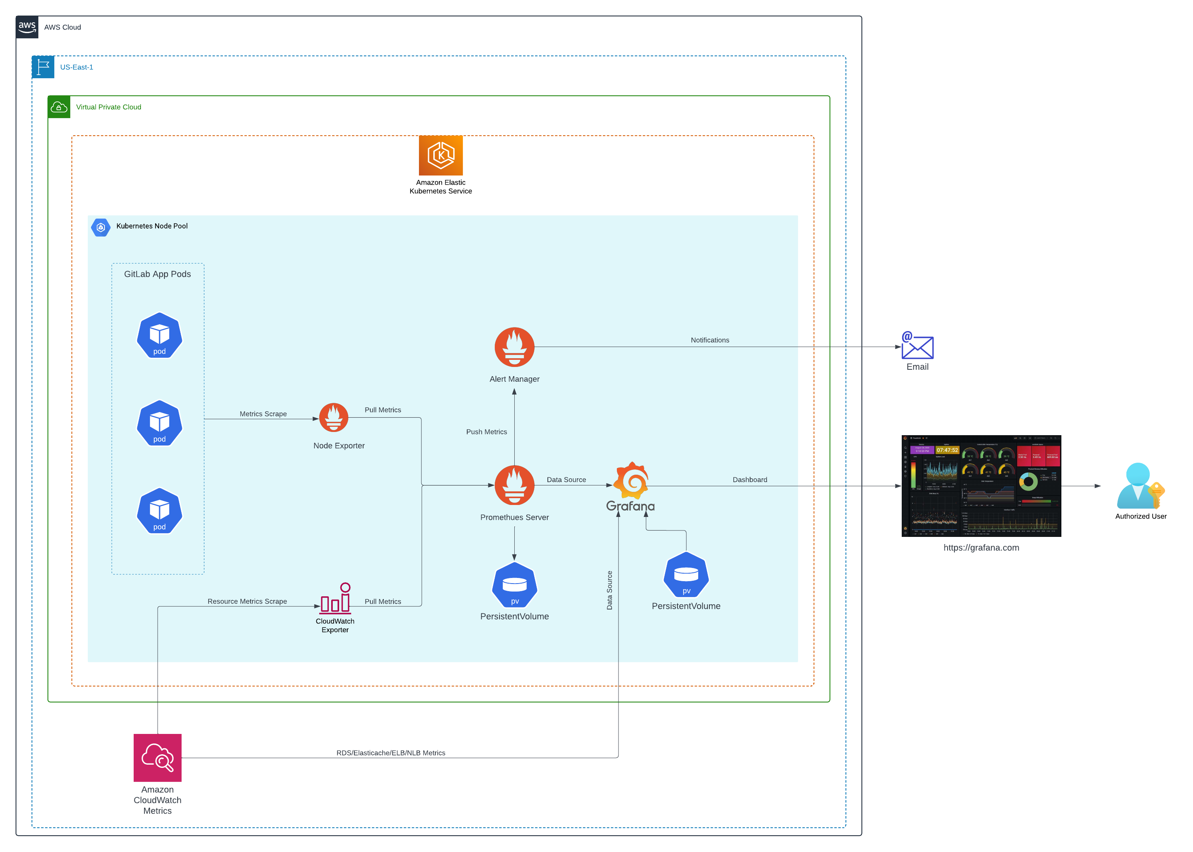 *Image 62: Monitoring Stack* Architecture

This designed monitoring architecture in our Amazon EKS environment is tailored to provide comprehensive insights into the health and performance of GitLab application components. A key player in this architecture is Node Exporter, working in harmony with the Prometheus deployment within the EKS cluster.  
  
Node Exporter efficiently collects pod-level and resource-level metrics from various GitLab application components. Notably, it now excels in directly scraping container metrics from kubelet, significantly enhancing our visibility into the overall system performance. This optimized data collection process ensures a more nuanced understanding of container behavior and performance.  
  
To seamlessly bridge Prometheus and AWS, we leverage the Prometheus CloudWatch Exporter, deployed through the Helm chart from "https://prometheus-community.github.io/helm-charts." The associated values file, "prom_cloudwatch_exporter.yaml.tpl," found in the templates directory, guides the exporter in fetching resource-level metrics from CloudWatch. This integration ensures a unified view of both on-premises and cloud resources within our monitoring infrastructure.  
  
The Prometheus Server, a central component deployed alongside the GitLab Helm chart in the EKS cluster, serves as the repository for all metrics. It efficiently receives and persists data from Node Exporter and Prometheus CloudWatch Exporter. Additionally, the Prometheus Server plays a pivotal role in alerting, forwarding configured alerts to the Alerts manager. This cohesive ecosystem of data handling and alerting forms the robust foundation of our monitoring capabilities.

Grafana, our visualization powerhouse, is deployed using the Helm chart from "https://grafana.github.io/helm-charts" within the EKS cluster. By leveraging the "aws-grafana.yaml.tpl" values file in the templates directory, Grafana serves as the unified dashboard for our monitoring stack. Utilizing Prometheus and CloudWatch as data sources, Grafana enables the creation of custom-tailored dashboards, providing detailed insights into EKS cluster health, resource utilization, CPU metrics, and more. The optimized data collection and visualization offered by Node Exporter enhance our ability to make informed decisions and optimize our resources effectively.

**Components deployed in Monitoring stack**  
  
**1. Prometheus - Metrics Collection Mastery:**

* ***Capabilities:***

Prometheus, a leading open-source monitoring and alerting toolkit, excels in collecting time-series data, making it indispensable for tracking the dynamic performance of GitLab components. And it is a highly customizable metrics collection and monitoring system that excels in scraping, storing, and querying time-series data.  
  
With a powerful query language (Promql) and a multi-dimensional data model, Prometheus provides GitLab with fine-grained insights into the performance and health of its applications and infrastructure.

* ***Deployment:***

Integrated seamlessly within the GitLab Helm Chart, Prometheus becomes an integral part of GitLab's deployment, ensuring it captures a broad spectrum of metrics from the underlying infrastructure.  
The values file (values_template.tpl.yml) empowers tailored configurations, allowing GitLab to specify interest for optimal performance tracking.

* ***Monitoring:***

Prometheus monitors GitLab's services, including HTTP response codes, database performance, and custom application metrics.  
Alerts can be set up based on defined thresholds, enabling GitLab to proactively address issues before they impact users.

Prometheus is chosen for its versatility and community support, providing GitLab with a robust foundation for metric collection and monitoring across diverse workloads.

**2. Node Exporter - Holistic System Metrics:**

* ***Capabilities:***

Node Exporter is a lightweight Prometheus exporter that collects machine-level metrics, offering detailed insights into CPU, memory, disk, and network usage.  
It provides a comprehensive view of the AMI-GitLab EKS node instances, facilitating resource optimization and troubleshooting.

* ***Deployment:***

Deployed alongside Prometheus within the GitLab Helm Chart, Node Exporter becomes the eyes and ears of GitLab's virtual and physical machines.  
Customization via the values file ensures adaptability, accommodating GitLab's unique system metrics requirements.

* ***Monitoring:***

Node Exporter provides AMI-GitLab with critical system-level metrics, such as CPU usage, memory consumption, and disk I/O, aiding in capacity planning and performance optimization.  
We can set alerts based on Node Exporter metrics to detect and respond to abnormal system behavior.

Node Exporter is selected for its minimal resource footprint and efficiency in collecting essential machine-level metrics, providing AMI-GitLab with a holistic view of its infrastructure.

3**. Prometheus CloudWatch Exporter - AWS Resource Metrics:**

* ***Capabilities:***

Prometheus CloudWatch Exporter bridges the gap between Prometheus and AWS, allowing AMI-GitLab to scrape metrics from various AWS services like EC2, S3, and RDS.

It extends Prometheus's reach into the AWS environment, ensuring GitLab has a unified view of both on-premises and cloud resources.

* ***Deployment:***

Incorporated into the Prometheus Helm Chart, CloudWatch Exporter is seamlessly integrated into GitLab's monitoring stack.  
The values file configures AWS-specific settings, allowing AMI-GitLab to extract vital metrics from its AWS infrastructure.

* ***Monitoring:***

CloudWatch Exporter enables AMI-GitLab to monitor AWS-specific metrics, such as EC2 instance status, S3 bucket performance, and RDS database metrics.  
Metrics collected from AWS resources are leveraged for autoscaling decisions, optimizing resource utilization in the AMI-GitLab EKS cluster.

CloudWatch Exporter is essential for AMI-GitLab's hybrid infrastructure, ensuring AWS-native metrics are seamlessly integrated with Prometheus for a consolidated monitoring experience.

4. Grafana - Visualization Powerhouse:

* ***Capabilities:***

Grafana is a popular open-source platform for creating, sharing, and exploring interactive and customizable dashboards.

With a rich ecosystem of plugins, Grafana aggregates metrics from Prometheus, Node Exporter, CloudWatch Exporter offering AMI-GitLab a unified and visually appealing representation of its monitoring data.

* ***Deployment:***

Orchestrated via the Grafana Helm Chart, Grafana becomes GitLab's visualization hub.  
The values files (aws-grafana.yaml.tpl) enable precise dashboard configurations, tailored to GitLab's specific monitoring needs.

* ***Monitoring:***

Grafana dashboards provide GitLab's DevOps teams with a visual representation of critical metrics, facilitating quick identification of performance trends, anomalies, and potential issues.  
Real-time monitoring in Grafana enables GitLab to make informed decisions, optimize resource usage, and enhance overall system reliability. Grafana is selected for its versatility, extensibility, and ease of use, providing GitLab with a powerful visualization platform to turn complex metrics into actionable insights.

**Monitoring Workflow**

Within GitLab's EKS infrastructure, our monitoring workflow functions seamlessly, resembling a well-directed performance where each component plays a crucial role in capturing, analyzing, and presenting vital insights. The cornerstone of container metric collection has transitioned, with Node Exporter now efficiently scraping detailed container metrics directly from kubelet.

Node Exporter, as a vigilant scraper, reaches into GitLab's diverse application pods. Tuned to specific components like the GitLab Registry and Web Service, Node Exporter gathers metrics from different ports, contributing to the overall view within the Prometheus server.

The Prometheus CloudWatch Exporter acts as a mediator, efficiently bridging Prometheus and AWS by scraping metrics from various AWS services. This integration ensures a unified perspective, covering both on-premises and cloud resources in GitLab's monitoring repository.

Within Prometheus, the server serves as a vigilant sentinel, ready to raise alerts based on predefined triggers and thresholds. These alerts act as proactive signals, enabling GitLab to swiftly address potential issues before they impact users. The Prometheus server also functions as the main DataSource in Grafana for creating dashboards for visualization.

Grafana, our visualization powerhouse, orchestrates this symphony of monitoring data. Drawing from Prometheus and CloudWatch, Grafana crafts a custom dashboard providing stakeholders with a panoramic view of GitLab's resource landscape, from detailed metrics to overarching trends. This streamlined workflow ensures effective monitoring and empowers GitLab's teams to make informed decisions for optimizing performance and reliability.

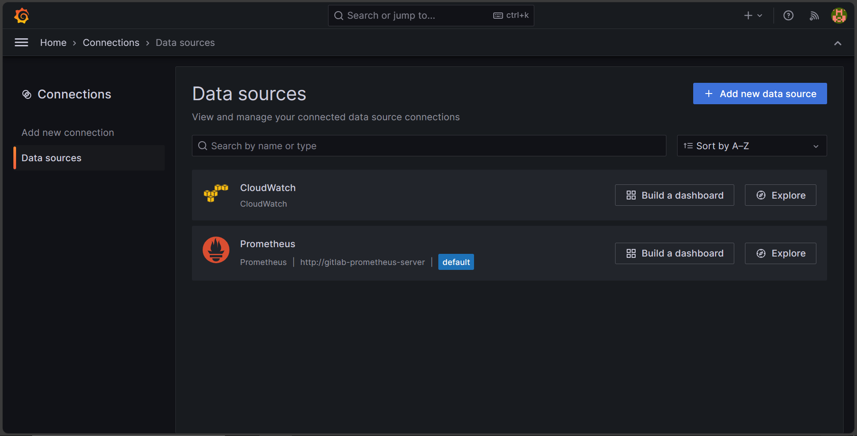  
  *Image 63: Data Sources In Grafana*

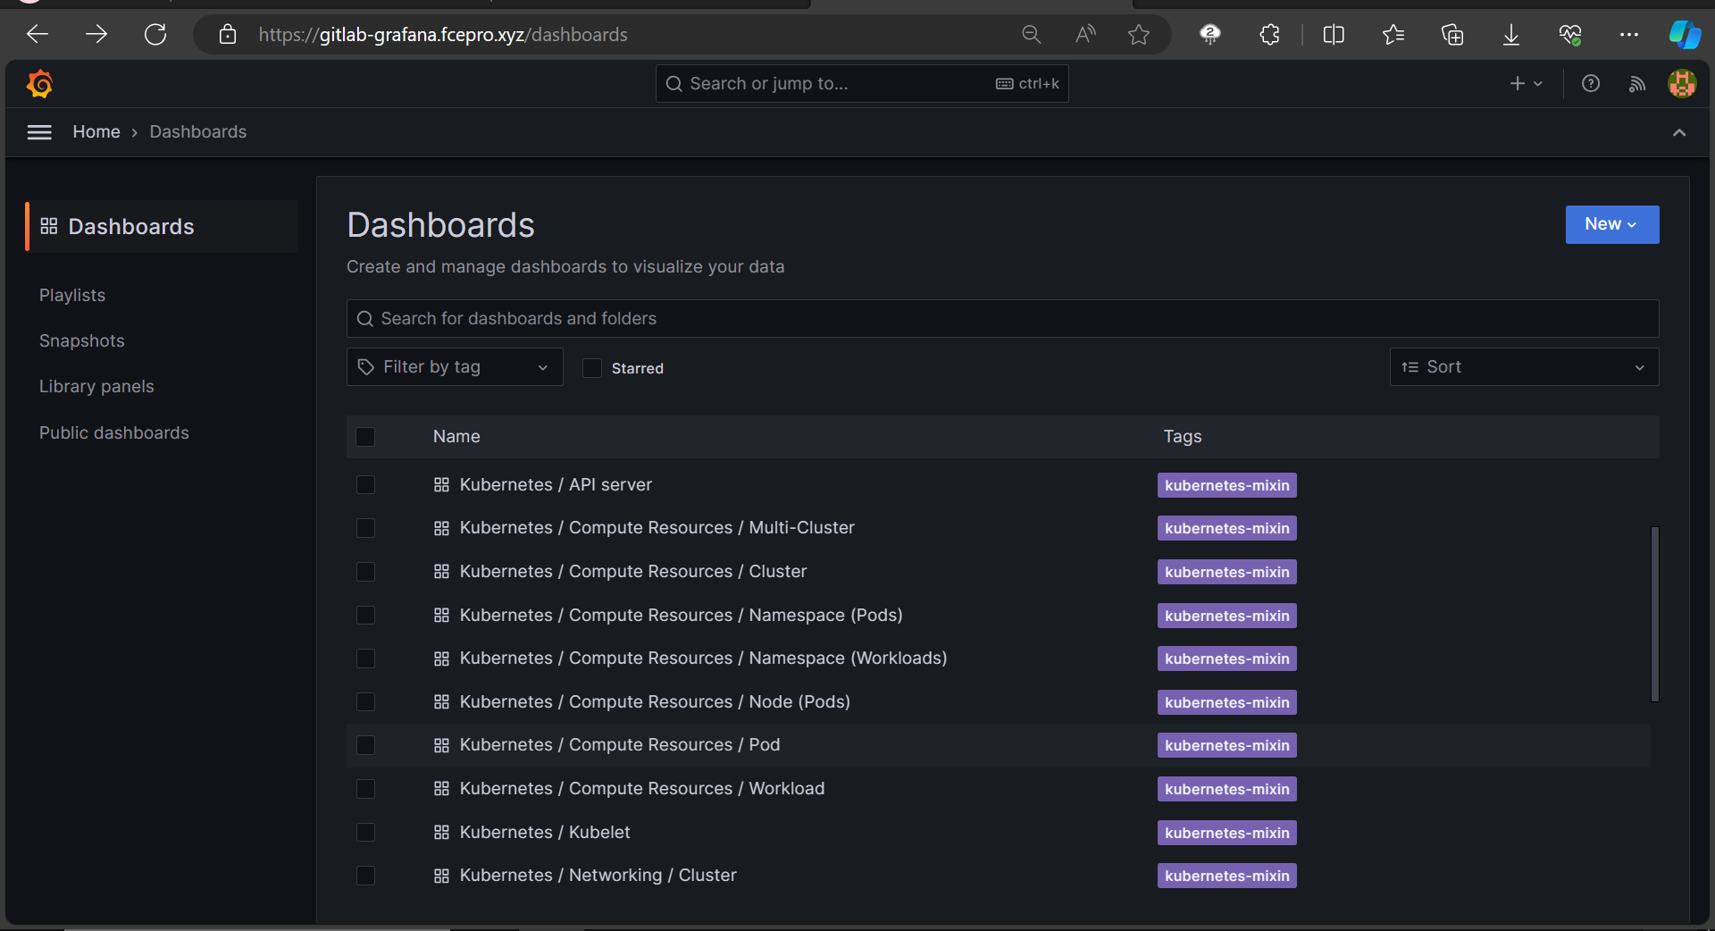  
  *Image 64: Dashboards In Grafana*

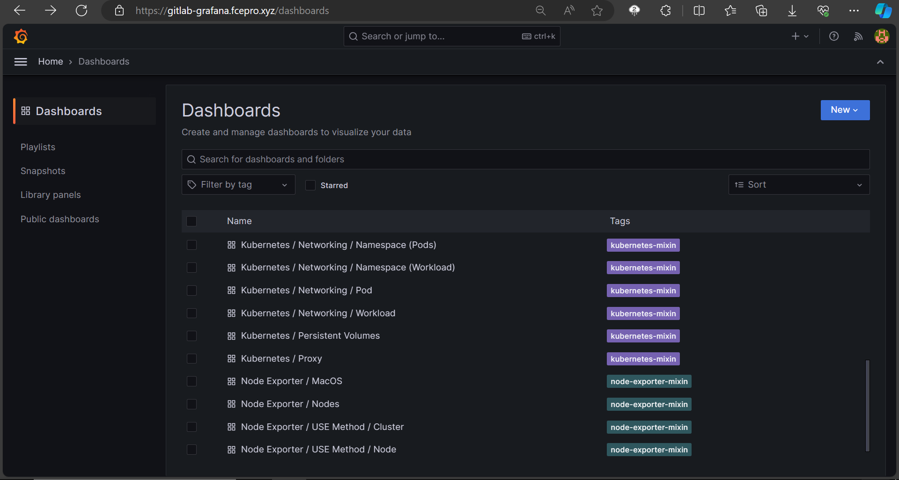  
  *Image 65: Dashboards In Grafana*

The monitoring workflow is keenly designed for GitLab's unique application environment. It empowers GitLab's teams to monitor individual components, gain strategic insights for continuous improvement, and ensure reliability in their operations.

**LOGGING**

**Overview**

In our GitLab CI/CD infrastructure, we've seamlessly integrated a robust logging system to provide a comprehensive record of activities and insights into application deployments. At the core of this logging solution is Fluent Bit, a lightweight and efficient log processor deployed as a daemon set within our Amazon Elastic Kubernetes Service (EKS) cluster.  
  
Our configuration is meticulously tuned to create distinct log streams within CloudWatch Logs, tailored to each GitLab application deployment. This deliberate organization ensures a granular and structured approach to log management, offering precise visibility into the performance and behavior of individual GitLab instances.  
Fluent Bit deployment acts as a restless observer, continuously harvesting logs and dispatching them to designated CloudWatch Log Groups. This streamlined approach not only simplifies log aggregation but also establishes a foundation for in-depth analysis and troubleshooting.  
  
The seamless integration of Fluent Bit with CloudWatch Logs empowers our CI/CD infrastructure with a comprehensive logging solution. This strategic implementation ensures that log data from each deployment is intelligently structured, easily accessible, and ready for analysis. This enhancement strengthens our ability to monitor, troubleshoot, and optimize the performance of our GitLab applications.

**Architecture**

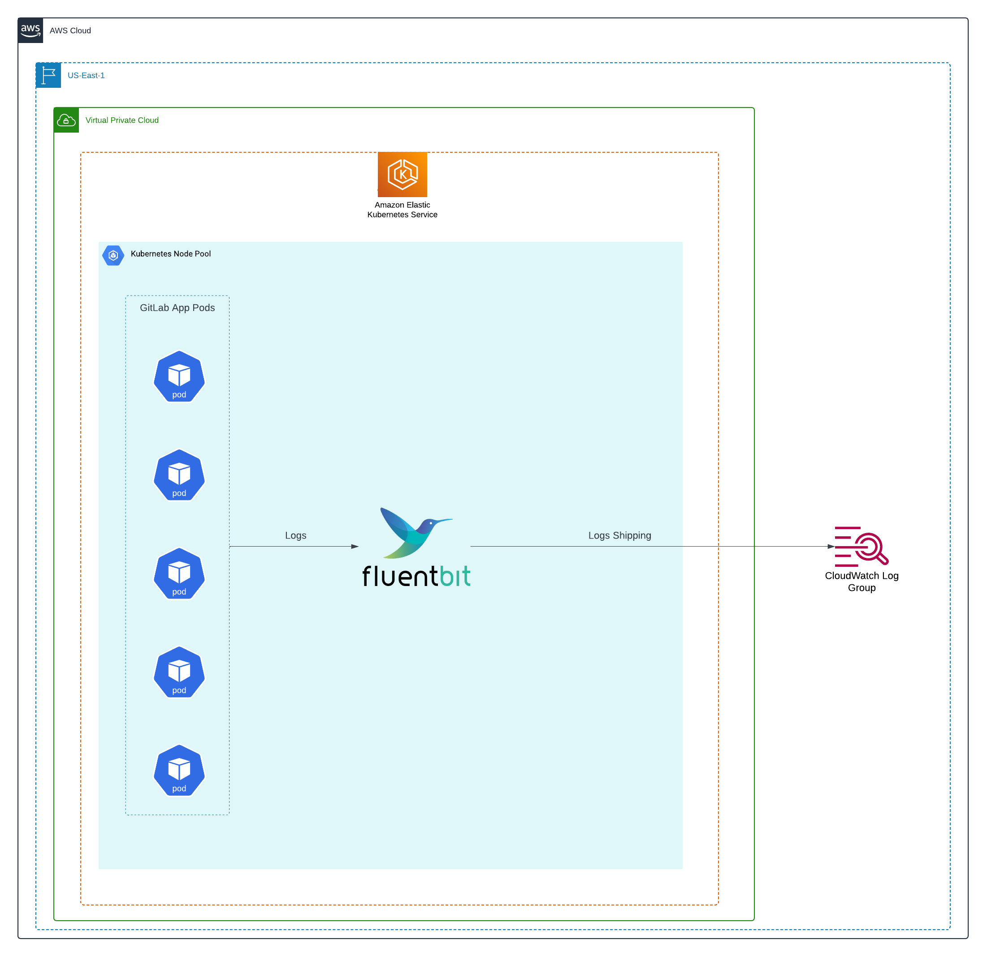  
 *Image 66: Logging Ecosystem* Architecture

The logging architecture revolves around Fluent Bit, a lightweight and efficient log processor, strategically deployed as a DaemonSet within our Amazon Elastic Kubernetes Service (EKS) cluster. This architecture ensures the systematic collection and forwarding of logs generated by various components and applications.

Benefits:  
1. Centralized Log Management:

Fluent Bit and CloudWatch Logs together provide a centralized and scalable solution for log storage and retrieval.

**2. Granular Visibility:**

Log streams enable granular visibility into the logs generated by specific GitLab applications,

allowing for targeted analysis and troubleshooting.

**3. Scalability and Efficiency:**

The DaemonSet deployment of Fluent Bit ensures scalability, and its lightweight nature

minimizes resource overhead.

This logging architecture empowers our CI/CD infrastructure with a robust and organized

approach to log management, enhancing our ability to monitor, analyze, and optimize the

performance of deployed GitLab applications.

**Log Shipping Workflow**

**Helm Deployment in CI/CD Pipeline**  
The Fluent Bit deployment initiates within the CI/CD pipeline, leveraging Helm charts for Kubernetes deployments. The Helm values file (aws_fluentbit_config.yaml) acts as a configuration blueprint, ensuring consistency and ease of management.

**Terraform Orchestration**  
  
Terraform scripts play an important role in orchestrating the deployment of Fluent Bit using helm chart. These scripts dynamically configure and provision the necessary resources in the EKS cluster, creating an infrastructure foundation for Fluent Bit's operation.

**DaemonSet Configuration**  
  
  
Fluent Bit is deployed as a DaemonSet in ‘kube-system’ namespace, strategically placing an

instance on each EKS node. This ensures comprehensive log collection across the entire cluster,

crucial for GitLab's distributed architecture.

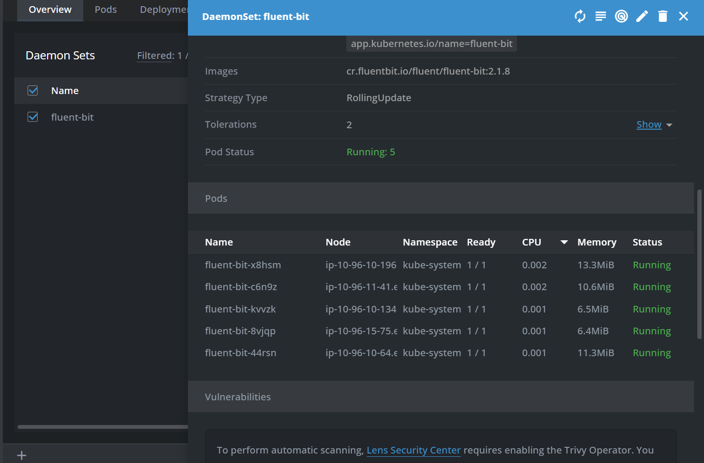  
 *Image 67: Fluentbit as Daemonset in eks*

**Log Collection from Containers**

Fluent Bit is configured to collect logs from specific paths within containers. It tailors its log

collection to exclude irrelevant logs, enhancing efficiency and reducing noise.

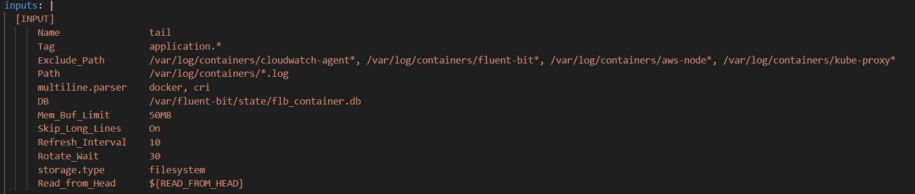

*Image 68: Custom Config for Fluentbit (inputs)*

**CloudWatch Logs Integration**

The core of the log shipping workflow lies in Fluent Bit's ability to forward logs to AWS CloudWatch Logs. The configuration specifies the CloudWatch region, log group name, and log stream prefix.

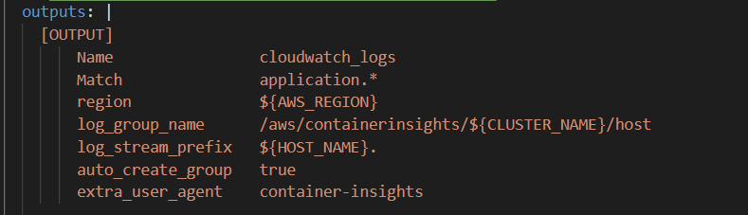

*Image 69: Custom Config for Fluentbit (outputs)*

Dynamic Log Group Creation

Fluent Bit dynamically creates log groups in CloudWatch, ensuring an organized structure for log storage. The log group name is dynamically generated based on the EKS cluster name and host information. The log streams are created based on the components name residing in the eks cluster. Log streams contains the logs of each event which will be very helpful for monitoring and debugging operations

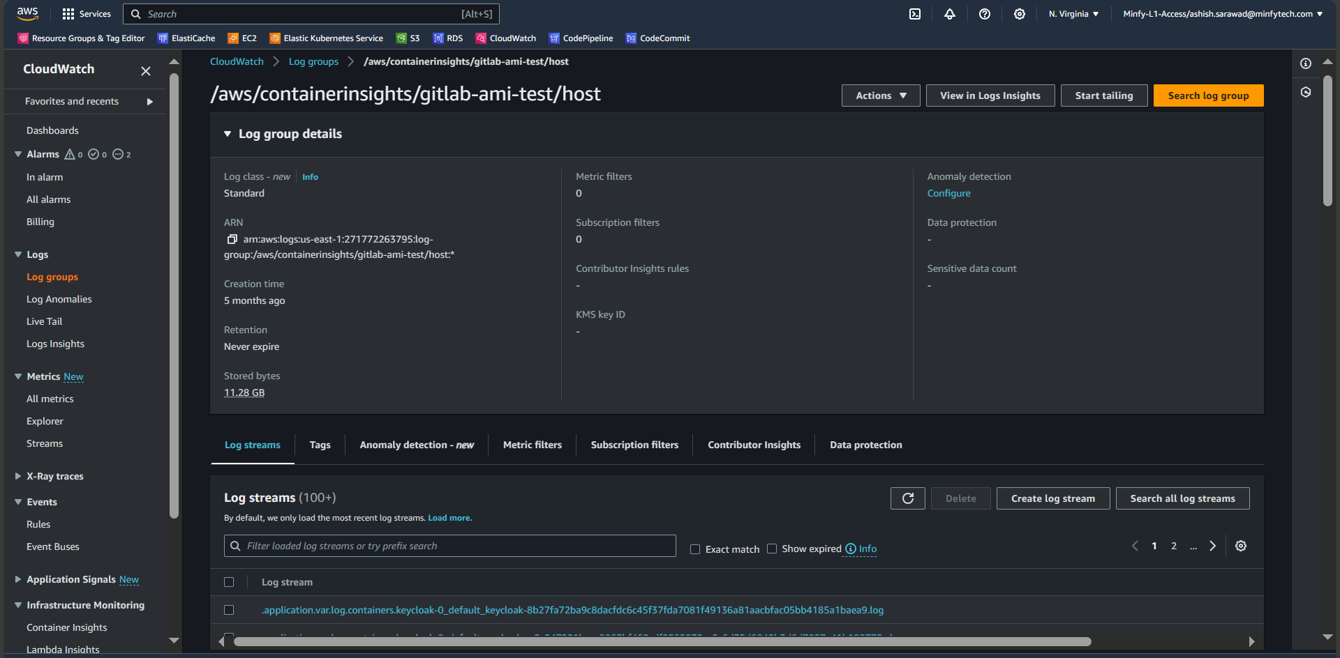  
  *Image 70: CloudWatch Log Group*

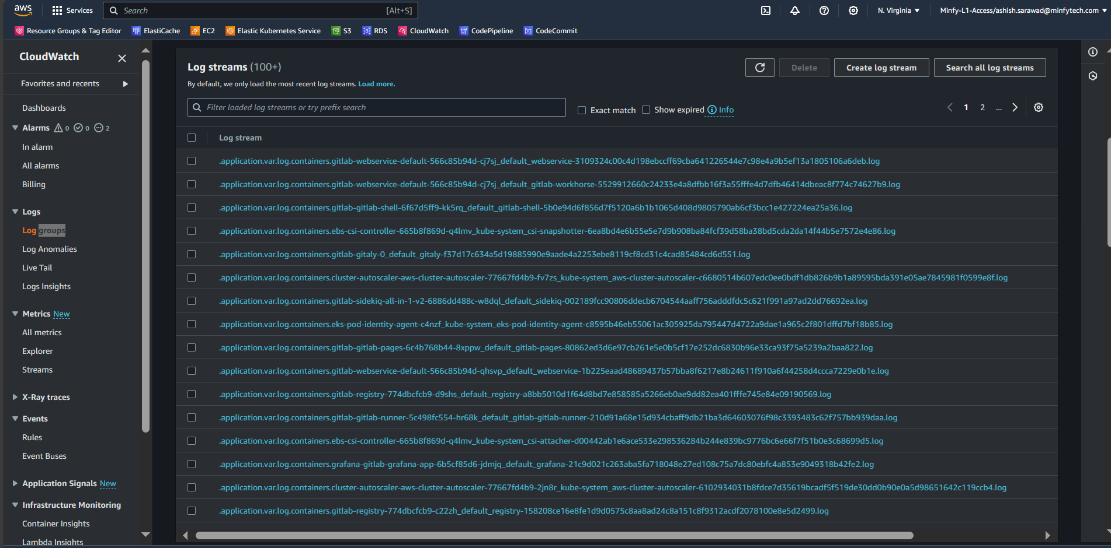  
  *Image 71: CloudWatch Log Group with Log Streams*

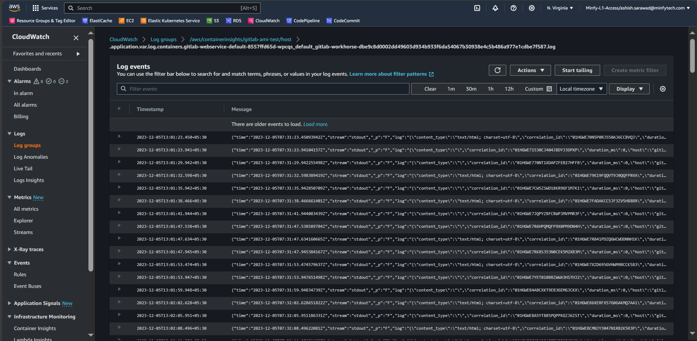

*Image 72: CloudWatch Log Stream of Webservice component*

The Fluent Bit deployment, orchestrated by Terraform, is seamlessly integrated into the GitLab CI/CD pipeline. Terraform scripts handle the dynamic provisioning of resources, and the Helm chart configuration is version-controlled within the GitLab repository.

This comprehensive log shipping workflow guarantees that every container's log, regardless of the namespace, is efficiently collected and forwarded to CloudWatch. It forms a critical component of GitLab's observability, providing detailed insights into the health and performance of deployed applications.

Conclusion  
  
GitLab modernization and DevOps implementation exhibit a meticulously designed and integrated system, harmonizing AWS and Kubernetes clusters. This architecture, fortified by AWS services like S3, RDS, and ElastiCache, forms a resilient foundation for GitLab deployment, ensuring data security, scalability, and efficient resource utilization.  
  
The orchestration prowess of Kubernetes takes center stage, managing critical GitLab components like Webservice, Sidekiq, Gitaly, and more. This orchestration ensures adaptability to diverse workloads, maintaining peak performance in our AWS-hosted environment.  
  
The implementation embraces best practices, incorporating Terraform for infrastructure provisioning, GitLab Helm Charts for deployment, and GitLab Environment Toolkit for GitLab-specific technicalities. This blend allows for seamless management of infrastructure and GitLab components, facilitated by a well-structured operation manual.  
  
Security and access control are paramount, addressed through IAM roles, Secrets Manager for sensitive information, and a bastion host configured with precision for secure access. CodeBuild, CodePipeline, and Terraform roles are defined, ensuring the right permissions for various services and components.

Efficiency extends to monitoring and logging, where Prometheus, Grafana, Fluent Bit, and CloudWatch collaboratively create a robust observability ecosystem. Container and resource metrics are meticulously collected, facilitating proactive issue resolution. Logs are intelligently structured in CloudWatch Logs, empowering us with a comprehensive logging solution.  
  
This GitLab modernization journey isn't merely an upgrade; it's a strategic move towards a future where GitLab environment is poised for growth, efficiency, and security. Together, with a collective commitment to excellence, we navigate the intricacies of GitLab modernization, ensuring a journey marked by achievement and innovation.

----------------------------------------------------------------------------------------------------